n…………………………………………0
St. Andrew’s Episcopal Church

17th Sunday after Pentecost
October 2, 2022 10:00am
Morning Prayer – Rite II

Lord God, you alone are the source of every good gift. Fill our hearts with faithfulness that when we are called to serve, we may answer, “here I am Lord,” with a spirit of discipleship. We pledge ourselves to be good and faithful stewards of the gifts you have entrusted to us, to share our time, talent and our material gifts as an outward sign of the treasure we hold in Jesus. Amen.

505 N. Pennsylvania Ave.
Roswell, NM 88201
575-622-1353
church@standrewsroswell.com
www.standrewsroswell.com

Prelude: When Morning Gilds the Skies – Joseph Barnby, arr Lloyd Larson

NOTE: Hymns are printed in the back of the bulletin.

Opening Hymn #11 – Awake, my soul

Leader I was glad when they said to me, “Let us go to the house of the Lord.”

The Leader then says to the people

Let us confess our sins against God and our neighbor.

Leaders and People together, all kneeling

Most merciful God, we confess that we have sinned against you in thought, word, and deed, by what we have done, and by what we have left undone.
We have not loved you with our whole heart;
we have not loved our neighbors as ourselves.
We are truly sorry and we humbly repent.
For the sake of your Son Jesus Christ, have mercy on us and forgive us;
that we may delight in your will, and walk in your ways, to the glory of
your Name. Amen.

The Leader alone says

Almighty God have mercy on us, forgive us all our sins through our Lord Jesus Christ, strengthen us in all goodness, and by the power of the Holy Spirit keep us in eternal life. Amen.

All stand.

Leader Lord, open our lips.
People And our mouth shall proclaim your praise.

Leaders and People

Glory to the Father, and to the Son, and to the Holy Spirit: as it was in the beginning, is now, and will be for ever. Amen. Alleluia.

Jubilate
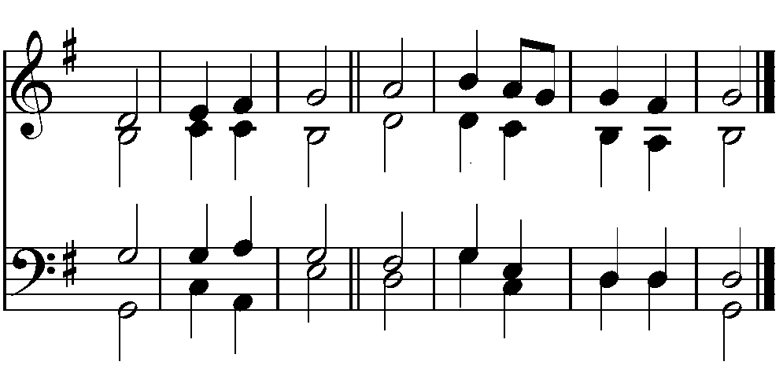

Be joyful in the | Lord, all you | lands; *
serve the Lord with gladness and come before his | presence | with a | song.

Know this: The Lord him | self is | God; *
he himself has made us, and we are his;
we are his | people and the | sheep of his | pasture.

Enter his gates with thanksgiving; go into his | courts with | praise; *
give thanks to | him and | call up on his | Name.

For the Lord is good; his mercy is | ever | lasting; *
and his faithfulness en | dures from | age to | age.

Glory to the Father, and | to the | Son, *
and | to the | Holy | Spirit;

As it was in the be | ginning, is | now, *
and | will be for | ever. A | men.

Psalm 37:1-10
1 Do not fret yourself because of evildoers; *
do not be jealous of those who do wrong.
2 For they shall soon wither like the grass, *
and like the green grass fade away.
3 Put your trust in the Lord and do good; *
dwell in the land and feed on its riches.
4 Take delight in the Lord, *
and he shall give you your heart's desire.
5 Commit your way to the Lord and put your trust in him, *
and he will bring it to pass.
6 He will make your righteousness as clear as the light *
and your just dealing as the noonday.
7 Be still before the Lord *
and wait patiently for him.
8 Do not fret yourself over the one who prospers, *
the one who succeeds in evil schemes.
9 Refrain from anger, leave rage alone; *
do not fret yourself; it leads only to evil.
10 For evildoers shall be cut off, *
but those who wait upon the Lord shall possess the land.

At the end of the Psalm is said

Glory to the Father, and to the Son, and to the Holy Spirit: *
as it was in the beginning, is now, and will be for ever. Amen.

The people sit.

First Lesson – Habakkuk 1:1-4, 2:1-4
The oracle that the prophet Habakkuk saw.
O Lord, how long shall I cry for help, and you will not listen?
Or cry to you "Violence!" and you will not save?
Why do you make me see wrong-doing and look at trouble?
Destruction and violence are before me;
strife and contention arise.
So the law becomes slack and justice never prevails.
The wicked surround the righteous--
therefore judgment comes forth perverted.
I will stand at my watchpost, and station myself on the rampart;
I will keep watch to see what he will say to me,
and what he will answer concerning my complaint.
Then the Lord answered me and said:
Write the vision;
make it plain on tablets, so that a runner may read it.
For there is still a vision for the appointed time;
it speaks of the end, and does not lie.
If it seems to tarry, wait for it;
it will surely come, it will not delay.
Look at the proud!
Their spirit is not right in them, but the righteous live by their faith.

The Word of the Lord.
People Thanks be to God.

Canticle 10 – The Second Song of Isaiah
Seek the Lord while he wills to be found; *
call upon him when he draws near.
Let the wicked forsake their ways *
and the evil ones their thoughts;
And let them turn to the Lord, and he will have compassion, *
and to our God, for he will richly pardon.
For my thoughts are not your thoughts, *
nor your ways my ways, says the Lord.
For as the heavens are higher than the earth, *
so are my ways higher than your ways,
and my thoughts than your thoughts.
For as rain and snow fall from the heavens *
and return not again, but water the earth,
Bringing forth life and giving growth, *
seed for sowing and bread for eating,
So is my word that goes forth from my mouth; *
it will not return to me empty;
But it will accomplish that which I have purposed, *
and prosper in that for which I sent it.

Glory to the Father, and to the Son, and to the Holy Spirit: *
as it was in the beginning, is now, and will be for ever. Amen.

Second Lesson – 2 Timothy 1:1-14
Paul, an apostle of Christ Jesus by the will of God, for the sake of the promise of life that is in Christ Jesus,
To Timothy, my beloved child:
Grace, mercy, and peace from God the Father and Christ Jesus our Lord.
I am grateful to God-- whom I worship with a clear conscience, as my ancestors did-- when I remember you constantly in my prayers night and day. Recalling your tears, I long to see you so that I may be filled with joy.
I am reminded of your sincere faith, a faith that lived first in your grandmother Lois and your mother Eunice and now, I am sure, lives in you. For this reason I remind you to rekindle the gift of God that is within you through the laying on of my hands; for God did not give us a spirit of cowardice, but rather a spirit of power and of love and of self-discipline.
Do not be ashamed, then, of the testimony about our Lord or of me his prisoner, but join with me in suffering for the gospel, relying on the power of God, who saved us and called us with a holy calling, not according to our works but according to his own purpose and grace. This grace was given to us in Christ Jesus before the ages began, but it has now been revealed through the appearing of our Savior Christ Jesus, who abolished death and brought life and immortality to light through the gospel. For this gospel I was appointed a herald and an apostle and a teacher, and for this reason I suffer as I do. But I am not ashamed, for I know the one in whom I have put my trust, and I am sure that he is able to guard until that day what I have entrusted to him. Hold to the standard of sound teaching that you have heard from me, in the faith and love that are in Christ Jesus. Guard the good treasure entrusted to you, with the help of the Holy Spirit living in us.

The Word of the Lord.
People Thanks be to God.

Canticle 13 – A Song of Praise
Glory to you, Lord God of our fathers; *
you are worthy of praise; glory to you.
Glory to you for the radiance of your holy Name; *
we will praise you and highly exalt you for ever.
Glory to you in the splendor of your temple; *
on the throne of your majesty, glory to you.
Glory to you, seated between the Cherubim; *
we will praise you and highly exalt you for ever.

Glory to you, beholding the depths; *
in the high vault of heaven, glory to you.
Glory to you, Father, Son, and Holy Spirit; *
we will praise you and highly exalt you for ever.

Third Lesson – Luke 17:5-10
The apostles said to the Lord, "Increase our faith!" The Lord replied, "If you had faith the size of a mustard seed, you could say to this mulberry tree, `Be uprooted and planted in the sea,' and it would obey you.
"Who among you would say to your slave who has just come in from plowing or tending sheep in the field, `Come here at once and take your place at the table'? Would you not rather say to him, `Prepare supper for me, put on your apron and serve me while I eat and drink; later you may eat and drink'? Do you thank the slave for doing what was commanded? So you also, when you have done all that you were ordered to do, say, `We are worthless slaves; we have done only what we ought to have done!'"

The Apostles’ Creed

Leaders and People together, all standing

I believe in God, the Father almighty, creator of heaven and earth.
I believe in Jesus Christ, his only Son, our Lord.
He was conceived by the power of the Holy Spirit
and born of the Virgin Mary.
He suffered under Pontius Pilate,
was crucified, died, and was buried.
He descended to the dead.
On the third day he rose again.
He ascended into heaven, and is seated at the right hand of the Father.
He will come again to judge the living and the dead.
I believe in the Holy Spirit, the holy catholic Church,
the communion of saints, the forgiveness of sins,
the resurrection of the body, and the life everlasting. Amen.

The Prayers

The people remain standing or kneel.

Leader The Lord be with you.
People And also with you.
Leader Let us pray.

Leaders and People

Our Father in heaven,
hallowed be your Name,
your kingdom come, your will be done,
on earth as in heaven.
Give us today our daily bread.
Forgive us our sins as we forgive those who sin against us.
Save us from the time of trial,
and deliver us from evil.
For the kingdom, the power, and the glory are yours,
now and for ever. Amen.

Suffrages B

Verse: Save your people, Lord, and bless your inheritance;
Response: Govern and uphold them, now and always.
V: Day by day we bless you;
R: We praise your Name for ever.
V: Lord, keep us from all sin today;
R: Have mercy on us, Lord, have mercy.
V: Lord, show us your love and mercy;
R: For we put our trust in you.
V: In you, Lord, is our hope;
R: And we shall never hope in vain.

The Leaders then say the following

The Collect of the Day
Almighty and everlasting God, you are always more ready to hear than we to pray, and to give more than we either desire or deserve: Pour upon us the abundance of your mercy, forgiving us those things of which our conscience
is afraid, and giving us those good things for which we are not worthy to ask, except through the merits and mediation of Jesus Christ our Savior; who lives and reigns with you and the Holy Spirit, one God, for ever and ever. Amen.

A Collect for Guidance
Heavenly Father, in you we live and move and have our being: We humbly pray you so to guide and govern us by your Holy Spirit, that in all the cares and occupations of our life we may not forget you, but may remember that we are ever walking in your sight; through Jesus Christ our Lord. Amen.

Prayer for Mission
Lord Jesus Christ, you stretched out your arms of love on the hard wood of the cross that everyone might come within the reach of your saving embrace: So clothe us in your Spirit that we, reaching forth our hands in love, may bring those who do not know you to the knowledge and love of you; for
the honor of your Name. Amen.

The people sit.

Choral offering: Children of the Heavenly Father – arr Dan Forrest

Leaders and People pray together

The General Thanksgiving

Almighty God, Father of all mercies,
we your unworthy servants give you humble thanks for all your goodness and loving-kindness to us and to all whom you have made.
We bless you for our creation, preservation, and all the blessings of this life;

but above all for your immeasurable love
in the redemption of the world by our Lord Jesus Christ;
for the means of grace, and for the hope of glory.
And, we pray, give us such an awareness of your mercies,
that with truly thankful hearts we may show forth your praise,
not only with our lips, but in our lives, by giving up ourselves to your service,
and by walking before you in holiness and righteousness all our days;
through Jesus Christ our Lord, to whom, with you and the Holy Spirit,
be honor and glory throughout all ages. Amen.

A Prayer of St. Chrysostom

Almighty God, you have given us grace at this time with one accord to make our common supplication to you; and you have promised through your well-beloved Son that when two or three are gathered together in his Name you will be in the midst of them: Fulfill now, O Lord, our desires and petitions as may be best for us; granting us in this world knowledge of your truth, and in the age to come life everlasting. Amen.

Leader Let us bless the Lord.
People Thanks be to God.

Closing Hymn #551 – Rise up, ye saints of God!

Postlude: Standing on the Promises – R. Kelso Carter, arr Mark Hayes

#11

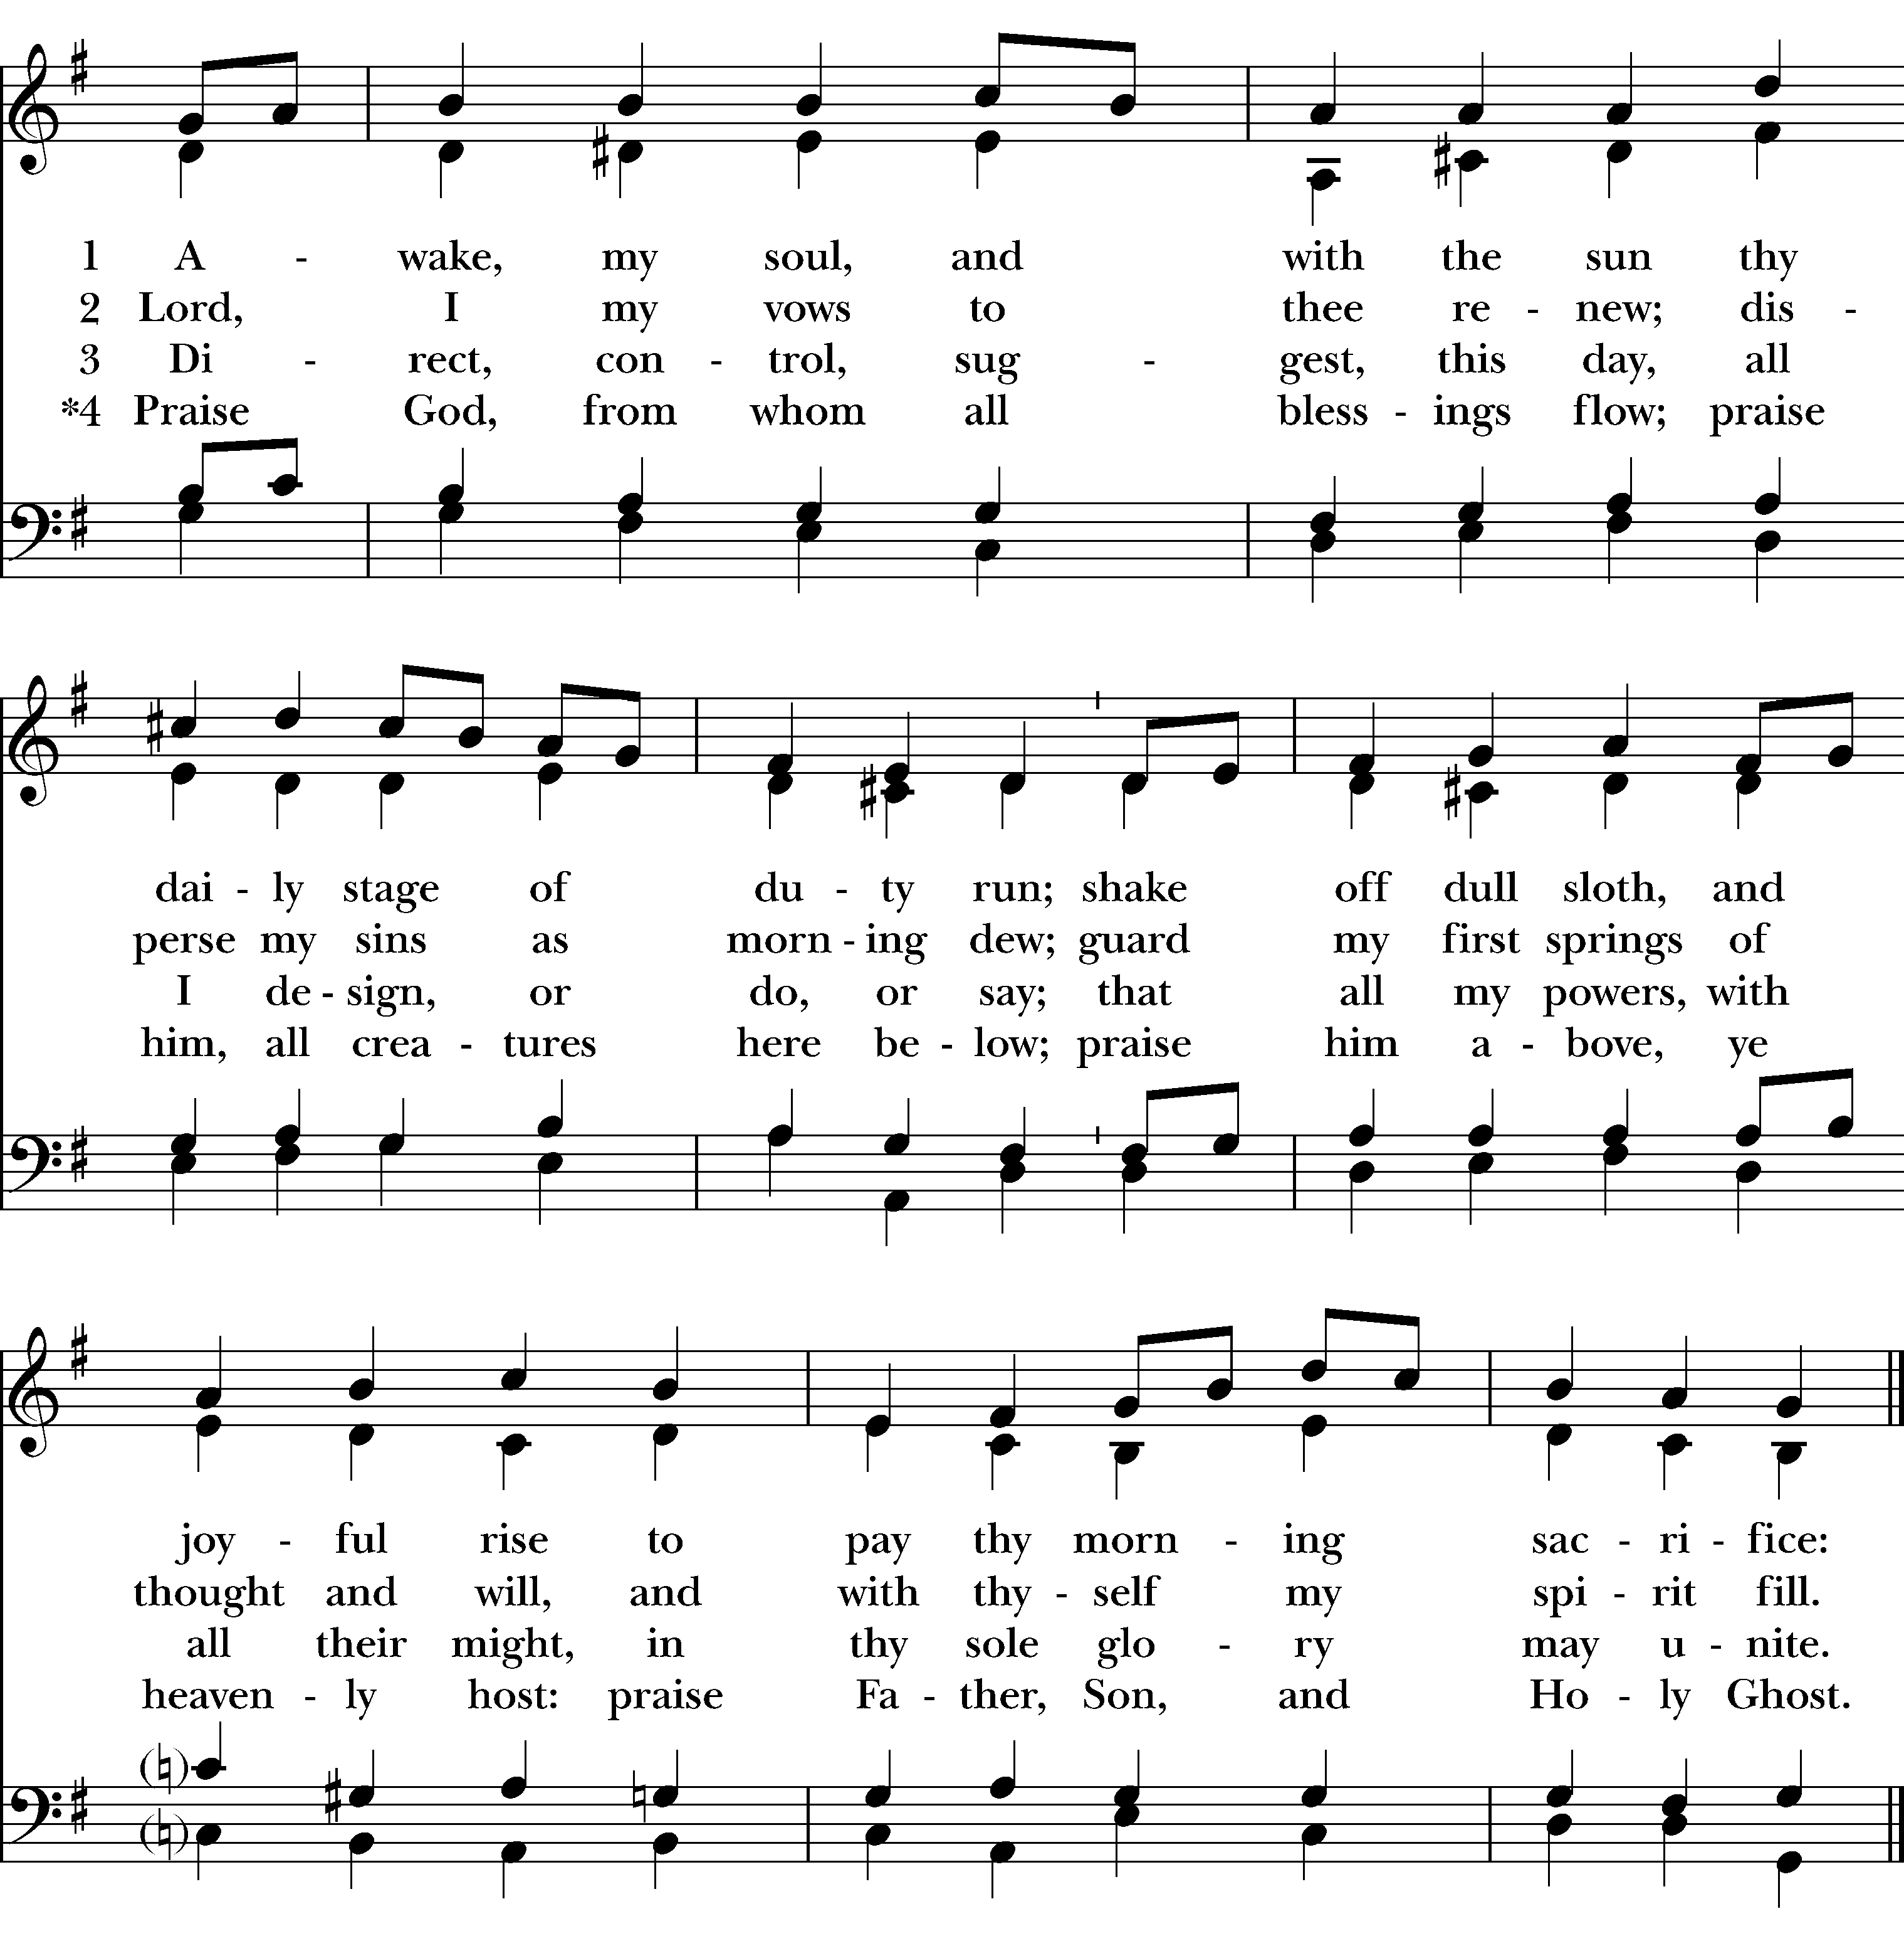

#551

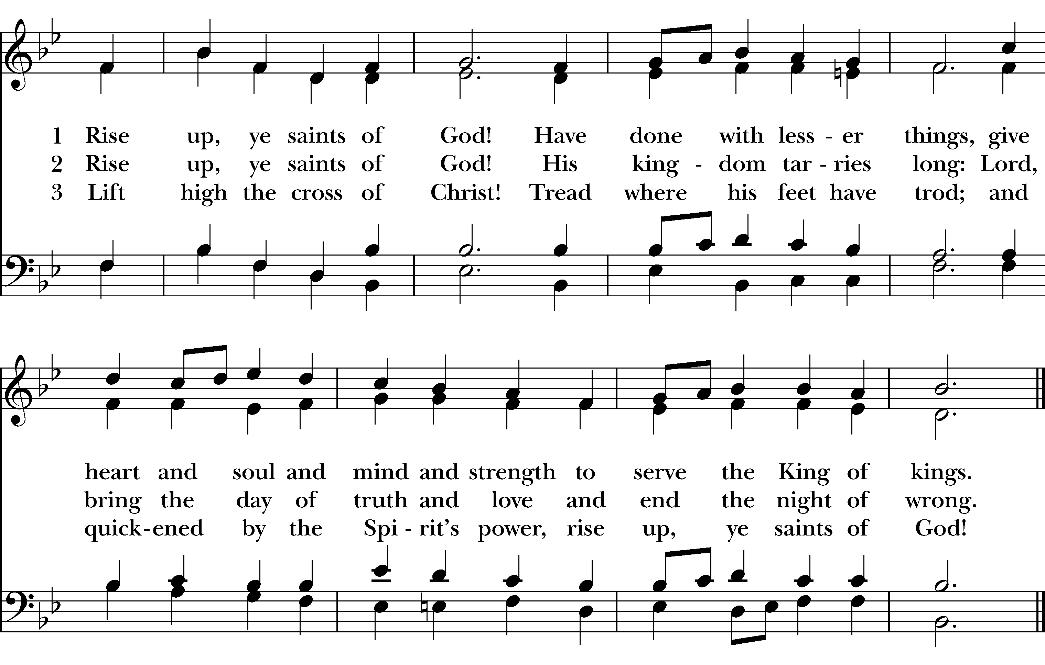

Please pray for our members and their families:
Earl Pittman, Craig Lysak, Manuel Linares, Jeremiah Bryant, Laura Read, Nancy Hartwick, Janet Macaluso, Alec, John Fuss, Cyndy Collins, Andrew Patton, Mary Ritter, Burnitta McClung, Bruce Currier, Mike Brazie, Billie Weber, Karen & Pat Hendricks, Lorinda & Royce, Cory Woodbury, Janelle McGuire, Andy Morehouse, Kelli, Jack Giovo, Stuart Shanor, Carol Anne, Marilyn Manatt, Gary Smith, Michelle, Ann Wonders, Isabel Castillo, Lisa Huff, Dwight & Anne Crowder, Julie Deaton, Betty, Aaron & Sarah, Kim C., Maddy, Abby K & family, Martin Kelley, Victoria Cobb, Pat Wiberg, Andrew W., Matthew, David Smith, Breanna Hickey, Lynn Waggoner, Rachel, Amanda Olivo, Sevie Bates, Florence Carr, Alice Smith, Beth Rogers, Jeannine Byron, Melody Green, Marisa, Lew Hightower, Clayton Thompson, Bill & Meredith Patton, Annette Mader, Julian Linares, Raymond Linares, Jennifer Linares, Cheryl Grey, Cassie, Gary Larson, Sandi Olivo

Please pray for friends of St. Andrew’s:
Dr. Dennis Knoche, Dale Williams, Bill Daily, Lenore Savage, Patricia Shupe, Tom Tutor, Dyess family, Rose Herrera, John Gilmore, Gretta Dickman, Susan H., Canon Lee Curtis, Bill Murphy, Jo Pendergrass, Nancy W., Andres Adauto, Coy Dickson, Rebecca Ellis, Victor & Laquita Pierce, Robert, Mark, Jenice Furguson, Rev. Susanna Metz, Del Journey, Courtney, Elena & family, Elena & Blanca’s mother, Robert, Aurora, Tristen, Belma Cloud, Josie Powell, Clifford Sipple family, Dayna, Karen Anderson, Andrea, Cox Family, Melissa J. & family, Fr. Hector Trejo, Shawna & family, Stephanie K., Sarah, Veronica, Michelle Siebel, Kalistro Linares, Michele Hillman, Sarah Wooldridge, Jerry & M.J., Rex Kartchner, Alison, Emily, Janet Carter, Meredith Miller, Maryanne D’Arcangelis, Christopher, Josie & Lloyd, Fern Simpson, Lara, Dyan, Nancy Klima, M. Lopez, Wilson, Susan, Keith Maston, Kevin Maston, Carli Salyards, Tammy Reed, Frank Roberts and family, Elizabeth Klijnsmit, Jaime Alvarez, Ron & Twylla M, Rosemary Henry, Mathew & family, Effie Silva, Baldo & Rena, Marty G., Tom & Marilyn

The flowers this morning are given by P.J. Greer
in memory of Cecil B. Greer

Lay Leader: Charles Currier
Verger: Sissy Mayne
Pianist: Karen Fuss
Ushers: Duane Evans, Ken Hernandez
Camera Operator: Teresa Patton
Altar Guild: Lorinda Wilkins, Karen Fuss

NOTICE: This service is video-recorded and streamed to the church’s public Facebook page.

