0
St. Andrew’s Episcopal Church

The Seventeenth Sunday after Pentecost
Proper 20
September 19, 2021 9:00 AM
Rite II

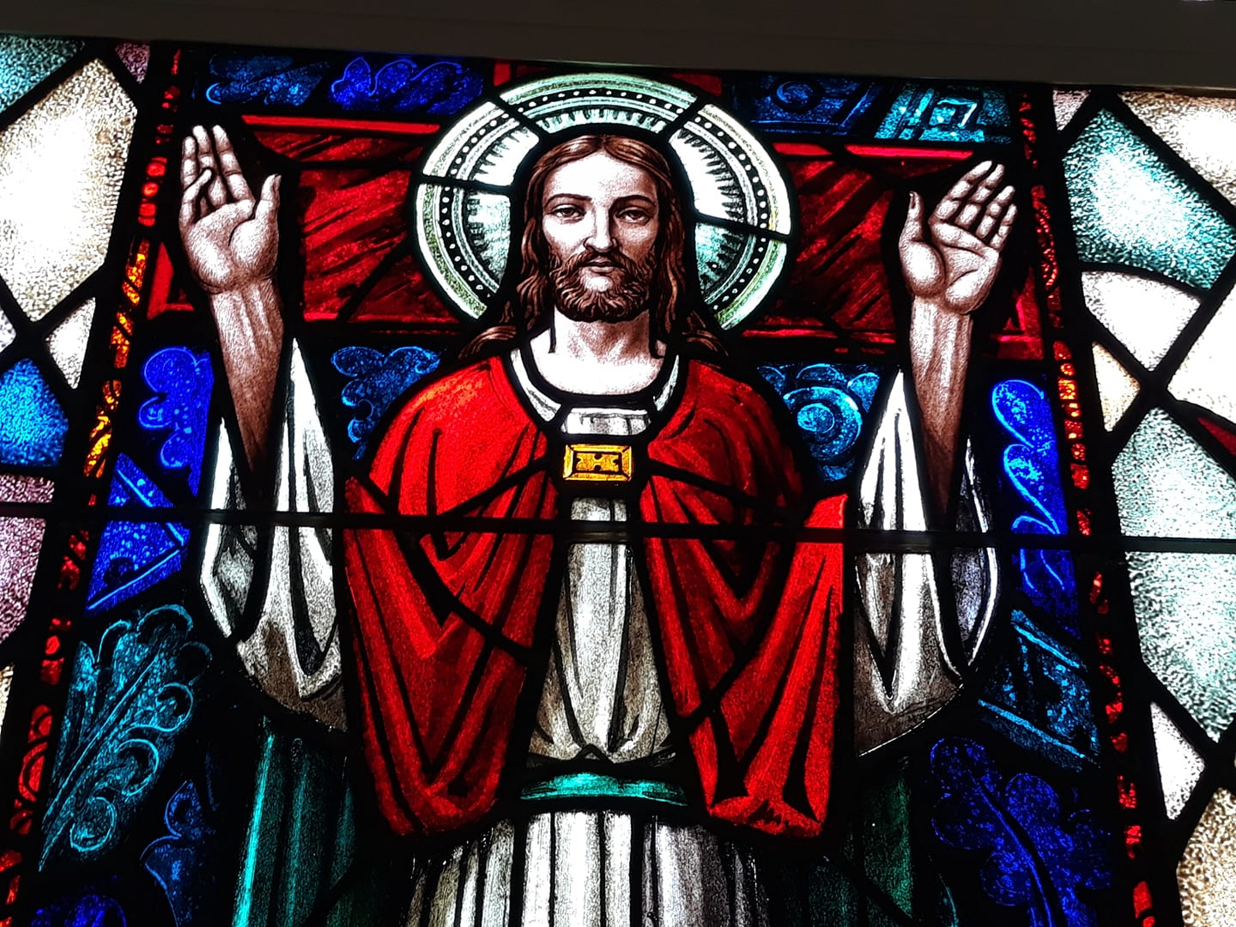

Lord God, you alone are the source of every good gift. Fill our hearts with faithfulness that when we are called to serve, we may answer, “here I am Lord,” with a spirit of discipleship. We pledge ourselves to be good and faithful stewards of the gifts you have entrusted to us, to share our time, talent and our material gifts as an outward sign of the treasure we hold in Jesus. Amen

505 N. Pennsylvania Ave.
Roswell, NM 88201
575-622-1353
standrewschurch@cableone.net
www.standrewsroswell.com

Prelude: Prelude in a Classical Style – Gordon Young

Hymns are printed in the back of the bulletin, beginning on page 18.

Processional Hymn #408 – Sing praise to God who reigns above

The people standing, the Celebrant says

Blessed be God: Father, Son, and Holy Spirit
People And blessed be his kingdom, now and for ever. Amen

The Celebrant may say

Almighty God, to you all hearts are open, all desires known,
and from you no secrets are hid: Cleanse the thoughts of our
hearts by the inspiration of your Holy Spirit, that we may
perfectly love you, and worthily magnify your holy Name;
through Christ our Lord. Amen.

When appointed, the following hymn or some other song of praise is sung
or said, all standing

Gloria in excelsis ~ Hymnal S-280

Glory to God in the highest,
and peace to his people on earth.

Lord God, heavenly King,
almighty God and Father,
we worship you, we give you thanks,
we praise you for your glory.

Lord Jesus Christ, only Son of the Father,
Lord God, Lamb of God,
you take away the sin of the world:
have mercy on us;

you are seated at the right hand of the Father:
receive our prayer.
For you alone are the Holy One,
you alone are the Lord,
you alone are the Most High,
Jesus Christ,
with the Holy Spirit,
in the glory of God the Father. Amen.

The Collect of the Day

The Celebrant says to the people

The Lord be with you.
People And also with you.
Celebrant Let us pray.

The Celebrant says the Collect.
Grant us, Lord, not to be anxious about earthly things, but to love things heavenly; and even now, while we are placed among things that are passing away, to hold fast to those that shall endure; through Jesus Christ our Lord, who lives and reigns with you and the Holy Spirit, one God, for ever and ever. Amen.

The Lessons

The people sit.

Proverbs 31:10-31
A capable wife who can find?
She is far more precious than jewels.
The heart of her husband trusts in her,
and he will have no lack of gain.
She does him good, and not harm,
all the days of her life.
She seeks wool and flax,
and works with willing hands.
She is like the ships of the merchant,
she brings her food from far away.
She rises while it is still night
and provides food for her household
and tasks for her servant-girls.
She considers a field and buys it;
with the fruit of her hands she plants a vineyard.
She girds herself with strength,
and makes her arms strong.
She perceives that her merchandise is profitable.
Her lamp does not go out at night.
She puts her hands to the distaff,
and her hands hold the spindle.
She opens her hand to the poor,
and reaches out her hands to the needy.
She is not afraid for her household when it snows,
for all her household are clothed in crimson.
She makes herself coverings;
her clothing is fine linen and purple.
Her husband is known in the city gates,
taking his seat among the elders of the land.
She makes linen garments and sells them;
she supplies the merchant with sashes.
Strength and dignity are her clothing,
and she laughs at the time to come.
She opens her mouth with wisdom,
and the teaching of kindness is on her tongue.
She looks well to the ways of her household,
and does not eat the bread of idleness.
Her children rise up and call her happy;
her husband too, and he praises her:
“Many women have done excellently,
but you surpass them all.”
Charm is deceitful, and beauty is vain,
but a woman who fears the Lord is to be praised.
Give her a share in the fruit of her hands,
and let her works praise her in the city gates.

The Word of the Lord.
People Thanks be to God.

Silence may follow.

Psalm 1
Beatus vir qui non abiit
1 Happy are they who have not walked in the counsel of the wicked, *
nor lingered in the way of sinners,
nor sat in the seats of the scornful!
2 Their delight is in the law of the Lord, *
and they meditate on his law day and night.
3 They are like trees planted by streams of water,
bearing fruit in due season, with leaves that do not wither; *
everything they do shall prosper.
4 It is not so with the wicked; *
they are like chaff which the wind blows away.
5 Therefore the wicked shall not stand upright when judgment comes, *
nor the sinner in the council of the righteous.
6 For the Lord knows the way of the righteous, *
but the way of the wicked is doomed.

The Epistle

James 3:13-4:3, 7-8a
Who is wise and understanding among you? Show by your good life that your works are done with gentleness born of wisdom. But if you have bitter envy and selfish ambition in your hearts, do not be boastful and false to the truth. Such wisdom does not come down from above, but is earthly, unspiritual, devilish. For where there is envy and selfish ambition, there will also be disorder and wickedness of every kind. But the wisdom from above is first pure, then peaceable, gentle, willing to yield, full of mercy and good fruits, without a trace of partiality or hypocrisy. And a harvest of righteousness is sown in peace for those who make peace.
Those conflicts and disputes among you, where do they come from? Do they not come from your cravings that are at war within you? You want something and do not have it; so you commit murder. And you covet something and cannot obtain it; so you engage in disputes and conflicts. You do not have, because you do not ask. You ask and do not receive, because you ask wrongly, in order to spend what you get on your pleasures.
Submit yourselves therefore to God. Resist the devil, and he will flee from you. Draw near to God, and he will draw near to you.

The Word of the Lord.
People Thanks be to God.

Sequence Hymn #635 – If thou but trust in God to guide thee

Then, all standing, the Deacon or a Priest reads the Gospel, first saying

The Holy Gospel of our Lord Jesus Christ according to Mark
People Glory to you, Lord Christ.

The Gospel

Mark 9:30-37
Jesus and his disciples passed through Galilee. He did not want anyone to know it; for he was teaching his disciples, saying to them, “The Son of Man is to be betrayed into human hands, and they will kill him, and three days after being killed, he will rise again.” But they did not understand what he was saying and were afraid to ask him.
Then they came to Capernaum; and when he was in the house he asked them, “What were you arguing about on the way?” But they were silent, for on the way they had argued with one another who was the greatest. He sat down, called the twelve, and said to them, “Whoever wants to be first must be last of all and servant of all.” Then he took a little child and put it among them; and taking it in his arms, he said to them, “Whoever welcomes one such child in my name welcomes me, and whoever welcomes me welcomes not me but the one who sent me.”

The Gospel of the Lord.
People Praise to you, Lord Christ.

The Sermon

The Nicene Creed

We believe in one God,
the Father, the Almighty,
maker of heaven and earth,
of all that is, seen and unseen.

We believe in one Lord, Jesus Christ,
the only Son of God,
eternally begotten of the Father,
God from God, Light from Light,
true God from true God,
begotten, not made,
of one Being with the Father.
Through him all things were made.
For us and for our salvation
he came down from heaven:
by the power of the Holy Spirit
he became incarnate from the Virgin Mary,
and was made man.
For our sake he was crucified under Pontius Pilate;
he suffered death and was buried.
On the third day he rose again
in accordance with the Scriptures;
he ascended into heaven
and is seated at the right hand of the Father.
He will come again in glory to judge the living and the dead,
and his kingdom will have no end.

We believe in the Holy Spirit, the Lord, the giver of life,
who proceeds from the Father and the Son.
With the Father and the Son he is worshiped and glorified.
He has spoken through the Prophets.
We believe in one holy catholic and apostolic Church.
We acknowledge one baptism for the forgiveness of sins.
We look for the resurrection of the dead,
and the life of the world to come. Amen.

The Prayers of the People

Form III

The Leader and People pray responsively

Father, we pray for your holy Catholic Church;
That we all may be one.

Grant that every member of the Church may truly and
humbly serve you;
That your Name may be glorified by all people.

We pray for all bishops, priests, and deacons;
That they may be faithful ministers of your Word and
Sacraments.

We pray for all who govern and hold authority in the nations
of the world;
That there may be justice and peace on the earth.

Give us grace to do your will in all that we undertake;
That our works may find favor in your sight.

Have compassion on those who suffer from any grief or trouble;
That they may be delivered from their distress.

Give to the departed eternal rest;
Let light perpetual shine upon them.

We praise you for your saints who have entered into joy;
May we also come to share in your heavenly kingdom.

Let us pray for our own needs and those of others.

Silence

The People may add their own petitions.

The Celebrant adds a concluding Collect.

Confession of Sin

A Confession of Sin is said here if it has not been said earlier. On
occasion, the Confession may be omitted.

The Deacon or Celebrant says

Let us confess our sins against God and our neighbor.

Silence may be kept.

Minister and People

Most merciful God,
we confess that we have sinned against you
in thought, word, and deed,
by what we have done,
and by what we have left undone.
We have not loved you with our whole heart;
we have not loved our neighbors as ourselves.
We are truly sorry and we humbly repent.
For the sake of your Son Jesus Christ,
have mercy on us and forgive us;
that we may delight in your will,
and walk in your ways,
to the glory of your Name. Amen.

The Bishop when present, or the Priest, stands and says

Almighty God have mercy on you, forgive you all your sins
through our Lord Jesus Christ, strengthen you in all
goodness, and by the power of the Holy Spirit keep you in
eternal life. Amen.

The Peace

All stand. The Celebrant says to the people

The peace of the Lord be always with you.
People And also with you.

During the Peace, please observe safe practices.

Announcements

The Holy Communion

Offertory Sentence

Walk in love, as Christ loved us and gave himself for us, an
offering and sacrifice to God. Ephesians 5:2

Offertory Music: Lord, I Stretch My Hands to You
~ Jay Althouse

The Great Thanksgiving

Eucharistic Prayer A

The people remain standing. The Celebrant, whether bishop or priest,
faces them and sings or says

The Lord be with you.
People And also with you.
Celebrant Lift up your hearts.
People We lift them to the Lord.
Celebrant Let us give thanks to the Lord our God.
People It is right to give him thanks and praise.

Then, facing the Holy Table, the Celebrant proceeds

It is right, and a good and joyful thing, always and everywhere to give thanks to you, Father Almighty, Creator of heaven and earth, through Jesus Christ our Lord; who on the first day of the week overcame death and the grave, and by his glorious resurrection opened to us the way of everlasting life.

Here a Proper Preface is sung or said on all Sundays, and on other
occasions as appointed.

Therefore we praise you, joining our voices with Angels and
Archangels and with all the company of heaven, who for ever
sing this hymn to proclaim the glory of your Name:

Celebrant and People

Holy, holy, holy Lord, God of power and might,
heaven and earth are full of your glory.
Hosanna in the highest.
Blessed is he who comes in the name of the Lord.
Hosanna in the highest.

The people stand or kneel.

Then the Celebrant continues

Holy and gracious Father: In your infinite love you made us
for yourself; and, when we had fallen into sin and become
subject to evil and death, you, in your mercy, sent Jesus
Christ, your only and eternal Son, to share our human
nature, to live and die as one of us, to reconcile us to you, the
God and Father of all.

He stretched out his arms upon the cross, and offered himself,
in obedience to your will, a perfect sacrifice for the whole
world.

On the night he was handed over to suffering and death, our
Lord Jesus Christ took bread; and when he had given thanks
to you, he broke it, and gave it to his disciples, and said, “Take,
eat: This is my Body, which is given for you. Do this for the
remembrance of me.”

After supper he took the cup of wine; and when he had given
thanks, he gave it to them, and said, “Drink this, all of you:
This is my Blood of the new Covenant, which is shed for you
and for many for the forgiveness of sins. Whenever you drink
it, do this for the remembrance of me.”

Therefore we proclaim the mystery of faith:

Celebrant and People

Christ has died.
Christ is risen.
Christ will come again.

The Celebrant continues

We celebrate the memorial of our redemption, O Father, in
this sacrifice of praise and thanksgiving. Recalling his death,
resurrection, and ascension, we offer you these gifts.

Sanctify them by your Holy Spirit to be for your people the
Body and Blood of your Son, the holy food and drink of new
and unending life in him. Sanctify us also that we may faithfully
receive this holy Sacrament, and serve you in unity, constancy,
and peace; and at the last day bring us with all your saints
into the joy of your eternal kingdom.

All this we ask through your Son Jesus Christ. By him, and
with him, and in him, in the unity of the Holy Spirit all honor
and glory is yours, Almighty Father, now and for ever. AMEN.

And now, as our Savior
Christ has taught us,
we are bold to say,

People and Celebrant

Our Father, who art in heaven,
hallowed be thy Name,
thy kingdom come,
thy will be done,
on earth as it is in heaven.
Give us this day our daily bread.
And forgive us our trespasses,
as we forgive those
who trespass against us.
And lead us not into temptation,
but deliver us from evil.
For thine is the kingdom,
and the power, and the glory,
for ever and ever. Amen.

The Breaking of the Bread

The Celebrant breaks the consecrated Bread.

A period of silence is kept.

Then may be sung or said

[Alleluia.] Christ our Passover is sacrificed for us;
Therefore let us keep the feast. [Alleluia.]

In Lent, Alleluia is omitted, and may be omitted at other times except
during Easter Season.

In place of, or in addition to, the preceding, some other suitable
anthem may be used.

Facing the people, the Celebrant says the following Invitation

The Gifts of God for the People of God.

and may add Take them in remembrance that Christ died for
you, and feed on him in your hearts by faith,
with thanksgiving.

The ministers receive the Sacrament in both kinds, and then immediately deliver it to the people.

The Bread and the Cup are given to the communicants with these words

The Body of our Lord Jesus Christ keep you in
everlasting life. [Amen.]

or with these words

The Body of Christ, the bread of heaven. [Amen.]

During the ministration of Communion, hymns, psalms, or anthems may be sung.

Prayer for Online Worshipers

The Celebrant may lead online worshipers in the prayer for Spiritual Communion.

Celebrant and People

God of grace, we present to you our souls and bodies with the earnest wish that we may always be united to you and each other. Since we may not always be together to receive you sacramentally, unite us spiritually that our hearts may embrace you with all the affections of our souls. Let nothing ever separate us from you, through the communion of saints, in all times and places. Amen.

After Communion, the Celebrant says

Let us pray.

Celebrant and People

Eternal God, heavenly Father,
you have graciously accepted us as living members
of your Son our Savior Jesus Christ,
and you have fed us with spiritual food
in the Sacrament of his Body and Blood.
Send us now into the world in peace,
and grant us strength and courage
to love and serve you
with gladness and singleness of heart;
through Christ our Lord. Amen.

The Bishop when present, or the Priest, may bless the people.

Blessing

Recessional Hymn #534 – God is working his purpose out

Dismissal

The Deacon, or the Celebrant, dismisses them with these words

Let us go forth in the name of Christ.
People Thanks be to God.

Postlude: Toccata in G – Denis Elliot

The flowers are given by Janet Macaluso
In honor of her mother, Janet Perri

Pianist: Karen Fuss
Lay Reader: Duane Evans
Celebrant: The Rev. Canon Lee Curtis
The Rev. Dr. Maurice Geldert
Usher: Donald Daugherty
Altar Guild: Cyndy Collins
Carol Anne Linson
Ronnie Whitaker
Congregation: In-person and friends viewing through Facebook Livestream

#408

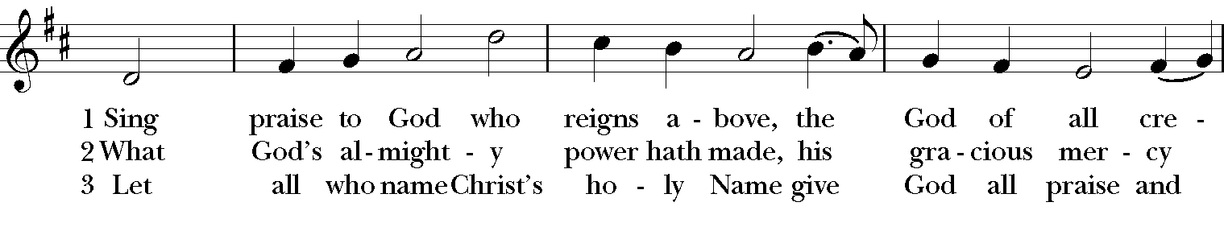
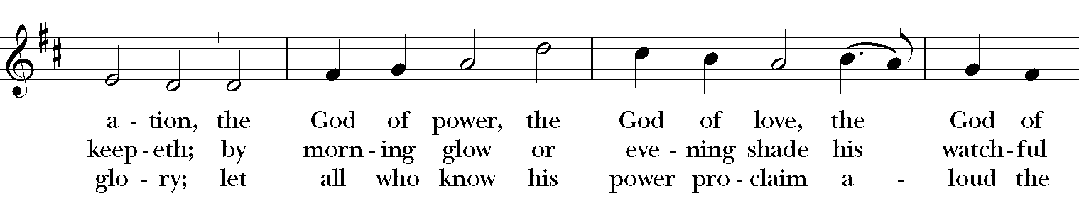
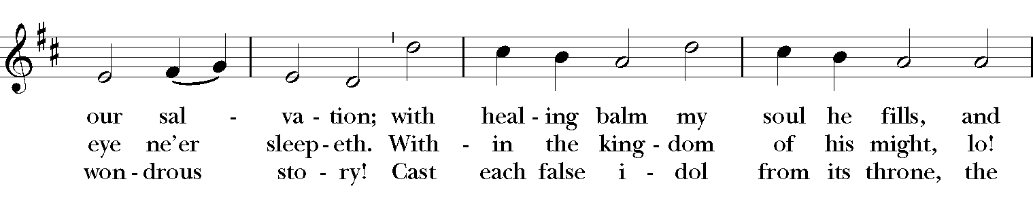
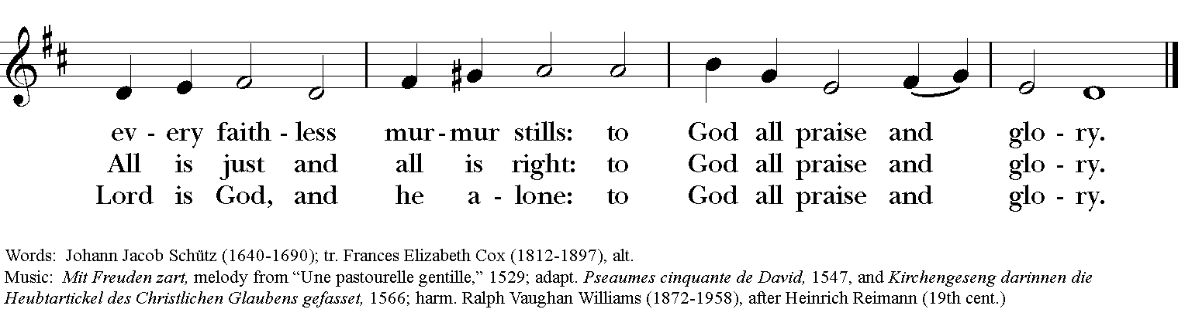

#635

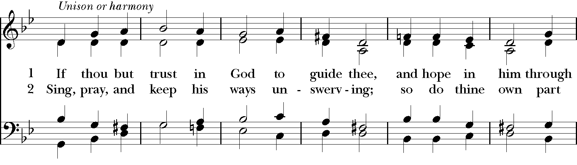
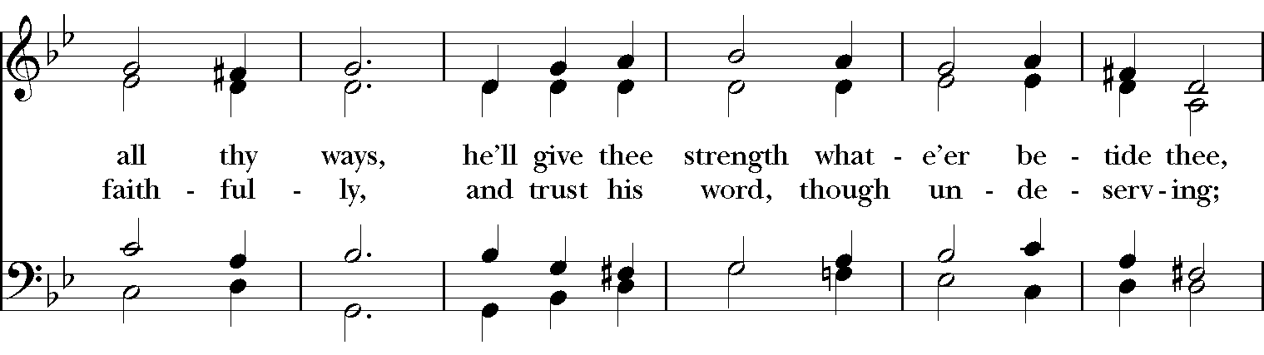
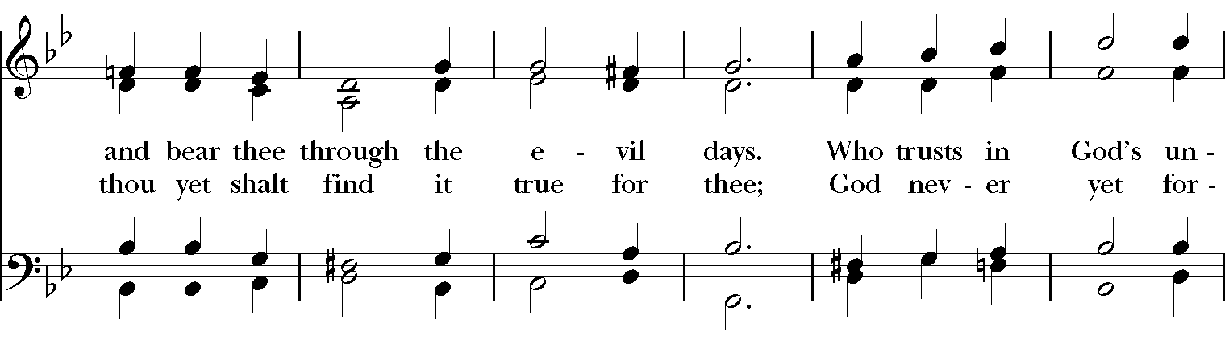
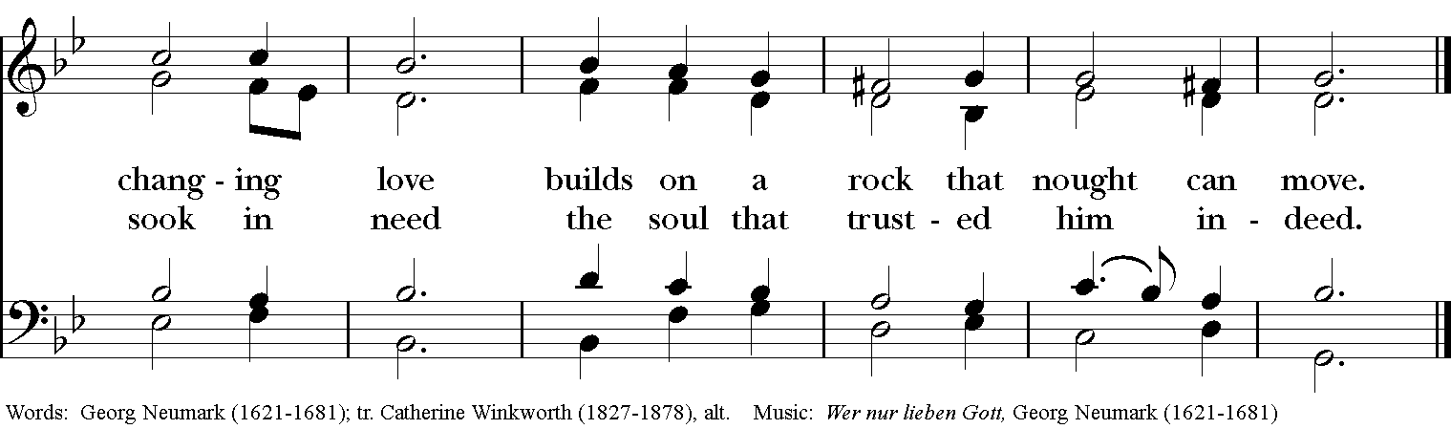

#534

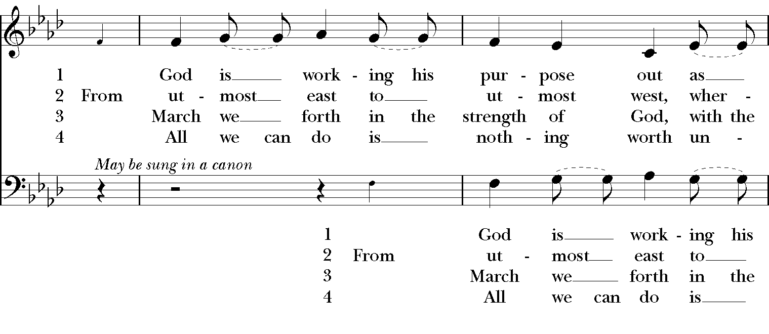
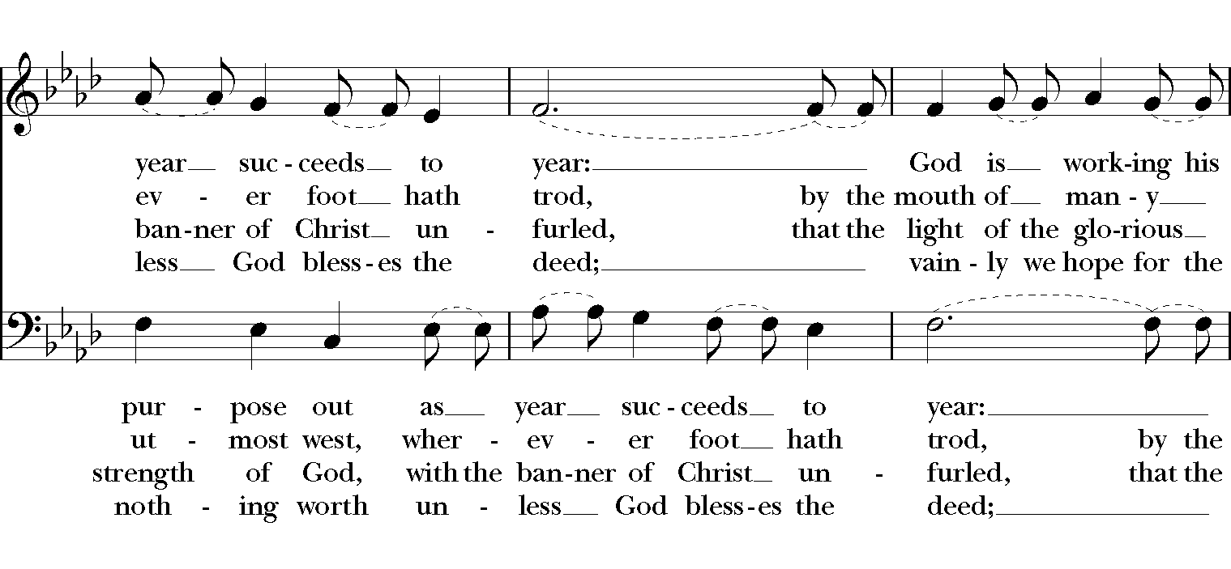
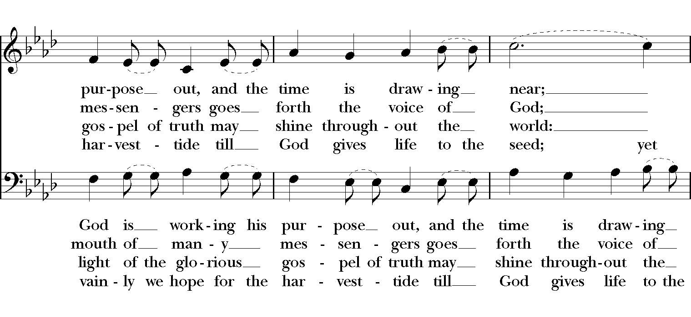
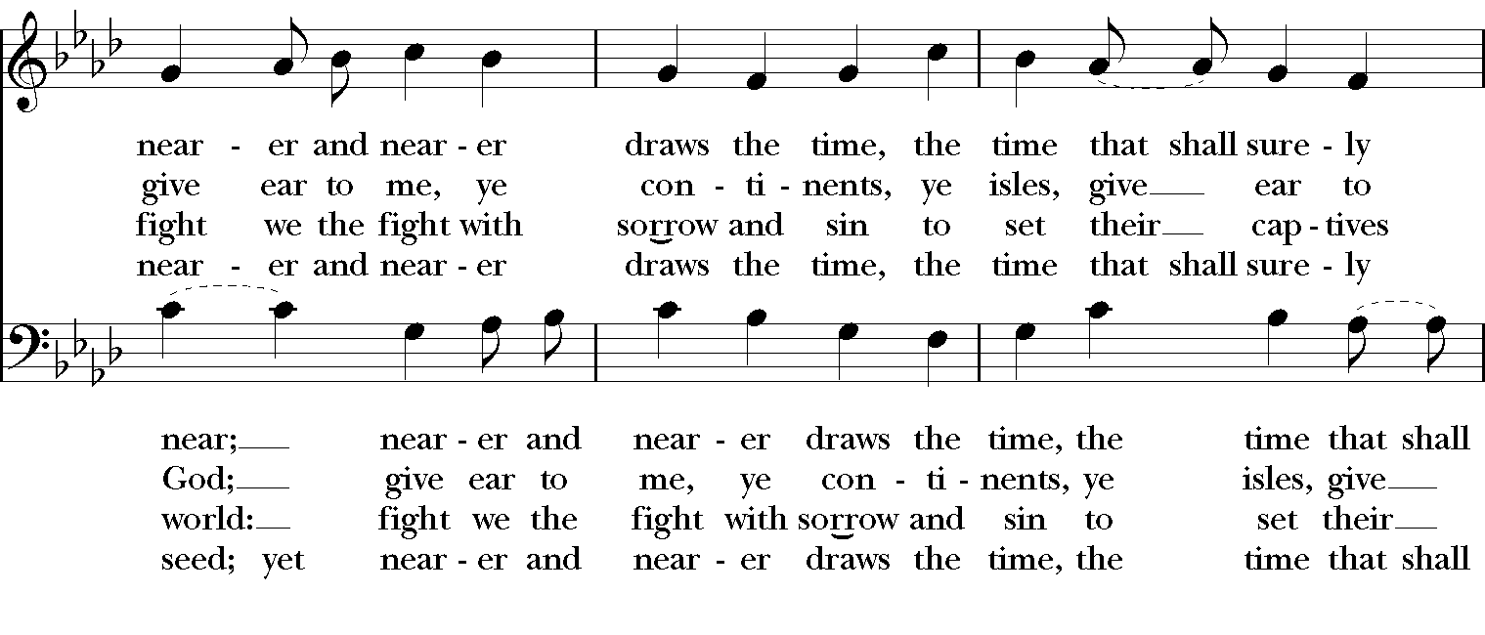
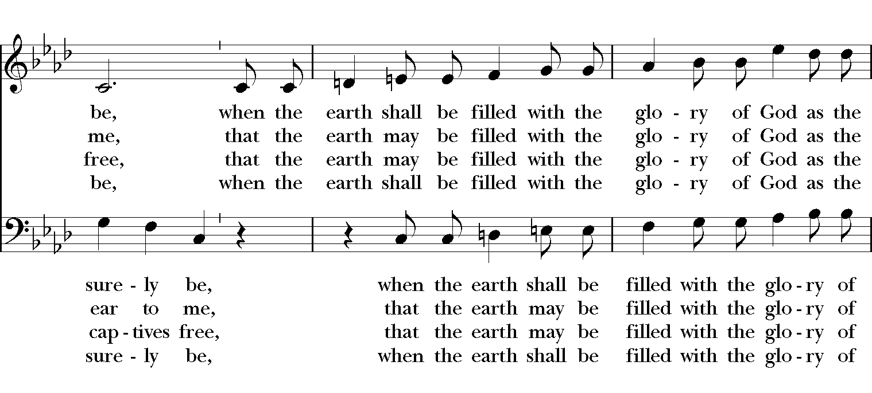
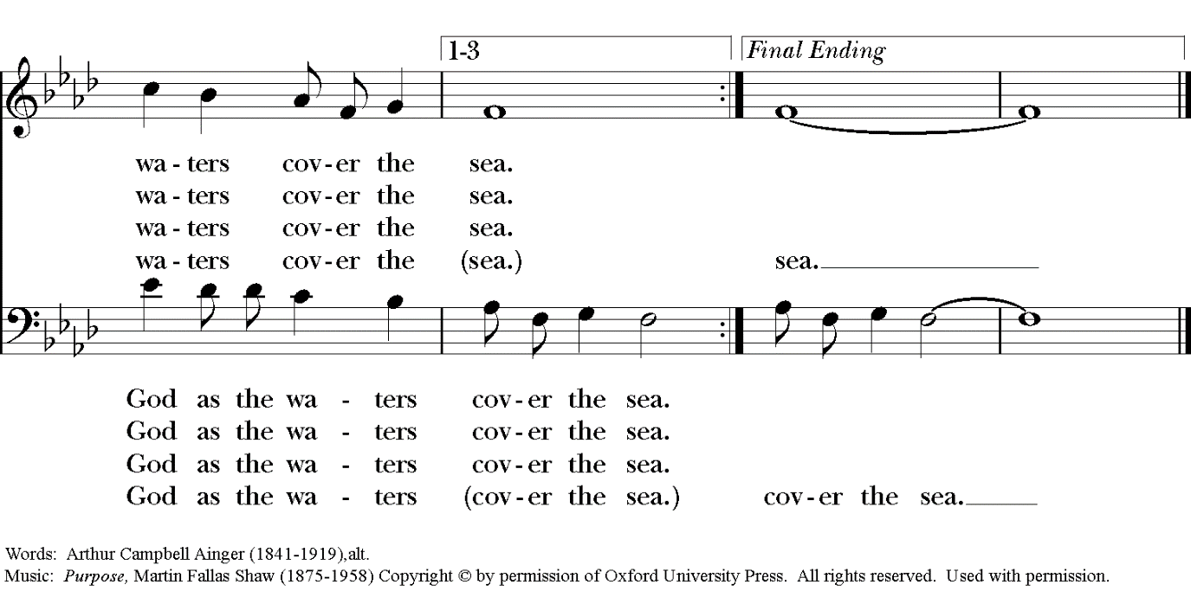

Our prayers for our members and their families:

Pat, Kelli, Jack Giovo, Laura Read, Jerimiah Bryant, Randy, Kay Stovell, Ronnie Whitaker, Christa Kelley, Stuart Shanor, Carol Anne, Elly Mulkey, Bud Milner and Kimberly Ramsey, Jerry and Marty Childress, Marilyn Manatt and Janie Blue, Gary Smith, Michelle, Ann Wonders, Isabel Castillo, Lisa Huff, Molly Pittman, Dwight and Anne Crowder, Julie Deaton, Betty, Victoria S., Andrew P., Aaron & Sarah, Kim C., Lynne and Jimmy Hooper, Richard Morris, Maddy, Abby K & family, Janet M., Martin Kelly, Victoria Cobb, Pat Wiberg, Cory Woodbury, Andrew W., Matthew, Kendall & Pam Kelley, David Smith, Breanna Hickey, Billie Weber, Lynn Waggoner, Rachel, Gabe Martin, Amanda Olivo, Sevie Bates, Florence Carr, Jessica Morris, Alice Smith, Beth Rogers, Jeannine Byron, Melody Green, Marisa, Lew Hightower, Jennie Evans, Clayton Thompson, Bill & Meredith Patton, Annette Mader, John Keeth, Soraya, Manuel, Charmaine and Charles Martin, Julian Linares, Raymond Linares, Jennifer Linares, Jean Hooper, Cheryl Grey, Cassie, Gary and Judy Larson, Sandi Olivo.

Our prayers for friends of St. Andrew’s:

Gretta Dickman, Susan H., Bob & Esther St. Lewis, Canon Lee Curtis, Bill Murphy, Jo Pendergrass, Nancy W., Andres Adauto, Coy Dickson, Steve Hazelbaker, Johnny Pena, Rebecca Ellis, Victor & Laquita Pierce, Robert, Mark, Jenice Furguson, The Rev. Susanna Metz, Del Journey, Courtney, Heidi Huckabee, Janie Mendoza, Bill Anderson, Elena and family, Elena & Blanca’s Mother and family, Joan Accardi, Robert, Aurora, Patty & George Swenson, Tristen, Belma & Alan Cloud, Josie Powell, Clifford Sipple Family, Julie and Donna Franco, Dayna, Karen Anderson, Dee & Eddie, Andrea, Mitchel Rosen, the Cox Family, Melissa J. & Family, Fr. Hector Trejo, (Vicar of Juarez), Shawna and family, Stephanie K., Sarah, Veronica, Michelle Siebel, Kalistro Linares, Michele Hillman, Sarah Wooldridge, Jerry & M.J., Rex Kartchner, Alison, Emily, Janet Carter, Meredith Miller, Maryanne D’Arcangelis, Christopher, Josie & Lloyd, Fern Simpson, Lara, Dyan, Nancy Klima, M. Lopez, Ed Tinsley, Wilson, Susan, Keith Maston, Kevin Maston, Carli Salyards, Tammy Reed, Frank Roberts and family, Elizabeth Klijnsmit, Jaime Alvarez, Ron & Twylla M, Rosemary Henry, Mathew and family, Effie Silva, Baldo & Rena, Marty G., Tom & Marilyn, Joy W.

