n…………………………………………0
St. Andrew’s Episcopal Church

6th Sunday of Easter
May 14, 2023 10:00am
Holy Eucharist – Rite II

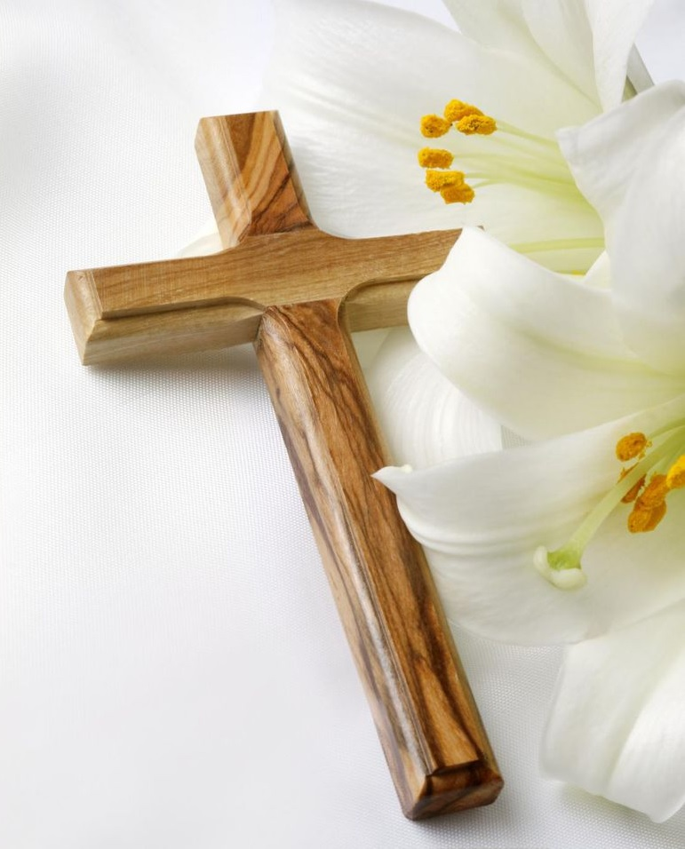

Lord God, you alone are the source of every good gift. Fill our hearts with faithfulness that when we are called to serve, we may answer, “here I am Lord,” with a spirit of discipleship. We pledge ourselves to be good and faithful stewards of the gifts you have entrusted to us, to share our time, talent and our material gifts as an outward sign of the treasure we hold in Jesus. Amen.

505 N. Pennsylvania Ave.
Roswell, NM 88201
575-622-1353
church@standrewsroswell.com
www.standrewsroswell.com

This service is video-recorded and streamed to the church’s public Facebook page.

Prelude: Rejoice, the Lord Is King – John Darwall, arr James Mansfield

Processional Hymn #398 – I sing the almighty power of God

The people standing, the Celebrant says

Alleluia. Christ is risen.
People The Lord is risen indeed. Alleluia.

Almighty God, to you all hearts are open, all desires known, and from you no secrets are hid: Cleanse the thoughts of our hearts by the inspiration of your Holy Spirit, that we may perfectly love you, and worthily magnify your holy Name; through Christ our Lord. Amen.

Hymn S280 – Gloria in excelsis (Glory to God)
Glory to God in the highest, and peace to his people on earth.
Lord God, heavenly King, almighty God and Father,
we worship you, we give you thanks, we praise you for your glory.
Lord Jesus Christ, only Son of the Father, Lord God, Lamb of God,
you take away the sin of the world; have mercy on us;
you are seated at the right hand of the Father; receive our prayer.
For you alone are the Holy One, you alone are the Lord,
you alone are the Most High, Jesus Christ, with the Holy Spirit,
in the glory of God the Father. Amen.

The Collect of the Day
Celebrant The Lord be with you.
People And also with you.
Celebrant Let us pray.

The Celebrant says the Collect.

O God, you have prepared for those who love you such good things as surpass our understanding: Pour into our hearts such love towards you, that we, loving you in all things and above all things, may obtain your promises, which exceed all that we can desire; through Jesus Christ our Lord, who lives and reigns with you and the Holy Spirit, one God, for ever and ever. Amen.
The Lessons

The people sit.

Acts 17:22-31
Paul stood in front of the Areopagus and said, “Athenians, I see how extremely religious you are in every way. For as I went through the city and looked carefully at the objects of your worship, I found among them an altar with the inscription, ‘To an unknown god.’ What therefore you worship as unknown, this I proclaim to you. The God who made the world and everything in it, he who is Lord of heaven and earth, does not live in shrines made by human hands, nor is he served by human hands, as though he needed anything, since he himself gives to all mortals life and breath and all things. From one ancestor he made all nations to inhabit the whole earth, and he allotted the times of their existence and the boundaries of the places where they would live, so that they would search for God and perhaps grope for him and find him—though indeed he is not far from each one of us. For ‘In him we live and move and have our being’; as even some of your own poets have said,
‘For we too are his offspring.’
Since we are God’s offspring, we ought not to think that the deity is like gold, or silver, or stone, an image formed by the art and imagination of mortals. While God has overlooked the times of human ignorance, now he commands all people everywhere to repent, because he has fixed a day on which he will have the world judged in righteousness by a man whom he has appointed, and of this he has given assurance to all by raising him from the dead.”

The Word of the Lord.
People Thanks be to God.

Psalm 66:7-18
7 Bless our God, you peoples; *
make the voice of his praise to be heard;
8 Who holds our souls in life, *
and will not allow our feet to slip.
9 For you, O God, have proved us; *
you have tried us just as silver is tried.
10 You brought us into the snare; *
you laid heavy burdens upon our backs.
11 You let enemies ride over our heads; we went through fire and water; *
but you brought us out into a place of refreshment.
12 I will enter your house with burnt-offerings
and will pay you my vows, *
which I promised with my lips
and spoke with my mouth when I was in trouble.
13 I will offer you sacrifices of fat beasts with the smoke of rams; *
I will give you oxen and goats.
14 Come and listen, all you who fear God, *
and I will tell you what he has done for me.
15 I called out to him with my mouth, *
and his praise was on my tongue.
16 If I had found evil in my heart, *
the Lord would not have heard me;
17 But in truth God has heard me; *
he has attended to the voice of my prayer.
18 Blessed be God, who has not rejected my prayer, *
nor withheld his love from me.

The Epistle – 1 Peter 3:13-22
Now who will harm you if you are eager to do what is good? But even if you do suffer for doing what is right, you are blessed. Do not fear what they fear, and do not be intimidated, but in your hearts sanctify Christ as Lord. Always be ready to make your defense to anyone who demands from you an accounting for the hope that is in you; yet do it with gentleness and reverence. Keep your conscience clear, so that, when you are maligned, those who abuse you for your good conduct in Christ may be put to shame. For it is better to suffer for doing good, if suffering should be God's will, than to suffer for doing evil. For Christ also suffered for sins once for all, the righteous for the unrighteous, in order to bring you to God. He was put to death in the flesh, but made alive in the spirit, in which also he went and made a proclamation to the spirits in prison, who in former times did not obey, when God waited patiently in the days of Noah, during the building of the ark, in which a few, that is, eight persons, were saved through water. And baptism, which this prefigured, now saves you-- not as a removal of dirt from the body, but as an appeal to God for a good conscience, through the resurrection of Jesus Christ, who has gone into heaven and is at the right hand of God, with angels, authorities, and powers made subject to him.

The Word of the Lord.
People Thanks be to God.

Sequence Hymn #694 – God be in my head

Then, all standing, the Deacon or a Priest reads the Gospel, first saying

The Holy Gospel of our Lord Jesus Christ according to John
People Glory to you, Lord Christ.

John 14:15-21
Jesus said, ”If you love me, you will keep my commandments. And I will ask the Father, and he will give you another Advocate, to be with you forever. This is the Spirit of truth, whom the world cannot receive, because it neither sees him nor knows him. You know him, because he abides with you, and he will be in you.
”I will not leave you orphaned; I am coming to you. In a little while the world will no longer see me, but you will see me; because I live, you also will live. On that day you will know that I am in my Father, and you in me, and I in you. They who have my commandments and keep them are those who love me; and those who love me will be loved by my Father, and I will love them and reveal myself to them.”

The Gospel of the Lord.
People Praise to you, Lord Christ.

The Sermon

The Nicene Creed
We believe in one God, the Father, the Almighty,
maker of heaven and earth, of all that is, seen and unseen.
We believe in one Lord, Jesus Christ, the only Son of God,
eternally begotten of the Father, God from God, Light from Light, true God from true God, begotten, not made, of one Being with the Father.
Through him all things were made.
For us and for our salvation he came down from heaven:
by the power of the Holy Spirit
he became incarnate from the Virgin Mary, and was made man.
For our sake he was crucified under Pontius Pilate;
he suffered death and was buried.
On the third day he rose again in accordance with the Scriptures;
he ascended into heaven and is seated at the right hand of the Father.
He will come again in glory to judge the living and the dead,
and his kingdom will have no end.
We believe in the Holy Spirit, the Lord, the giver of life,
who proceeds from the Father and the Son.
With the Father and the Son he is worshiped and glorified.
He has spoken through the Prophets.
We believe in one holy catholic and apostolic Church.
We acknowledge one baptism for the forgiveness of sins.
We look for the resurrection of the dead,
and the life of the world to come. Amen.

The Prayers of the People – Form III

The Leader and People pray responsively

Father, we pray for your holy Catholic Church;
That we all may be one.

Grant that every member of the Church may truly and humbly serve you;
That your Name may be glorified by all people.

We pray for all bishops, priests, and deacons;
That they may be faithful ministers of your Word and Sacraments.

We pray for all who govern and hold authority in the nations of the world;
That there may be justice and peace on the earth.

Give us grace to do your will in all that we undertake;
That our works may find favor in your sight.

Have compassion on those who suffer from any grief or trouble;
That they may be delivered from their distress.

Give to the departed eternal rest;
Let light perpetual shine upon them.

We praise you for your saints who have entered into joy;
May we also come to share in your heavenly kingdom.

Let us pray for our own needs and those of others.

The People may add their own petitions.

The Celebrant adds a concluding Collect.

The Peace

Celebrant The peace of the Lord be always with you.
People And also with you.

Announcements

The People stand while the offerings of bread and wine are presented.
Offertory Music: In Christ Alone – arr Benjamin Harlan

Doxology
Praise God, from whom all blessings flow;
praise him, all creatures here below;
praise him above, ye heavenly host:
praise Father, Son, and Holy Ghost.

The Great Thanksgiving – Eucharistic Prayer A

The Celebrant, whether bishop or priest, faces them and sings or says

The Lord be with you.
People And also with you.
Celebrant Lift up your hearts.
People We lift them to the Lord.
Celebrant Let us give thanks to the Lord our God.
People It is right to give him thanks and praise.

Then, facing the Holy Table, the Celebrant proceeds

It is right, and a good and joyful thing, always and everywhere to give thanks to you, Father Almighty, Creator of heaven and earth.

Here a Proper Preface is said on all Sundays, and on other occasions as appointed.

Therefore we praise you, joining our voices with Angels and Archangels and with all the company of heaven, who for ever sing this hymn to proclaim the glory of your Name:

Hymn S125 – Sanctus
Holy, holy, holy Lord, God of power and might,
heaven and earth are full of your glory.
Hosanna in the highest. Hosanna in the highest.
Blessed is he who comes in the name of the Lord.
Hosanna in the highest. Hosanna in the highest.

The people stand or kneel. Then the Celebrant continues

Holy and gracious Father: In your infinite love you made us for yourself; and, when we had fallen into sin and become subject to evil and death, you, in your mercy, sent Jesus Christ, your only and eternal Son, to share our human

nature, to live and die as one of us, to reconcile us to you, the God and Father of all.
He stretched out his arms upon the cross, and offered himself, in obedience to your will, a perfect sacrifice for the whole world.

On the night he was handed over to suffering and death, our Lord Jesus Christ took bread; and when he had given thanks to you, he broke it, and gave it to his disciples, and said, “Take, eat: This is my Body, which is given for you. Do this for the remembrance of me.”

After supper he took the cup of wine; and when he had given thanks, he gave it to them, and said, “Drink this, all of you: This is my Blood of the new

Covenant, which is shed for you and for many for the forgiveness of sins. Whenever you drink it, do this for the remembrance of me.”
Therefore we proclaim the mystery of faith:

Celebrant and People

Christ has died.
Christ is risen.
Christ will come again.

The Celebrant continues

We celebrate the memorial of our redemption, O Father, in this sacrifice of praise and thanksgiving. Recalling his death, resurrection, and ascension, we offer you these gifts.

Sanctify them by your Holy Spirit to be for your people the Body and Blood of your Son, the holy food and drink of new and unending life in him. Sanctify us also that we may faithfully receive this holy Sacrament, and serve you in unity, constancy, and peace; and at the last day bring us with all your saints into the joy of your eternal kingdom.

All this we ask through your Son Jesus Christ. By him, and with him, and in him, in the unity of the Holy Spirit all honor and glory is yours, Almighty Father, now and for ever. AMEN.
And now, as our Savior Christ has taught us, we are bold to say,

People and Celebrant

Our Father, who art in heaven, hallowed be thy Name,
thy kingdom come, thy will be done, on earth as it is in heaven.
Give us this day our daily bread.
And forgive us our trespasses, as we forgive those who trespass against us.
And lead us not into temptation, but deliver us from evil.
For thine is the kingdom, and the power, and the glory,
for ever and ever. Amen.

The Breaking of the Bread

The Celebrant breaks the consecrated Bread.

[Alleluia.] Christ our Passover is sacrificed for us;
Therefore let us keep the feast. [Alleluia.]

Facing the people, the Celebrant says the following Invitation

The Gifts of God for the People of God.

and may add Take them in remembrance that Christ died for you, and feed on him in your hearts by faith, with thanksgiving.

During the ministration of Communion, hymns, psalms, or anthems may be sung.

After Communion, the Celebrant says

Let us pray.

Prayer for Online Worshipers
God of grace, we present to you our souls and bodies with the earnest wish that we may always be united to you and each other. Since we may not always be together to receive you sacramentally, unite us spiritually that our hearts may embrace you with all the affections of our souls. Let nothing ever
separate us from you, through the communion of saints, in all times and places. Amen.
Post-Communion Prayer
Eternal God, heavenly Father, you have graciously accepted us as living members of your Son our Savior Jesus Christ, and you have fed us with spiritual food in the Sacrament of his Body and Blood. Send us now into the
world in peace, and grant us strength and courage to love and serve you with gladness and singleness of heart; through Christ our Lord. Amen.

Blessing

Recessional Hymn #347 – Go forth for God

Dismissal

Postlude: Rejoice, Ye Pure In Heart – Arthur Messiter, arr Douglas Wagner

The flowers this morning are given by Robert Willis
in memory of Bob & Betty Willis

Celebrant: The Very Rev. Dr. Maurice Geldert
Verger: Sissy Mayne
Choir Director: John Fuss
Organist/Pianist: Karen Fuss
Lay Reader: Domenic Macaluso
Chalice Bearer: Pat Walker
Ushers: Greg Anderson, Betty Cosio-Avalos
Camera Operator: P.J. Greer
Altar Guild: Lorinda Wilkins, Karen Fuss

Please pray for our members and their families:
Carol Anne, Tom LeBarre, Suzanne Berry, Pat Walker, John Fuss, Melody Green, Jerry O’Dette, Sevie Bates, Kate Dorff, Cyndy & Rick Collins, Janet Macaluso, Jeffrey Miller, Aaron Burkett, Earl Pittman, Craig Lysak, Manuel Linares, Jeremiah Bryant, Nancy Hartwick, Burnitta McClung, Bruce Currier, Mike Brazie, Billie Weber, Karen & Pat Hendricks, Lorinda & Royce, Cory Woodbury, Janelle McGuire, Andy Morehouse, Kelli, Stuart Shanor, Marilyn Manatt, Gary Smith, Michelle, Ann Wonders, Isabel Castillo, Lisa Huff, Julie Deaton, Betty, Kim C., Maddy, Abby K & family, Martin Kelley, Victoria Cobb, Pat Wiberg, Andrew W., Matthew, David Smith, Rachel, Amanda Olivo, Florence Carr, Alice Smith, Beth Rogers, Jeannine Byron, Marisa, Lew Hightower, Clayton Thompson, Bill & Meredith Patton, Annette Mader, Julian Linares, Raymond Linares, Jennifer Linares, Cassie, Sandi Olivo, Fern Simpson

Please pray for friends of St. Andrew’s:
Annalee Kraft, Rehanna, Michelle Brooke & her family, Gary Eberhart’s family, Victoria, Wilson family, Shane Olive, Dr. Dennis Knoche, Dale Williams, Bill Daily, Lenore Savage, Dyess family, Rose Herrera, Gretta Dickman, Susan H., Canon Lee Curtis, Bill Murphy, Jo Pendergrass, Nancy W., Andres Adauto, Coy Dickson, Rebecca Ellis, Victor & Laquita Pierce, Robert, Mark, Jenice Furguson, Rev. Susanna Metz, Del Journey, Courtney, Elena & family, Elena & Blanca’s mother, Robert, Aurora, Tristen, Belma Cloud, Josie Powell, Clifford Sipple family, Dayna, Karen Anderson, Andrea, Cox Family, Melissa J. & family, Fr. Hector Trejo, Shawna & family, Stephanie K., Sarah, Veronica, Michelle Siebel, Kalistro Linares, Michele Hillman, Sarah Wooldridge, Jerry & M.J., Rex Kartchner, Alison, Emily, Janet Carter, Meredith Miller, Maryanne D’Arcangelis, Lara, Dyan, Nancy Klima, M. Lopez, Wilson, Susan, Keith Maston, Kevin Maston, Carli Salyards, Tammy Reed, Frank Roberts & family, Elizabeth Klijnsmit, Jaime Alvarez, Ron & Twylla M, Rosemary Henry, Mathew & family, Effie Silva, Baldo & Rena, Marty G., Tom & Marilyn

