n…………………………………………0
St. Andrew’s Episcopal Church

5th Sunday of Easter
April 28, 2024 10:00am
Holy Eucharist – Rite II

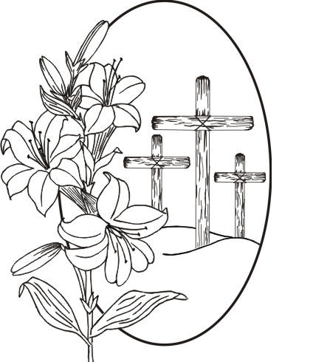

Lord God, you alone are the source of every good gift. Fill our hearts with faithfulness that when we are called to serve, we may answer, “Here I am Lord,” with a spirit of discipleship. We pledge ourselves to be good and faithful stewards of the gifts you have entrusted to us, to share our time, talent, and our material gifts as an outward sign of the treasure we hold in Jesus. Amen.

505 N. Pennsylvania Ave.
Roswell, NM 88201
575-622-1353
church@standrewsroswell.com
www.standrewsroswell.com

This service is video-recorded and streamed to the church’s public Facebook page.
Prelude: Variations on “I Come With Joy to Meet My Lord” – Traditional American, Arr Anthony Giamanco

Processional Hymn #632 – O Christ, the Word Incarnate

The people standing, the Celebrant says BCP 355

Alleluia. Christ is risen.
People The Lord is risen indeed. Alleluia.

Almighty God, to you all hearts are open, all desires known, and from you no secrets are hid: Cleanse the thoughts of our hearts by the inspiration of your Holy Spirit, that we may perfectly love you, and worthily magnify your holy Name; through Christ our Lord. Amen.

Hymn S236 – Song of Praise
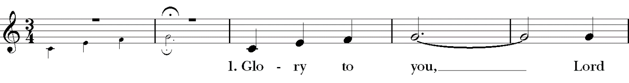
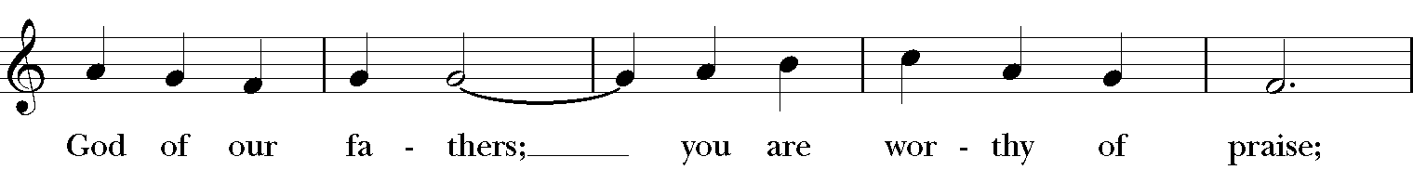
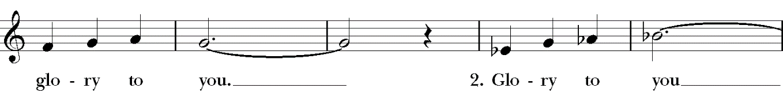
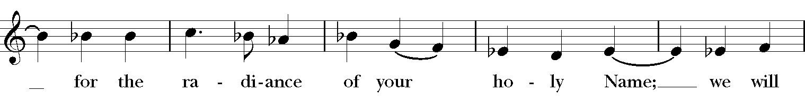
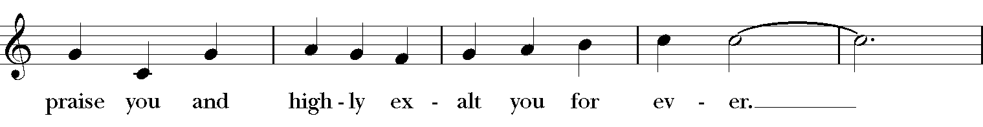
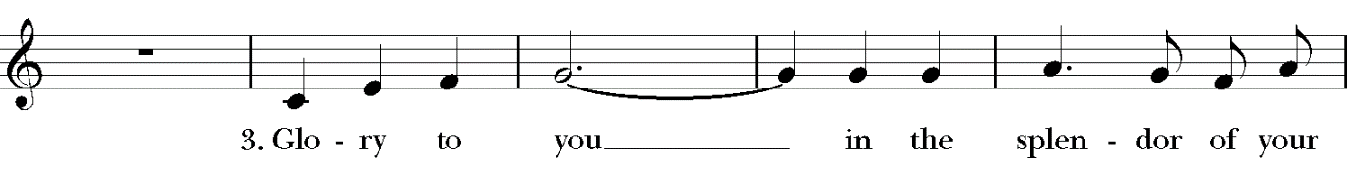
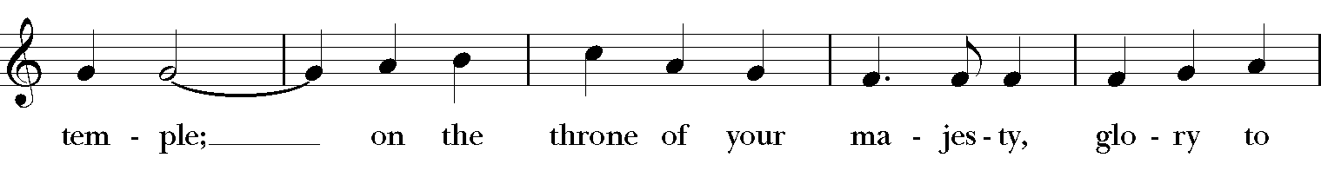
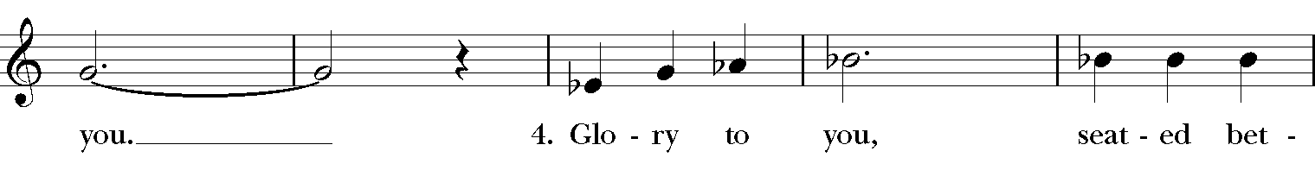
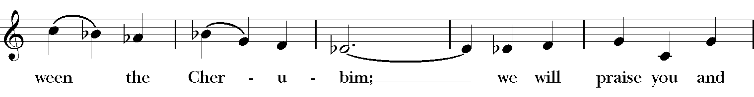
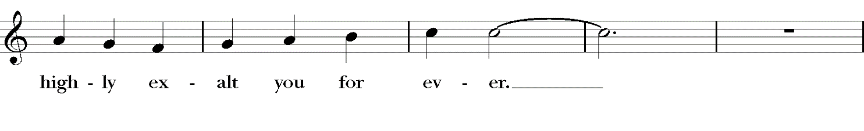
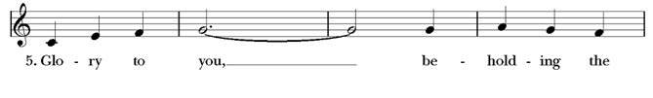
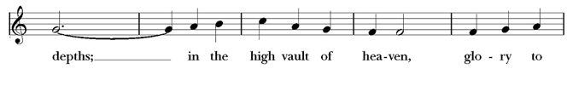
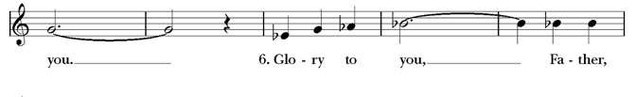
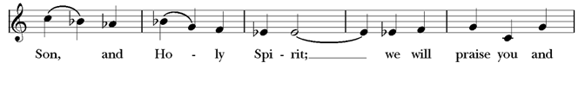
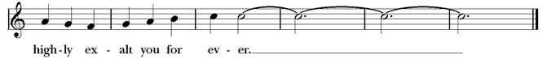

The Collect of the Day
Celebrant The Lord be with you.
People And also with you.
Celebrant Let us pray.

The Celebrant says the Collect.
Almighty God, whom truly to know is everlasting life: Grant us so perfectly to know your Son Jesus Christ to be the way, the truth, and the life, that we may steadfastly follow his steps in the way that leads to eternal life; through Jesus Christ your Son our Lord, who lives and reigns with you, in the unity of the Holy Spirit, one God, for ever and ever. Amen.

The people sit for The Lessons

Acts 8:26-40
An angel of the Lord said to Philip, “Get up and go toward the south to the road that goes down from Jerusalem to Gaza.” (This is a wilderness road.) So he got up and went. Now there was an Ethiopian eunuch, a court official of the Candace, queen of the Ethiopians, in charge of her entire treasury. He had come to Jerusalem to worship and was returning home; seated in his chariot, he was reading the prophet Isaiah. Then the Spirit said to Philip, “Go over to this chariot and join it.” So Philip ran up to it and heard him reading the prophet Isaiah. He asked, “Do you understand what you are reading?” He replied, “How can I, unless someone guides me?” And he invited Philip to get in and sit beside him. Now the passage of the scripture that he was reading was this:
“Like a sheep he was led to the slaughter,
and like a lamb silent before its shearer, so he does not open his mouth.
In his humiliation justice was denied him.
Who can describe his generation? For his life is taken away from the earth.”
The eunuch asked Philip, “About whom, may I ask you, does the prophet say this, about himself or about someone else?” Then Philip began to speak, and starting with this scripture, he proclaimed to him the good news about Jesus. As they were going along the road, they came to some water; and the eunuch said, “Look, here is water! What is to prevent me from being baptized?” He commanded the chariot to stop, and both of them, Philip and the eunuch, went down into the water, and Philip baptized him. When they came up out of the water, the Spirit of the Lord snatched Philip away; the eunuch saw him no more, and went on his way rejoicing. But Philip found himself at Azotus, and as he was passing through the region, he proclaimed the good news to all the towns until he came to Caesarea.

The Word of the Lord.
People Thanks be to God.

Psalm 22:24-30
24 My praise is of him in the great assembly; *
I will perform my vows in the presence of those who worship him.
25 The poor shall eat and be satisfied,
and those who seek the Lord shall praise him: *
"May your heart live for ever!"
26 All the ends of the earth shall remember and turn to the Lord, *
and all the families of the nations shall bow before him.
27 For kingship belongs to the Lord; *
he rules over the nations.
28 To him alone all who sleep in the earth bow down in worship; *
all who go down to the dust fall before him.
29 My soul shall live for him; my descendants shall serve him; *
they shall be known as the Lord's for ever.
30 They shall come and make known to a people yet unborn *
the saving deeds that he has done.

The Epistle – 1 John 4:7-21
Beloved, let us love one another, because love is from God; everyone who loves is born of God and knows God. Whoever does not love does not know God, for God is love. God's love was revealed among us in this way: God sent his only Son into the world so that we might live through him. In this is love, not that we loved God but that he loved us and sent his Son to be the atoning sacrifice for our sins. Beloved, since God loved us so much, we also ought to love one another. No one has ever seen God; if we love one another, God lives in us, and his love is perfected in us.
By this we know that we abide in him and he in us, because he has given us of his Spirit. And we have seen and do testify that the Father has sent his Son as the Savior of the world. God abides in those who confess that Jesus is the Son of God, and they abide in God. So we have known and believe the love that God has for us.
God is love, and those who abide in love abide in God, and God abides in them. Love has been perfected among us in this: that we may have boldness on the day of judgment, because as he is, so are we in this world. There is no fear in love, but perfect love casts out fear; for fear has to do with punishment, and whoever fears has not reached perfection in love. We love because he first loved us. Those who say, "I love God," and hate their brothers or sisters, are liars; for those who do not love a brother or sister whom they have seen, cannot love God whom they have not seen. The commandment we have from him is this: those who love God must love their brothers and sisters also.

The Word of the Lord.
People Thanks be to God.

Sequence Hymn #581 vs 1,2,3,5 – Where charity and love prevail

Then, all standing, the Deacon or a Priest reads the Gospel, first saying

The Holy Gospel of our Lord Jesus Christ according to John
People Glory to you, Lord Christ.

John 15:1-8
Jesus said to his disciples, ”I am the true vine, and my Father is the vinegrower. He removes every branch in me that bears no fruit. Every branch that bears fruit he prunes to make it bear more fruit. You have already been cleansed by the word that I have spoken to you. Abide in me as I abide in you. Just as the branch cannot bear fruit by itself unless it abides in the vine, neither can you unless you abide in me. I am the vine, you are the branches. Those who abide in me and I in them bear much fruit, because apart from me you can do nothing. Whoever does not abide in me is thrown away like a branch and withers; such branches are gathered, thrown into the fire, and burned. If you abide in me, and my words abide in you, ask for whatever you wish, and it will be done for you. My Father is glorified by this, that you bear much fruit and become my disciples.”

The Gospel of the Lord.
People Praise to you, Lord Christ.

The Sermon

The Nicene Creed BCP 358
We believe in one God, the Father, the Almighty,
maker of heaven and earth, of all that is, seen and unseen.
We believe in one Lord, Jesus Christ, the only Son of God,
eternally begotten of the Father, God from God, Light from Light, true God from true God, begotten, not made, of one Being with the Father.
Through him all things were made.
For us and for our salvation he came down from heaven:
by the power of the Holy Spirit
he became incarnate from the Virgin Mary, and was made man.
For our sake he was crucified under Pontius Pilate;
he suffered death and was buried.
On the third day he rose again in accordance with the Scriptures;
he ascended into heaven and is seated at the right hand of the Father.
He will come again in glory to judge the living and the dead,
and his kingdom will have no end.
We believe in the Holy Spirit, the Lord, the giver of life,
who proceeds from the Father and the Son.
With the Father and the Son he is worshiped and glorified.
He has spoken through the Prophets.
We believe in one holy catholic and apostolic Church.
We acknowledge one baptism for the forgiveness of sins.
We look for the resurrection of the dead,
and the life of the world to come. Amen.

The Prayers of the People – Form III BCP 387

The Leader and People pray responsively

Father, we pray for your holy Catholic Church;
That we all may be one.

Grant that every member of the Church may truly and humbly serve you;
That your Name may be glorified by all people.

We pray for all bishops, priests, and deacons;
That they may be faithful ministers of your Word and Sacraments.

We pray for all who govern and hold authority in the nations of the world;
That there may be justice and peace on the earth.

Give us grace to do your will in all that we undertake;
That our works may find favor in your sight.

Have compassion on those who suffer from any grief or trouble;
That they may be delivered from their distress.

Give to the departed eternal rest;
Let light perpetual shine upon them.

We praise you for your saints who have entered into joy;
May we also come to share in your heavenly kingdom.

Let us pray for our own needs and those of others.
The People may add their own petitions.

The Celebrant adds a concluding Collect.

Confession of Sin BCP 360
Celebrant Let us confess our sins against God and our neighbor.

Most merciful God, we confess that we have sinned against you
in thought, word, and deed,
by what we have done, and by what we have left undone.
We have not loved you with our whole heart;
we have not loved our neighbors as ourselves.
We are truly sorry and we humbly repent.
For the sake of your Son Jesus Christ, have mercy on us and forgive us;
that we may delight in your will, and walk in your ways,
to the glory of your Name. Amen.

The Bishop when present, or the Priest, stands and says

Almighty God have mercy on you, forgive you all your sins through our Lord Jesus Christ, strengthen you in all goodness, and by the power of the Holy Spirit keep you in eternal life. Amen.

The Peace
Celebrant The peace of the Lord be always with you.
People And also with you.
Announcements

The Offertory
The People stand while the offerings of bread and wine are presented.
The loose plate offering goes to the Rector’s Discretionary Fund unless otherwise announced.

Music at the Offering: The Risen Christ – Getty & Madeira, Arr Fettke

Presentation Hymn #143 vs 5
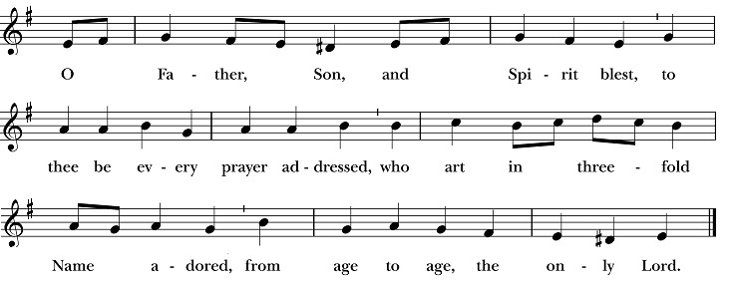

Blessing of the Offering
Celebrant All things come of thee, O Lord.
People And of thine own have we given thee.

The Great Thanksgiving – Eucharistic Prayer B BCP 367

All standing, the Celebrant, whether bishop or priest, faces the people and sings or says

The Lord be with you.
People And also with you.
Celebrant Lift up your hearts.
People We lift them to the Lord.
Celebrant Let us give thanks to the Lord our God.
People It is right to give him thanks and praise.

Then, facing the Holy Table, the Celebrant proceeds
It is right, and a good and joyful thing, always and everywhere to give thanks to you, Father Almighty, Creator of heaven and earth.

Here a Proper Preface is said on all Sundays, and on other occasions as appointed.

Therefore we praise you, joining our voices with Angels and Archangels and with all the company of heaven, who for ever sing this hymn to proclaim the glory of your Name:

Hymn S128 – Sanctus 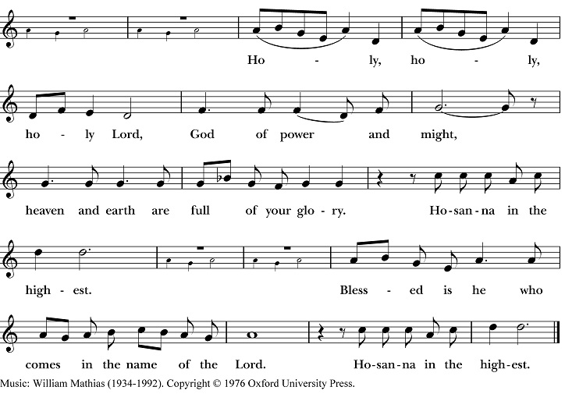

The people stand or kneel. Then the Celebrant continues

We give thanks to you, O God, for the goodness and love which you have made known to us in creation; in the calling of Israel to be your people; in your Word spoken through the prophets; and above all in the Word made flesh, Jesus, your Son. For in these last days you sent him to be incarnate from the Virgin Mary, to be the Savior and Redeemer of the world. In him, you have delivered us from evil, and made us worthy to stand before you. In him, you have brought us out of error into truth, out of sin into righteousness, out of death into life.
On the night before he died for us, our Lord Jesus Christ took bread; and when he had given thanks to you, he broke it, and gave it to his disciples, and said, “Take, eat: This is my Body, which is given for you. Do this for the remembrance of me.”

After supper he took the cup of wine; and when he had given thanks, he gave it to them, and said, “Drink this, all of you: This is my Blood of the new Covenant, which is shed for you and for many for the forgiveness of sins. Whenever you drink it, do this for the remembrance of me.”

Therefore, according to his command, O Father,

Celebrant and People

We remember his death,
We proclaim his resurrection,
We await his coming in glory;

The Celebrant continues
And we offer our sacrifice of praise and thanksgiving to you, O Lord of all; presenting to you, from your creation, this bread and this wine.

We pray you, gracious God, to send your Holy Spirit upon these gifts that they may be the Sacrament of the Body of Christ and his Blood of the new Covenant. Unite us to your Son in his sacrifice, that we may be acceptable through him, being sanctified by the Holy Spirit. In the fullness of time, put all things in subjection under your Christ, and bring us to that heavenly country where, with [ _________ and] all your saints, we may enter the everlasting heritage of your sons and daughters; through Jesus Christ our Lord, the firstborn of all creation, the head of the Church, and the author of our salvation.

By him, and with him, and in him, in the unity of the Holy Spirit all honor and glory is yours, Almighty Father, now and for ever. AMEN.
And now, as our Savior Christ has taught us, we are bold to say,

People and Celebrant

Our Father, who art in heaven, hallowed be thy Name,
thy kingdom come, thy will be done,
on earth as it is in heaven.
Give us this day our daily bread.
And forgive us our trespasses,
as we forgive those who trespass against us.
And lead us not into temptation, but deliver us from evil.
For thine is the kingdom, and the power, and the glory,
for ever and ever. Amen.
The Breaking of the Bread

The Celebrant breaks the consecrated Bread.

A period of silence is kept.

Hymn S154 – Fraction Anthem: Christ our Passover
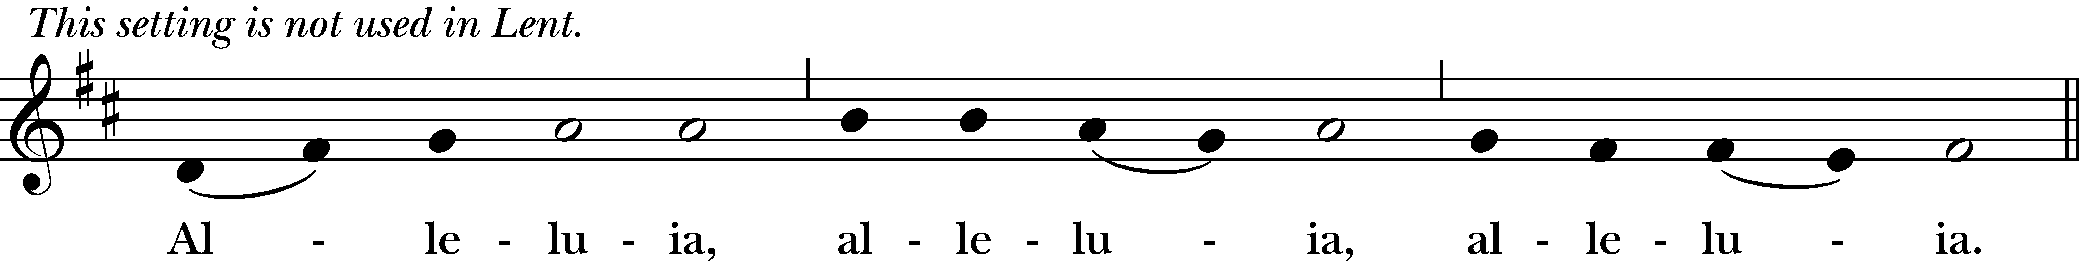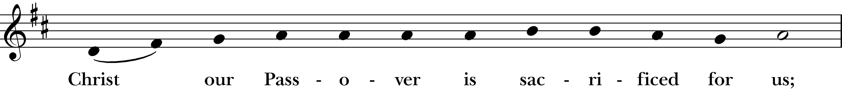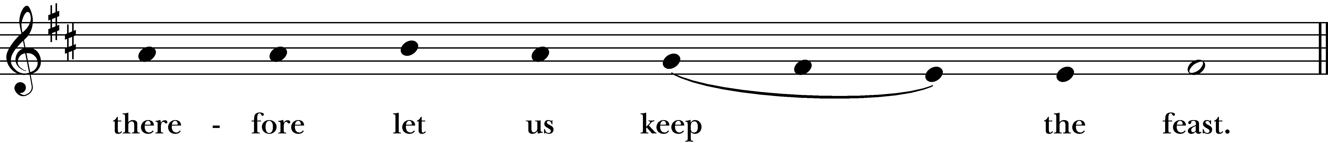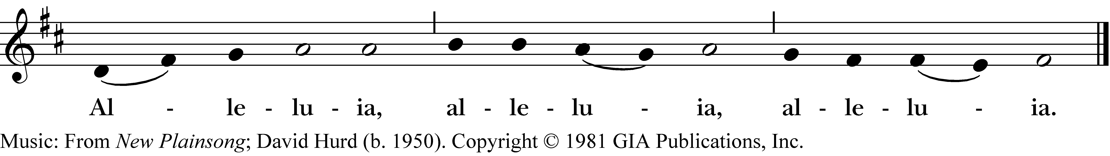

Facing the people, the Celebrant says the following Invitation

The Gifts of God for the People of God.
and may add Take them in remembrance that Christ died for you, and feed on him in your hearts by faith, with thanksgiving.

All baptized Christians are welcome to receive Communion. If you are not baptized, you may come forward to receive a blessing by folding your arms over your chest. Gluten free hosts are available upon request. If you are interested in being baptized, please speak to Mtr. Susan after the service.

After Communion, the Celebrant says

Let us pray.

Post-Communion Prayer BCP 365
Eternal God, heavenly Father, you have graciously accepted us as living members of your Son our Savior Jesus Christ, and you have fed us with spiritual food in the Sacrament of his Body and Blood. Send us now into the world in peace, and grant us strength and courage to love and serve you with gladness and singleness of heart; through Christ our Lord. Amen.

Blessing

Recessional Hymn #344 – Lord dismiss us with thy blessing

Dismissal

Postlude: Lord, You Give the Great Commission – Cyril Taylor, Arr Gordon Young

The flowers this morning are given by Anita Smith
in loving memory of Bill Smith & in thanksgiving for her family

Celebrant: The Rev. Dr. Susan Pigott
Verger: Sissy Mayne
Organist/Pianist: Karen Fuss
Choir Director: John Fuss
Lay Reader: Mary Geldert
Chalice Bearer: Charles Currier
Ushers: Greg Anderson, Donald Daugherty
Altar Guild: Lorinda Wilkins, Ronnie Whitaker, Betty Cosio-Avalos, Judy Kelley

Please pray for our members and their families:
Stacy Galassini, Mike Leshnov, Bill Mayne, Cory Butler, Sarah & Zada, Rebecca & Rick Ellis, Jason Bethany, Almeta LeBarre, Christa Kelley, Beth Bierwirth, Pat Walker, Earl & Kathleen Pittman, David Knadle, Sean K., Abby R. & family, Emma Cortez & Jeremiah Bryant, Alice B. Smith, Pat & Karen Hendricks, Janet Macaluso & her family, Lynn Townsend, Julie Deaton, Carol Anne & her mom, Nancy Hartwick, Suzanne Berry, John Fuss, Sevie Bates, Kate Dorff, Aaron Burkett, Craig Lysak, Burnitta McClung, Bruce Currier, Billie Weber, Lorinda & Royce, Cory Woodbury, Janelle McGuire, Andy Morehouse, Kelli, Marilyn Manatt, Michelle, Ann Wonders, Isabel Castillo, Lisa Huff, Betty, Kim C., Victoria Cobb, Pat Wiberg, Andrew W., Florence Carr, Beth Rogers, Jeannine Byron, Lew Hightower, Clayton Thompson, Bill & Meredith Patton, Annette Mader, Cassie, Fern Simpson

Please pray for friends of St. Andrew’s:
April Hill, Holly Cain, Julie Cox & family, Jackie Hite, Donald Gonzales, Amber Owen, Rebecca Clements, Mary Scott, David R., Christina Lule, Kayla & Rosie, Pedro Sanchez, Antonio Soto, Susan Welch, Richard Hidalgo, Denise Baker, Cathy & Bill Hackett, Annalee Kraft, Michelle Brooke & her family, Wilson family, Shane Olive, Dr. Dennis Knoche, Dale Williams, Bill Daily, Lenore Savage, Rose Herrera, Gretta Dickman, Susan H., Bill Murphy, Nancy W., Andres Adauto, Rebecca Ellis, Victor & Laquita Pierce, Jenice Furguson, Rev. Susanna Metz, Del Journey, Elena & family, Elena’s mother, Belma Cloud, Josie Powell, Clifford Sipple family, Karen Anderson, Cox Family, Melissa J. & family, Fr. Hector Trejo, Shawna & family, Stephanie K., Michelle Siebel, Kalistro Linares, Michele Hillman, Sarah Wooldridge, Jerry & M.J., Rex Kartchner, Janet Carter, Meredith Miller, Maryanne D’Arcangelis, Lara, Dyan, Nancy Klima, M. Lopez, Keith Maston, Kevin Maston, Carli Salyards, Tammy Reed, Frank Roberts & family, Elizabeth Klijnsmit, Jaime Alvarez, Ron & Twylla M, Rosemary Henry, Mathew & family, Effie Silva, Baldo & Rena, Marty G., Tom & Marilyn

