n…………………………………………0
St. Andrew’s Episcopal Church

5th Sunday in Lent
March 17, 2024 10:00am
Holy Eucharist – Rite II

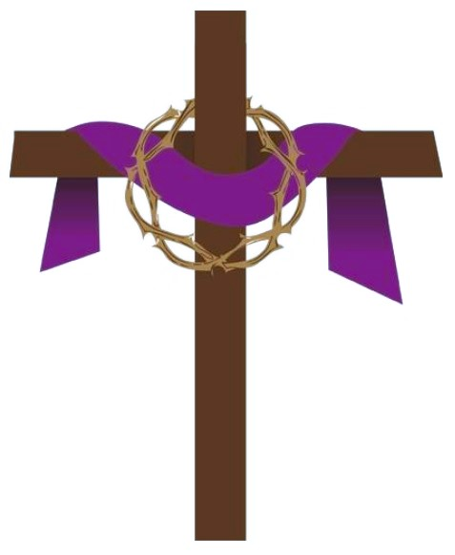
Lord God, you alone are the source of every good gift. Fill our hearts with faithfulness that when we are called to serve, we may answer, “Here I am Lord,” with a spirit of discipleship. We pledge ourselves to be good and faithful stewards of the gifts you have entrusted to us, to share our time, talent and our material gifts as an outward sign of the treasure we hold in Jesus. Amen.

505 N. Pennsylvania Ave.
Roswell, NM 88201
575-622-1353
church@standrewsroswell.com
www.standrewsroswell.com

This service is video-recorded and streamed to the church’s public Facebook page.
Prelude: Jesus Walked This Lonesome Valley – Trad Appalachian Tune, Arr Hugh Livingston

Processional Hymn #709 – O God of Bethel, by whose hand

The people standing, the Celebrant says BCP 355
Bless the Lord who forgives all our sins.
People His mercy endures for ever.

Almighty God, to you all hearts are open, all desires known, and from you no secrets are hid: Cleanse the thoughts of our hearts by the inspiration of your Holy Spirit, that we may perfectly love you, and worthily magnify your holy Name; through Christ our Lord. Amen.

Hymn S102 – Trisagion (Holy God) *To be sung three times
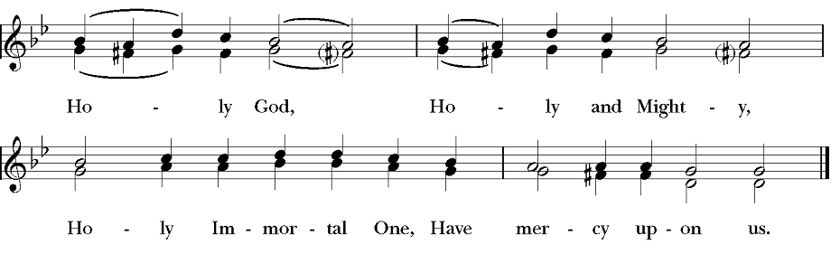

The Collect of the Day
Celebrant The Lord be with you.
People And also with you.
Celebrant Let us pray.

The Celebrant says the Collect.
Almighty God, you alone can bring into order the unruly wills and affections of sinners: Grant your people grace to love what you command and desire what you promise; that, among the swift and varied changes of the world, our hearts may surely there be fixed where true joys are to be found; through Jesus Christ our Lord, who lives and reigns with you and the Holy Spirit, one God, now and for ever. Amen.

The people sit for The Lessons

Jeremiah 31:31-34
The days are surely coming, says the Lord, when I will make a new covenant with the house of Israel and the house of Judah. It will not be like the covenant that I made with their ancestors when I took them by the hand to bring them out of the land of Egypt—a covenant that they broke, though I was their husband, says the Lord. But this is the covenant that I will make with the house of Israel after those days, says the Lord: I will put my law within them, and I will write it on their hearts; and I will be their God, and they shall be my people. No longer shall they teach one another, or say to each other, “Know the Lord,” for they shall all know me, from the least of them to the greatest, says the Lord; for I will forgive their iniquity, and remember their sin no more.

The Word of the Lord.
People Thanks be to God.

Psalm 51:1-13
1 Have mercy on me, O God, according to your loving-kindness; *
in your great compassion blot out my offenses.
2 Wash me through and through from my wickedness *
and cleanse me from my sin.
3 For I know my transgressions, *
and my sin is ever before me.
4 Against you only have I sinned *
and done what is evil in your sight.
5 And so you are justified when you speak *
and upright in your judgment.
6 Indeed, I have been wicked from my birth, *
a sinner from my mother's womb.
7 For behold, you look for truth deep within me, *
and will make me understand wisdom secretly.
8 Purge me from my sin, and I shall be pure; *
wash me, and I shall be clean indeed.
9 Make me hear of joy and gladness, *
that the body you have broken may rejoice.
10 Hide your face from my sins *
and blot out all my iniquities.
11 Create in me a clean heart, O God, *
and renew a right spirit within me.
12 Cast me not away from your presence *
and take not your holy Spirit from me.
13 Give me the joy of your saving help again *
and sustain me with your bountiful Spirit.

The Epistle – Hebrews 5:5-10
Christ did not glorify himself in becoming a high priest, but was appointed by the one who said to him,
“You are my Son, today I have begotten you”;

as he says also in another place,
“You are a priest forever, according to the order of Melchizedek.”
In the days of his flesh, Jesus offered up prayers and supplications, with loud cries and tears, to the one who was able to save him from death, and he was heard because of his reverent submission. Although he was a Son, he learned obedience through what he suffered; and having been made perfect, he became the source of eternal salvation for all who obey him, having been designated by God a high priest according to the order of Melchizedek.

The Word of the Lord.
People Thanks be to God.

Sequence Hymn #337 vs 1,2 – And now, O Father, mindful of the love

Then, all standing, the Deacon or a Priest reads the Gospel, first saying

The Holy Gospel of our Lord Jesus Christ according to John
People Glory to you, Lord Christ.

John 12:20-33
Now among those who went up to worship at the festival were some Greeks. They came to Philip, who was from Bethsaida in Galilee, and said to him, “Sir, we wish to see Jesus.” Philip went and told Andrew; then Andrew and Philip went and told Jesus. Jesus answered them, “The hour has come for the Son of Man to be glorified. Very truly, I tell you, unless a grain of wheat falls into the earth and dies, it remains just a single grain; but if it dies, it bears much fruit. Those who love their life lose it, and those who hate their life in this world will keep it for eternal life. Whoever serves me must follow me, and where I am, there will my servant be also. Whoever serves me, the Father will honor.
“Now my soul is troubled. And what should I say—‘Father, save me from this hour’? No, it is for this reason that I have come to this hour. Father, glorify your name.” Then a voice came from heaven, “I have glorified it, and I will glorify it again.” The crowd standing there heard it and said that it was thunder. Others said, “An angel has spoken to him.” Jesus answered, “This voice has come for your sake, not for mine. Now is the judgment of this world; now the ruler of this world will be driven out. And I, when I am lifted up from the earth, will draw all people to myself.” He said this to indicate the kind of death he was to die.

The Gospel of the Lord.
People Praise to you, Lord Christ.

The Sermon

The Nicene Creed BCP 358
We believe in one God, the Father, the Almighty,
maker of heaven and earth, of all that is, seen and unseen.
We believe in one Lord, Jesus Christ, the only Son of God,
eternally begotten of the Father, God from God, Light from Light, true God from true God, begotten, not made, of one Being with the Father.
Through him all things were made.
For us and for our salvation he came down from heaven:
by the power of the Holy Spirit
he became incarnate from the Virgin Mary, and was made man.
For our sake he was crucified under Pontius Pilate;
he suffered death and was buried.
On the third day he rose again in accordance with the Scriptures;
he ascended into heaven and is seated at the right hand of the Father.
He will come again in glory to judge the living and the dead,
and his kingdom will have no end.
We believe in the Holy Spirit, the Lord, the giver of life,
who proceeds from the Father and the Son.
With the Father and the Son he is worshiped and glorified.
He has spoken through the Prophets.
We believe in one holy catholic and apostolic Church.
We acknowledge one baptism for the forgiveness of sins.
We look for the resurrection of the dead,
and the life of the world to come. Amen.

Confession of Sin BCP 360
Celebrant Let us confess our sins against God and our neighbor.

Most merciful God,
we confess that we have sinned against you
in thought, word, and deed,
by what we have done, and by what we have left undone.
We have not loved you with our whole heart;
we have not loved our neighbors as ourselves.
We are truly sorry and we humbly repent.
For the sake of your Son Jesus Christ, have mercy on us and forgive us;
that we may delight in your will, and walk in your ways,
to the glory of your Name. Amen.

The Bishop when present, or the Priest, stands and says

Almighty God have mercy on you, forgive you all your sins through our Lord Jesus Christ, strengthen you in all goodness, and by the power of the Holy Spirit keep you in eternal life. Amen.

The Peace
Celebrant The peace of the Lord be always with you.
People And also with you.

Announcements

The Offertory
The People stand while the offerings of bread and wine are presented.
The loose plate offering goes to the Rector’s Discretionary Fund unless otherwise announced.

Music at the Offering: What Wondrous Love Is This – arr Trevor Manor

Presentation Hymn #143 vs 5
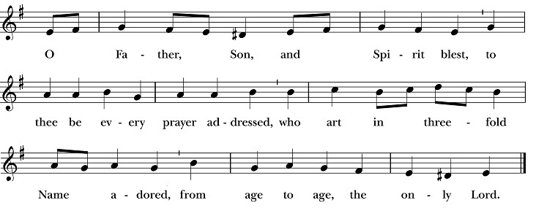

Blessing of the Offering
Celebrant All things come of thee, O Lord.
People And of thine own have we given thee.

The Great Thanksgiving – Eucharistic Prayer D BCP 372

All standing, the Celebrant, whether bishop or priest, faces the people and sings or says

The Lord be with you.
People And also with you.
Celebrant Lift up your hearts.
People We lift them to the Lord.
Celebrant Let us give thanks to the Lord our God.
People It is right to give him thanks and praise.

Then, facing the Holy Table, the Celebrant proceeds

It is truly right to glorify you, Father, and to give you thanks; for you alone are God, living and true, dwelling in light inaccessible from before time and for ever.

Fountain of life and source of all goodness, you made all things and fill them with your blessing; you created them to rejoice in the splendor of your radiance.

Countless throngs of angels stand before you to serve you night and day; and, beholding the glory of your presence, they offer you unceasing praise. Joining with

them, and giving voice to every creature under heaven, we acclaim you, and glorify your Name, as we sing,

Hymn S128 – Sanctus
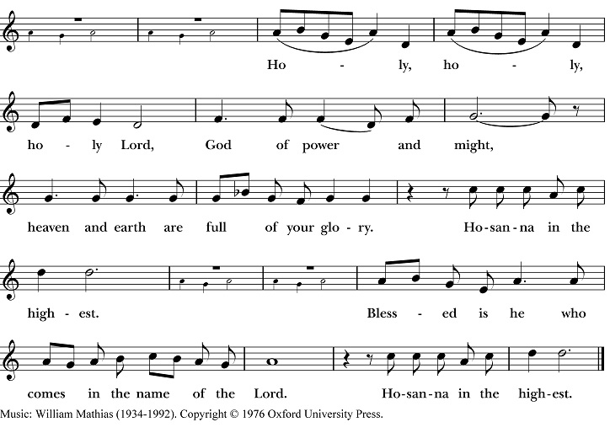

The people stand or kneel. Then the Celebrant continues

We acclaim you, holy Lord, glorious in power. Your mighty works reveal your wisdom and love. You formed us in your own image, giving the whole world into our care, so that, in obedience to you, our Creator, we might rule and serve all your creatures. When our disobedience took us far from you, you did not abandon us to the power of death. In your mercy you came to our help, so that in seeking you we might find you. Again and again you called us into covenant with you, and through the prophets you taught us to hope for salvation.
Father, you loved the world so much that in the fullness of time you sent your only Son to be our Savior. Incarnate by the Holy Spirit, born of the Virgin Mary, he lived as one of us, yet without sin. To the poor he proclaimed the good news of salvation; to prisoners, freedom; to the sorrowful, joy. To fulfill your purpose he gave himself up to death; and, rising from the grave, destroyed death, and made the whole creation new.

And, that we might live no longer for ourselves, but for him who died and rose for us, he sent the Holy Spirit, his own first gift for those who believe, to complete his work in the world, and to bring to fulfillment the sanctification of all.

When the hour had come for him to be glorified by you, his heavenly Father, having loved his own who were in the world, he loved them to the end; at supper with them he took bread, and when he had given thanks to you, he broke it, and gave it to his disciples, and said, “Take, eat: This is my Body, which is given for you. Do this for the remembrance of me.”

After supper he took the cup of wine; and when he had given thanks, he gave it to them, and said, “Drink this, all of you: This is my Blood of the new Covenant, which is shed for you and for many for the forgiveness of sins. Whenever you drink it, do this for the remembrance of me.”
Father, we now celebrate this memorial of our redemption. Recalling Christ’s death and his descent among the dead, proclaiming his resurrection and ascension to your right hand, awaiting his coming in glory; and offering to you, from the gifts you have given us, this bread and this cup, we praise you and we bless you.

Celebrant and People

We praise you, we bless you,
we give thanks to you,
and we pray to you, Lord our God.

The Celebrant continues

Lord, we pray that in your goodness and mercy your Holy Spirit may descend upon us, and upon these gifts, sanctifying them and showing them to be holy gifts

for your holy people, the bread of life and the cup of salvation, the Body and Blood of your Son Jesus Christ.

Grant that all who share this bread and cup may become one body and one spirit, a living sacrifice in Christ, to the praise of your Name.

Remember, Lord, your one holy catholic and apostolic Church, redeemed by the blood of your Christ. Reveal its unity, guard its faith, and preserve it in peace.
Remember Presiding Bishop Michael Curry, our Bishop Michael Hunn, and all who minister in your Church.
Remember all your people, and those who seek your truth.
Remember all those on our Prayer List.
Remember all who have died in the peace of Christ, and those whose faith is known to you alone; bring them into the place of eternal joy and light.

And grant that we may find our inheritance with [the Blessed Virgin Mary, with patriarchs, prophets, apostles, and martyrs, with ___________, and] all the

saints who have found favor with you in ages past. We praise you in union with them and give you glory through your Son Jesus Christ our Lord.

Through Christ, and with Christ, and in Christ, all honor and glory are yours, Almighty God and Father, in the unity of the Holy Spirit, for ever and ever. AMEN.
And now, as our Savior Christ has taught us, we are bold to say,

People and Celebrant

Our Father, who art in heaven, hallowed be thy Name,
thy kingdom come, thy will be done,
on earth as it is in heaven.
Give us this day our daily bread.
And forgive us our trespasses,
as we forgive those who trespass against us.
And lead us not into temptation, but deliver us from evil.
For thine is the kingdom, and the power, and the glory,
for ever and ever. Amen.

The Breaking of the Bread

The Celebrant breaks the consecrated Bread.

A period of silence is kept.

Hymn S158 – Fraction Anthem: Agnus Dei
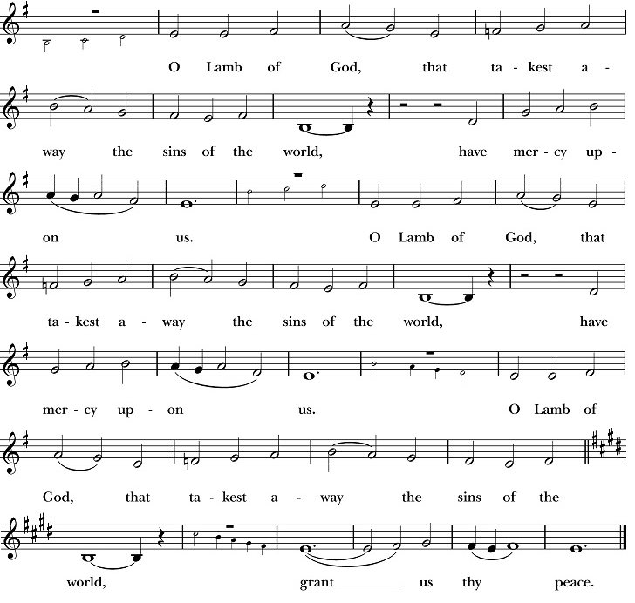

Facing the people, the Celebrant says the following Invitation

The Gifts of God for the People of God.
and may add Take them in remembrance that Christ died for you, and feed on him in your hearts by faith, with thanksgiving.

All baptized Christians are welcome to receive Communion. If you are not baptized, you may come forward to receive a blessing by folding your arms over your chest. Gluten free hosts are available upon request. If you are interested in being baptized, please speak to Mtr. Susan after the service.

After Communion, the Celebrant says

Let us pray.

Prayer for Online Worshipers
God of grace, we present to you our souls and bodies with the earnest wish that we may always be united to you and each other. Since we may not always be together to receive you sacramentally, unite us spiritually that our hearts may embrace you with all the affections of our souls. Let nothing ever separate us from you, through the communion of saints, in all times and places. Amen.

Post-Communion Prayer BCP 365
Eternal God, heavenly Father, you have graciously accepted us as living members of your Son our Savior Jesus Christ, and you have fed us with spiritual food in the Sacrament of his Body and Blood. Send us now into the world in peace, and grant us strength and courage to love and serve you with gladness and singleness of heart; through Christ our Lord. Amen.

Blessing
Celebrant Bow down before the Lord.

The people kneel as the Celebrant continues

Look with compassion, O Lord, upon this your people; that, rightly observing this holy season, they may learn to know you more fully, and to serve you with a more perfect will; through Christ our Lord. Amen.

Recessional Hymn #473 – Lift high the cross

Dismissal

Postlude: The Royal Banners Forward Go – Sarum Plainsong, Arr Wilbur Held

Celebrant: The Rev. Dr. Susan Pigott
Verger: Sissy Mayne
Choir Director: John Fuss
Organist/Pianist: Karen Fuss
Lay Reader: Bryan Evans
Chalice Bearer: Charles Currier
Ushers: Greg Anderson, Gini Bartley
Altar Guild: Lorinda Wilkins, Karen Fuss, Sarah Gifford

Please pray for our members and their families:
Cory Butler, Sarah & Zada, Rebecca & Rick Ellis, Jason Bethany, Almeta LeBarre, Katy Galassini, Christa Kelley, Beth Bierwirth, Pat Walker, Earl & Kathleen Pittman, David Knadle, Sean K., Abby R. & family, Emma Cortez & Jeremiah Bryant, Alice B. Smith, Pat & Karen Hendricks, Janet Macaluso, Lynn Townsend, Julie Deaton, Carol Anne, Nancy Hartwick, Suzanne Berry, John Fuss, Sevie Bates, Kate Dorff, Aaron Burkett, Craig Lysak, Manuel Linares, Burnitta McClung, Bruce Currier, Billie Weber, Lorinda & Royce, Cory Woodbury, Janelle McGuire, Andy Morehouse, Kelli, Marilyn Manatt, Michelle, Ann Wonders, Isabel Castillo, Lisa Huff, Betty, Kim C., Maddy, Victoria Cobb, Pat Wiberg, Andrew W., Matthew, Rachel, Florence Carr, Beth Rogers, Jeannine Byron, Marisa, Lew Hightower, Clayton Thompson, Bill & Meredith Patton, Annette Mader, Julian Linares, Raymond Linares, Jennifer Linares, Cassie, Fern Simpson

Please pray for friends of St. Andrew’s:
Julie Cox & family, Arthana, Jackie Hite, Donald Gonzales, Amber Owen, Rebecca Clements, Mary Scott, David R., Christina Lule, Kayla & Rosie, Pedro Sanchez, Antonio Soto, Susan Welch, Richard Hidalgo, Denise Baker, Cathy & Bill Hackett, Annalee Kraft, Rehanna, Michelle Brooke & her family, Victoria, Wilson family, Shane Olive, Dr. Dennis Knoche, Dale Williams, Bill Daily, Lenore Savage, Rose Herrera, Gretta Dickman, Susan H., Bill Murphy, Nancy W., Andres Adauto, Rebecca Ellis, Victor & Laquita Pierce, Robert, Mark, Jenice Furguson, Rev. Susanna Metz, Del Journey, Courtney, Elena & family, Elena’s mother, Aurora, Tristen, Belma Cloud, Josie Powell, Clifford Sipple family, Dayna, Karen Anderson, Andrea, Cox Family, Melissa J. & family, Fr. Hector Trejo, Shawna & family, Stephanie K., Sarah, Veronica, Michelle Siebel, Kalistro Linares, Michele Hillman, Sarah Wooldridge, Jerry & M.J., Rex Kartchner, Alison, Emily, Janet Carter, Meredith Miller, Maryanne D’Arcangelis, Lara, Dyan, Nancy Klima, M. Lopez, Wilson, Keith Maston, Kevin Maston, Carli Salyards, Tammy Reed, Frank Roberts & family, Elizabeth Klijnsmit, Jaime Alvarez, Ron & Twylla M, Rosemary Henry, Mathew & family, Effie Silva, Baldo & Rena, Marty G., Tom & Marilyn

