n…………………………………………0
St. Andrew’s Episcopal Church

Third Sunday of Advent
December 17, 2023 10:00am
Holy Eucharist – Rite II

Lord God, you alone are the source of every good gift. Fill our hearts with faithfulness that when we are called to serve, we may answer, “here I am Lord,” with a spirit of discipleship. We pledge ourselves to be good and faithful stewards of the gifts you have entrusted to us, to share our time, talent and our material gifts as an outward sign of the treasure we hold in Jesus. Amen.

505 N. Pennsylvania Ave.
Roswell, NM 88201
575-622-1353
church@standrewsroswell.com
www.standrewsroswell.com

This service is video-recorded and streamed to the church’s public Facebook page.

Prelude: Lo, How A Rose E’er Blooming – 16th c. German, arr John M. Rasley

Processional Hymn #74 – Blest be the King whose coming

Lighting of the Advent candle (from a liturgy written by The Rev. Matthew Kozlowski)
Celebrant Today we light the first, second, and third candles of the Advent wreath. Each candle has a meaning. The first candle is HOPE, the second candle is PEACE, and the third candle is JOY.
You will go out in joy and be led forth in peace; the mountains and hills will burst into song before you, and all the trees of the field will clap their hands. ~ Isaiah 55:12
Gracious God, you came to us in human flesh and you abide with us in the Holy Spirit. Fill us with your joy, and help us shine as a light to the world. Through Jesus Christ, who makes our joy complete. Amen.

While the candle is being lit, all sing:

Hymn #56 verse 6 – O come, O come, Emmanuel

The people standing, the Celebrant says BCP 355
Bless the Lord who forgives all our sins.
People His mercy endures for ever.

Almighty God, to you all hearts are open, all desires known, and from you no secrets are hid: Cleanse the thoughts of our hearts by the inspiration of your Holy Spirit, that we may perfectly love you, and worthily magnify your holy Name; through Christ our Lord. Amen.

Hymn S91 – Kyrie (Lord, have mercy upon us)
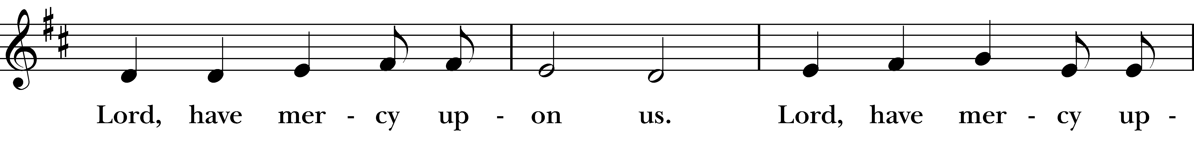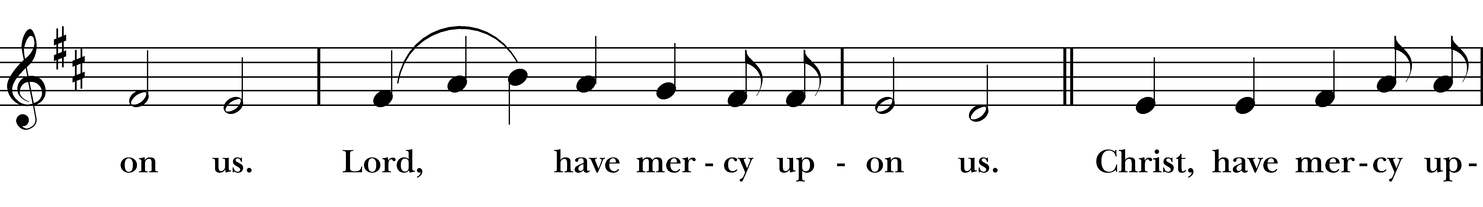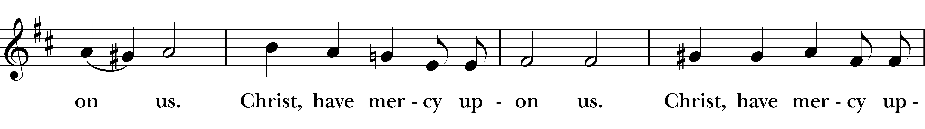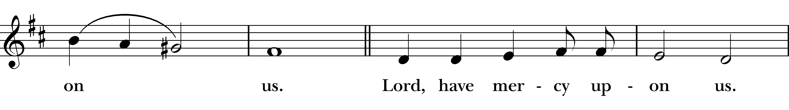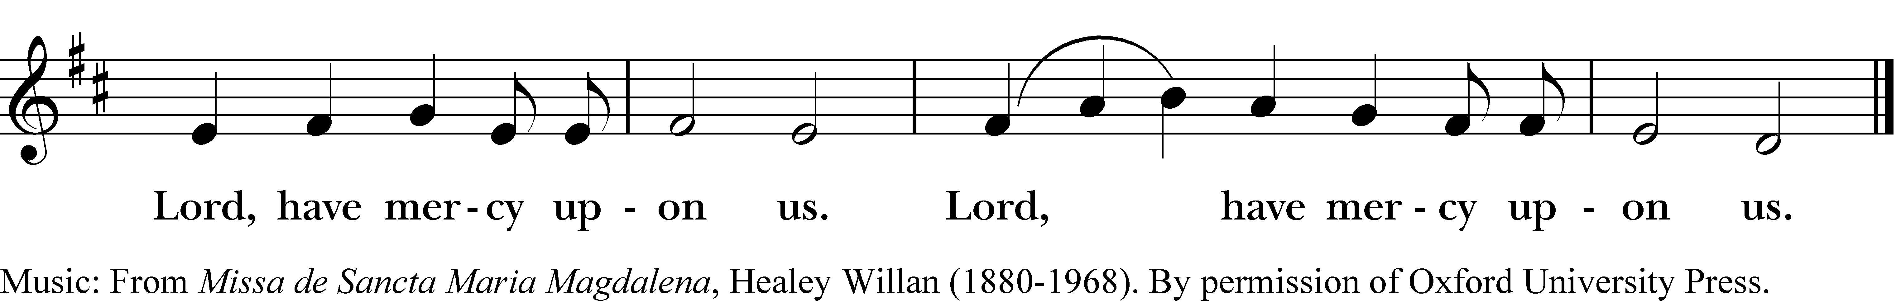

The Collect of the Day
Celebrant The Lord be with you.
People And also with you.
Celebrant Let us pray.

The Celebrant says the Collect.
Stir up your power, O Lord, and with great might come among us; and, because we are sorely hindered by our sins, let your bountiful grace and mercy speedily help and deliver us; through Jesus Christ our Lord, to whom, with you and the Holy Spirit, be honor and glory, now and for ever. Amen.

The people sit for The Lessons

Isaiah 61:1-4, 8-11
The spirit of the Lord God is upon me, because the Lord has anointed me;
he has sent me to bring good news to the oppressed,
to bind up the brokenhearted, to proclaim liberty to the captives,
and release to the prisoners;
to proclaim the year of the Lord's favor, and the day of vengeance of our God; to comfort all who mourn;
to provide for those who mourn in Zion—
to give them a garland instead of ashes,
the oil of gladness instead of mourning,
the mantle of praise instead of a faint spirit.
They will be called oaks of righteousness,
the planting of the Lord, to display his glory.
They shall build up the ancient ruins,
they shall raise up the former devastations;
they shall repair the ruined cities, the devastations of many generations.
For I the Lord love justice, I hate robbery and wrongdoing;
I will faithfully give them their recompense,
and I will make an everlasting covenant with them.
Their descendants shall be known among the nations,
and their offspring among the peoples;
all who see them shall acknowledge
that they are a people whom the Lord has blessed.
I will greatly rejoice in the LORD, my whole being shall exult in my God;
for he has clothed me with the garments of salvation,
he has covered me with the robe of righteousness,
as a bridegroom decks himself with a garland,
and as a bride adorns herself with her jewels.
For as the earth brings forth its shoots,
and as a garden causes what is sown in it to spring up,
so the Lord God will cause righteousness and praise
to spring up before all the nations.

The Word of the Lord.
People Thanks be to God.

Psalm 126
1 When the Lord restored the fortunes of Zion, *
then were we like those who dream.
2 Then was our mouth filled with laughter, *
and our tongue with shouts of joy.
3 Then they said among the nations, *
"The Lord has done great things for them."
4 The Lord has done great things for us, *
and we are glad indeed.
5 Restore our fortunes, O Lord, *
like the watercourses of the Negev.
6 Those who sowed with tears *
will reap with songs of joy.
7 Those who go out weeping, carrying the seed, *
will come again with joy, shouldering their sheaves.

The Epistle – 1 Thessalonians 5:16-24
Rejoice always, pray without ceasing, give thanks in all circumstances; for this is the will of God in Christ Jesus for you. Do not quench the Spirit. Do not despise the words of prophets, but test everything; hold fast to what is good; abstain from every form of evil.
May the God of peace himself sanctify you entirely; and may your spirit and soul and body be kept sound and blameless at the coming of our Lord Jesus Christ. The one who calls you is faithful, and he will do this.

The Word of the Lord.
People Thanks be to God.

Sequence Hymn #76 vs 1,2,3,5 – On Jordan’s bank the Baptist’s cry

Then, all standing, the Deacon or a Priest reads the Gospel, first saying

The Holy Gospel of our Lord Jesus Christ according to John
People Glory to you, Lord Christ.

John 1:6-8,19-28
There was a man sent from God, whose name was John. He came as a witness to testify to the light, so that all might believe through him. He himself was not the light, but he came to testify to the light.
This is the testimony given by John when the Jews sent priests and Levites from Jerusalem to ask him, “Who are you?” He confessed and did not deny it, but confessed, “I am not the Messiah.” And they asked him, “What then? Are you Elijah?” He said, “I am not.” “Are you the prophet?” He answered, “No.” Then they said to him, “Who are you? Let us have an answer for those who sent us. What do you say about yourself?” He said, “I am the voice of one crying out in the wilderness, ‘Make straight the way of the Lord,’” as the prophet Isaiah said. Now they had been sent from the Pharisees. They asked him, “Why then are you baptizing if you are neither the Messiah, nor Elijah, nor the prophet?” John answered them, “I baptize with water. Among you stands one whom you do not know, the one who is coming after me; I am not worthy to untie the thong of his sandal.” This took place in Bethany across the Jordan where John was baptizing.

The Gospel of the Lord.
People Praise to you, Lord Christ.

The Sermon

The Nicene Creed BCP 358
We believe in one God, the Father, the Almighty,
maker of heaven and earth, of all that is, seen and unseen.
We believe in one Lord, Jesus Christ, the only Son of God,
eternally begotten of the Father, God from God, Light from Light, true God from true God, begotten, not made, of one Being with the Father.
Through him all things were made.
For us and for our salvation he came down from heaven:
by the power of the Holy Spirit
he became incarnate from the Virgin Mary, and was made man.
For our sake he was crucified under Pontius Pilate;
he suffered death and was buried.
On the third day he rose again in accordance with the Scriptures;
he ascended into heaven and is seated at the right hand of the Father.
He will come again in glory to judge the living and the dead,
and his kingdom will have no end.
We believe in the Holy Spirit, the Lord, the giver of life,
who proceeds from the Father and the Son.
With the Father and the Son he is worshiped and glorified.
He has spoken through the Prophets.
We believe in one holy catholic and apostolic Church.
We acknowledge one baptism for the forgiveness of sins.
We look for the resurrection of the dead,
and the life of the world to come. Amen.

The Prayers of the People – Form V BCP 389

Leader In peace, let us pray to the Lord, saying, “Lord, have mercy.”

For the holy Church of God, that it may be filled with truth and love, and be found without fault at the day of your coming, we pray to you, O Lord.

Lord, have mercy.

For Michael Curry, our Presiding Bishop, for Michael Hunn, our own Bishop, for all bishops and other ministers, and for all the holy people of God, we pray to you, O Lord.

Lord, have mercy.

For all who fear God and believe in you, Lord Christ, that our divisions may cease, and that all may be one as you and the Father are one, we pray to you, O Lord.

Lord, have mercy.

For the mission of the Church, that in faithful witness it may preach the Gospel to the ends of the earth, we pray to you, O Lord.

Lord, have mercy.

For those who do not yet believe, and for those who have lost their faith, that they may receive the light of the Gospel, we pray to you, O Lord.

Lord, have mercy.

For the peace of the world, that a spirit of respect and forbearance may grow among nations and peoples, we pray to you, O Lord.

Lord, have mercy.
For those in positions of public trust - especially Joe, our President, Michelle, our Governor, and Tim, our Mayor - that they may serve justice, and promote the dignity and freedom of every person, we pray to you, O Lord.

Lord, have mercy.

For the poor, the persecuted, the sick, and all who suffer; for refugees, prisoners, and all who are in danger; that they may be relieved and protected, we pray to you, O Lord.

Lord, have mercy.

For this congregation - for those who are present, and for those who are absent - that we may be delivered from hardness of heart, and show forth your glory in all that we do, we pray to you, O Lord.

Lord, have mercy.

For all who have commended themselves to our prayers, especially __________; for our families, friends, and neighbors; that being freed from anxiety, they may live in joy, peace, and health, we pray to you, O Lord.

Lord, have mercy.

For all who have died in the communion of your Church, and those whose faith is known to you alone, that, with all the saints, they may have rest in that place where there is no pain or grief, but life eternal, we pray to you, O Lord.

Lord, have mercy.

Rejoicing in the fellowship of St. John the Baptist and of all the saints, let us commend ourselves, and one another, and all our life to Christ our God.
To you, O Lord our God.

The Celebrant adds the following

For yours is the majesty, O Father, Son, and Holy Spirit; yours is the kingdom and the power and the glory, now and for ever. Amen.

Confession of Sin BCP 360
Celebrant Let us confess our sins against God and our neighbor.

Most merciful God,
we confess that we have sinned against you
in thought, word, and deed,
by what we have done, and by what we have left undone.
We have not loved you with our whole heart;
we have not loved our neighbors as ourselves.
We are truly sorry and we humbly repent.
For the sake of your Son Jesus Christ, have mercy on us and forgive us;
that we may delight in your will, and walk in your ways,
to the glory of your Name. Amen.

The Bishop when present, or the Priest, stands and says

Almighty God have mercy on you, forgive you all your sins through our Lord Jesus Christ, strengthen you in all goodness, and by the power of the Holy Spirit keep you in eternal life. Amen.

The Peace
Celebrant The peace of the Lord be always with you.
People And also with you.

Announcements

The People stand while the offerings of bread and wine are presented.

Music at the Offering: Sleepers, Wake! – Mendelssohn

Doxology
Praise God, from whom all blessings flow;
praise him, all creatures here below;
praise him above, ye heavenly host:
praise Father, Son, and Holy Ghost.

Blessing of the Offering
Celebrant All things come of thee, O Lord.
People And of thine own have we given thee.

The Great Thanksgiving – Eucharistic Prayer B BCP 367

The Celebrant, whether bishop or priest, faces the people and sings or says

The Lord be with you.
People And also with you.
Celebrant Lift up your hearts.
People We lift them to the Lord.
Celebrant Let us give thanks to the Lord our God.
People It is right to give him thanks and praise.

Then, facing the Holy Table, the Celebrant proceeds

It is right, and a good and joyful thing, always and everywhere to give thanks to you, Father Almighty, Creator of heaven and earth.

Here a Proper Preface is said on all Sundays, and on other occasions as appointed.

Therefore we praise you, joining our voices with Angels and Archangels and with all the company of heaven, who for ever sing this hymn to proclaim the glory of your Name:

Hymn S130 – Sanctus
Holy, holy, holy Lord, God of power and might,
Holy, holy, holy Lord, God of power and might,
heaven and earth are full, full of your glory.
Hosanna in the highest. Hosanna in the highest.
Blessed is he who comes in the name of the Lord.
Hosanna in the highest. Hosanna in the highest.

The people stand or kneel. Then the Celebrant continues

We give thanks to you, O God, for the goodness and love which you have made known to us in creation; in the calling of Israel to be your people; in your Word spoken through the prophets; and above all in the Word made flesh, Jesus, your
Son. For in these last days you sent him to be incarnate from the Virgin Mary, to be the Savior and Redeemer of the world. In him, you have delivered us from evil, and made us worthy to stand before you. In him, you have brought us out of error into truth, out of sin into righteousness, out of death into life.

On the night before he died for us, our Lord Jesus Christ took bread; and when he had given thanks to you, he broke it, and gave it to his disciples, and said, “Take, eat: This is my Body, which is given for you. Do this for the remembrance of me.”

After supper he took the cup of wine; and when he had given thanks, he gave it to them, and said, “Drink this, all of you: This is my Blood of the new Covenant, which is shed for you and for many for the forgiveness of sins. Whenever you drink it, do this for the remembrance of me.”

Therefore, according to his command, O Father,

Celebrant and People
We remember his death,
We proclaim his resurrection,
We await his coming in glory;

The Celebrant continues
And we offer our sacrifice of praise and thanksgiving to you, O Lord of all; presenting to you, from your creation, this bread and this wine.

We pray you, gracious God, to send your Holy Spirit upon these gifts that they may be the Sacrament of the Body of Christ and his Blood of the new Covenant. Unite us to your Son in his sacrifice, that we may be acceptable through him,
being sanctified by the Holy Spirit. In the fullness of time, put all things in subjection under your Christ, and bring us to that heavenly country where, with [_________ and] all your saints, we may enter the everlasting heritage of your sons and daughters; through Jesus Christ our Lord, the firstborn of all creation, the head of the Church, and the author of our salvation.

By him, and with him, and in him, in the unity of the Holy Spirit all honor and glory is yours, Almighty Father, now and for ever. AMEN.

And now, as our Savior Christ has taught us, we are bold to say,

People and Celebrant

Our Father, who art in heaven, hallowed be thy Name,
thy kingdom come, thy will be done,
on earth as it is in heaven.
Give us this day our daily bread.
And forgive us our trespasses,
as we forgive those who trespass against us.
And lead us not into temptation, but deliver us from evil.
For thine is the kingdom, and the power, and the glory,
for ever and ever. Amen.

The Breaking of the Bread

The Celebrant breaks the consecrated Bread.

Hymn S164 – Fraction Anthem: Agnus Dei
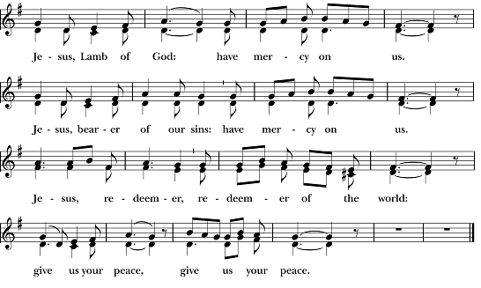

Facing the people, the Celebrant says the following Invitation

The Gifts of God for the People of God.
and may add Take them in remembrance that Christ died for you, and feed on him in your hearts by faith, with thanksgiving.
All baptized Christians are welcome to receive Communion. If you are not baptized, you may come forward to receive a blessing by folding your arms over your chest. Gluten free hosts are available upon request. If you are interested in being baptized, please speak to Mtr. Susan after the service.

After Communion, the Celebrant says

Let us pray.

Prayer for Online Worshipers
God of grace, we present to you our souls and bodies with the earnest wish that we may always be united to you and each other. Since we may not always be together to receive you sacramentally, unite us spiritually that our hearts may embrace you with all the affections of our souls. Let nothing ever
separate us from you, through the communion of saints, in all times and places. Amen.

Post-Communion Prayer BCP 365
Eternal God, heavenly Father, you have graciously accepted us as living members of your Son our Savior Jesus Christ, and you have fed us with spiritual food in the Sacrament of his Body and Blood. Send us now into the world in peace, and grant us strength and courage to love and serve you with gladness and singleness of heart; through Christ our Lord. Amen.

Blessing

Recessional Hymn #59 – Hark! a thrilling voice is sounding

Dismissal

Postlude: Savior of the Nations, Come – Erfurt Enchiridion, 1524; arr Douglas E. Wagner

Please pray for our members and their families:
Sean K., Abby R. & family, Husby family, Emma Cortez, Alice B. Smith, Pat & Karen Hendricks, Janet Macaluso, David Knadle, Gary & Enid Smith, Lynn Townsend, Julie Deaton, Carol Anne, Nancy Hartwick, Suzanne Berry, Pat Walker, John Fuss, Melody Green, Sevie Bates, Kate Dorff, Aaron Burkett, Earl & Kathleen Pittman, Craig Lysak, Manuel Linares, Jeremiah Bryant, Burnitta McClung, Bruce Currier, Billie Weber, Lorinda & Royce, Cory Woodbury, Janelle McGuire, Andy Morehouse, Kelli, Marilyn Manatt, Michelle, Ann Wonders, Isabel Castillo, Lisa Huff, Betty, Kim C., Maddy, Victoria Cobb, Pat Wiberg, Andrew W., Matthew, Rachel, Amanda Olivo, Florence Carr, Beth Rogers, Jeannine Byron, Marisa, Lew Hightower, Clayton Thompson, Bill & Meredith Patton, Annette Mader, Julian Linares, Raymond Linares, Jennifer Linares, Cassie, Sandi Olivo, Fern Simpson

From the office… Please help us keep our prayer lists updated. Let us know if there is someone who needs special prayers, or if there are names that can be removed from the list. Thank you!

Please pray for friends of St. Andrew’s:
Rebecca Clements, Mary Scott, David R., Christina Lule, Kayla & Rosie, Pedro Sanchez, Antonio Soto, Susan Welch, Richard Hidalgo, Donal & family, Denise Baker, Cathy & Bill Hackett, Annalee Kraft, Rehanna, Michelle Brooke & her family, Victoria, Wilson family, Shane Olive, Dr. Dennis Knoche, Dale Williams, Bill Daily, Lenore Savage, Rose Herrera, Gretta Dickman, Susan H., Bill Murphy, Nancy W., Andres Adauto, Rebecca Ellis, Victor & Laquita Pierce, Robert, Mark, Jenice Furguson, Rev. Susanna Metz, Del Journey, Courtney, Elena & family, Elena’s mother, Aurora, Tristen, Belma Cloud, Josie Powell, Clifford Sipple family, Dayna, Karen Anderson, Andrea, Cox Family, Melissa J. & family, Fr. Hector Trejo, Shawna & family, Stephanie K., Sarah, Veronica, Michelle Siebel, Kalistro Linares, Michele Hillman, Sarah Wooldridge, Jerry & M.J., Rex Kartchner, Alison, Emily, Janet Carter, Meredith Miller, Maryanne D’Arcangelis, Lara, Dyan, Nancy Klima, M. Lopez, Wilson, Keith Maston, Kevin Maston, Carli Salyards, Tammy Reed, Frank Roberts & family, Elizabeth Klijnsmit, Jaime Alvarez, Ron & Twylla M, Rosemary Henry, Mathew & family, Effie Silva, Baldo & Rena, Marty G., Tom & Marilyn

The flowers this morning are given by Nick & Janet Macaluso
in loving memory of Armando & Mary Macaluso

Celebrant: The Rev. Dr. Susan Pigott
Verger: Sissy Mayne
Choir Director: John Fuss
Organist/Pianist: Karen Fuss
Lay Reader: Charles Currier
Chalice Bearer: Shelly Currier
Ushers: Mark Kelley, Domenic Macaluso
Altar Guild: Anita Smith, Sue Evans, Diana Hudson

