0
St. Andrew’s Episcopal Church

Second Sunday of Advent
December 5, 2021 9:00 AM
Rite II

Lord God, you alone are the source of every good gift. Fill our hearts with faithfulness that when we are called to serve, we may answer, “here I am Lord,” with a spirit of discipleship. We pledge ourselves to be good and faithful stewards of the gifts you have entrusted to us, to share our time, talent and our material gifts as an outward sign of the treasure we hold in Jesus. Amen

505 N. Pennsylvania Ave.
Roswell, NM 88201
575-622-1353
church@standrewsroswell.com
www.standrewsroswell.com

Prelude: O Come, O Come, Emmanuel – Plainsong, arr Cindy Berry

Hymns are printed at the back of the bulletin, beginning on page 15.

Processional Hymn #67 – Comfort, comfort ye my people

The people standing, the Celebrant says

Bless the Lord who forgives all our sins.
People His mercy endures for ever.

The Celebrant may say

Almighty God, to you all hearts are open, all desires known, and
from you no secrets are hid: Cleanse the thoughts of our hearts by
the inspiration of your Holy Spirit, that we may perfectly love you,
and worthily magnify your holy Name; through Christ our Lord.
Amen.

Hymn S96 – Kyrie eleison (Lord, have mercy)

The Collect of the Day

The Celebrant says to the people

The Lord be with you.
People And also with you.
Celebrant Let us pray.

The Celebrant says the Collect.
Merciful God, who sent your messengers the prophets to preach repentance and prepare the way for our salvation: Give us grace to heed their warnings and forsake our sins, that we may greet with joy the coming of Jesus Christ our Redeemer; who lives and reigns with you and the Holy Spirit, one God, now and for ever. Amen.

The Lessons

The people sit.

Malachi 3:1-4
See, I am sending my messenger to prepare the way before me, and the Lord whom you seek will suddenly come to his temple. The messenger of the covenant in whom you delight-- indeed, he is coming, says the Lord of hosts. But who can endure the day of his coming, and who can stand when he appears?
For he is like a refiner's fire and like fullers' soap; he will sit as a refiner and purifier of silver, and he will purify the descendants of Levi and refine them like gold and silver, until they present offerings to the Lord in righteousness. Then the offering of Judah and Jerusalem will be pleasing to the Lord as in the days of old and as in former years.

The Word of the Lord.
People Thanks be to God.

Silence may follow.

Canticle 16 – The Song of Zechariah

Benedictus Dominus Deus
Blessed be the Lord, the God of Israel; *
he has come to his people and set them free.
He has raised up for us a mighty savior, *
born of the house of his servant David.
Through his holy prophets he promised of old,
that he would save us from our enemies, *
from the hands of all who hate us.
He promised to show mercy to our fathers *
and to remember his holy covenant.
This was the oath he swore to our father Abraham, *
to set us free from the hands of our enemies,
Free to worship him without fear, *
holy and righteous in his sight
all the days of our life.
You, my child, shall be called the prophet of the Most High, *
for you will go before the Lord to prepare his way,
To give his people knowledge of salvation *
by the forgiveness of their sins.
In the tender compassion of our God *
the dawn from on high shall break upon us,
To shine on those who dwell in darkness and the shadow of death, *
and to guide our feet into the way of peace.
Glory to the Father, and to the Son, and to the Holy Spirit: *
as it was in the beginning, is now, and will be for ever. Amen.

The Epistle

Philippians 1:3-11
I thank my God every time I remember you, constantly praying with joy in every one of my prayers for all of you, because of your sharing in the gospel from the first day until now. I am confident of this, that the one who began a good work among you will bring it to completion by the day of Jesus Christ. It is right for me to think this way about all of you, because you hold me in your heart, for all of you share in God's grace with me, both in my imprisonment and in the defense and confirmation of the gospel. For God is my witness, how I long for all of you with the compassion of Christ Jesus. And this is my prayer, that your love may overflow more and more with knowledge and full insight to help you to determine what is best, so that in the day of Christ you may be pure and blameless, having produced the harvest of righteousness that comes through Jesus Christ for the glory and praise of God.

The Word of the Lord.
People Thanks be to God.

Sequence Hymn #75 – There’s a voice in the wilderness crying

Then, all standing, the Deacon or a Priest reads the Gospel, first saying

The Holy Gospel of our Lord Jesus Christ according to Luke.
People Glory to you, Lord Christ.

The Gospel

Luke 3:1-6
In the fifteenth year of the reign of Emperor Tiberius, when Pontius Pilate was governor of Judea, and Herod was ruler of Galilee, and his brother Philip ruler of the region of Ituraea and Trachonitis, and Lysanias ruler of Abilene, during the high priesthood of Annas and Caiaphas, the word of God came to John son of Zechariah in the wilderness. He went into all the region around the Jordan, proclaiming a baptism of repentance for the forgiveness of sins, as it is written in the book of the words of the prophet Isaiah,
"The voice of one crying out in the wilderness:
'Prepare the way of the Lord,
make his paths straight.
Every valley shall be filled,
and every mountain and hill shall be made low,
and the crooked shall be made straight,
and the rough ways made smooth;
and all flesh shall see the salvation of God.'"

The Gospel of the Lord.
People Praise to you, Lord Christ.

The Sermon

The Nicene Creed

We believe in one God,
the Father, the Almighty,
maker of heaven and earth,
of all that is, seen and unseen.

We believe in one Lord, Jesus Christ,
the only Son of God,
eternally begotten of the Father,
God from God, Light from Light,
true God from true God,
begotten, not made,
of one Being with the Father.
Through him all things were made.
For us and for our salvation
he came down from heaven:
by the power of the Holy Spirit
he became incarnate from the Virgin Mary,
and was made man.
For our sake he was crucified under Pontius Pilate;
he suffered death and was buried.
On the third day he rose again
in accordance with the Scriptures;
he ascended into heaven
and is seated at the right hand of the Father.
He will come again in glory to judge the living and the dead,
and his kingdom will have no end.

We believe in the Holy Spirit, the Lord, the giver of life,
who proceeds from the Father and the Son.
With the Father and the Son he is worshiped and glorified.
He has spoken through the Prophets.
We believe in one holy catholic and apostolic Church.
We acknowledge one baptism for the forgiveness of sins.
We look for the resurrection of the dead,
and the life of the world to come. Amen.

The Prayers of the People

Form IV

Deacon or other leader

Let us pray for the Church and for the world.

Grant, Almighty God, that all who confess your Name may
be united in your truth, live together in your love, and reveal
your glory in the world.

Silence

Lord, in your mercy
Hear our prayer.

Guide the people of this land, and of all the nations, in the
ways of justice and peace; that we may honor one another
and serve the common good.

Silence

Lord, in your mercy
Hear our prayer.

Give us all a reverence for the earth as your own creation,
that we may use its resources rightly in the service of others
and to your honor and glory.

Silence

Lord, in your mercy
Hear our prayer.

Bless all whose lives are closely linked with ours, and grant
that we may serve Christ in them, and love one another as he
loves us.

Silence

Lord, in your mercy
Hear our prayer.

Comfort and heal all those who suffer in body, mind, or
spirit; give them courage and hope in their troubles, and
bring them the joy of your salvation.

Silence

Lord, in your mercy
Hear our prayer.

We commend to your mercy all who have died, that your will
for them may be fulfilled; and we pray that we may share
with all your saints in your eternal kingdom.

Silence

Lord, in your mercy
Hear our prayer.

The Celebrant adds a concluding Collect.
Confession of Sin

The Deacon or Celebrant says

Let us confess our sins against God and our neighbor.

Silence may be kept.

Minister and People

Most merciful God,
we confess that we have sinned against you
in thought, word, and deed,
by what we have done,
and by what we have left undone.
We have not loved you with our whole heart;
we have not loved our neighbors as ourselves.
We are truly sorry and we humbly repent.
For the sake of your Son Jesus Christ,
have mercy on us and forgive us;
that we may delight in your will,
and walk in your ways,
to the glory of your Name. Amen.

The Bishop when present, or the Priest, stands and says

Almighty God have mercy on you, forgive you all your sins
through our Lord Jesus Christ, strengthen you in all
goodness, and by the power of the Holy Spirit keep you in
eternal life. Amen.

The Peace

All stand. The Celebrant says to the people

The peace of the Lord be always with you.
People And also with you.

During the Peace, please observe safe practices.

Announcements

The Holy Communion

Offertory Sentence

Walk in love, as Christ loved us and gave himself for us, an
offering and sacrifice to God. Ephesians 5:2

Offertory Music: Every Valley – John Ness Beck

The Great Thanksgiving

Eucharistic Prayer B

The people remain standing. The Celebrant, whether bishop or priest,
faces them and sings or says

The Lord be with you.
People And also with you.
Celebrant Lift up your hearts.
People We lift them to the Lord.
Celebrant Let us give thanks to the Lord our God.
People It is right to give him thanks and praise.

Then, facing the Holy Table, the Celebrant proceeds

It is right, and a good and joyful thing, always and everywhere to give thanks to you, Father Almighty, Creator of heaven and earth.

Here a Proper Preface is sung or said on all Sundays, and on other
occasions as appointed.

Therefore we praise you, joining our voices with Angels and
Archangels and with all the company of heaven, who for ever
sing this hymn to proclaim the glory of your Name:

Celebrant and People

Holy, holy, holy Lord, God of power and might,
heaven and earth are full of your glory.
Hosanna in the highest.
Blessed is he who comes in the name of the Lord.
Hosanna in the highest.

The people stand or kneel.

Then the Celebrant continues

We give thanks to you, O God, for the goodness and love which you have made known to us in creation; in the calling of Israel to be your people; in your Word spoken through the prophets; and above all in

the Word made flesh, Jesus, your Son. For in these last days you sent him to be incarnate from the Virgin Mary, to be the Savior and Redeemer of the world. In him, you have delivered us from evil, and made us worthy to stand before you. In him, you have brought us out

of error into truth, out of sin into righteousness, out of death into life.

On the night before he died for us, our Lord Jesus Christ took bread;
and when he had given thanks to you, he broke it, and gave it to his disciples, and said, “Take, eat: This is my Body, which is given for you. Do this for the remembrance of me.”

After supper he took the cup of wine; and when he had given thanks,

he gave it to them, and said, “Drink this, all of you: This is my Blood

of the new Covenant, which is shed for you and for many for the forgiveness of sins. Whenever you drink it, do this for the remembrance of me.”

Therefore, according to his command, O Father,

Celebrant and People

We remember his death,
We proclaim his resurrection,
We await his coming in glory;

The Celebrant continues

And we offer our sacrifice of praise and thanksgiving to you,
O Lord of all; presenting to you, from your creation, this
bread and this wine.

We pray you, gracious God, to send your Holy Spirit upon these

gifts that they may be the Sacrament of the Body of Christ and

his Blood of the new Covenant. Unite us to your Son in his

sacrifice, that we may be acceptable through him, being sanctified

by the Holy Spirit. In the fullness of time, put all things in subjection under your Christ, and bring us to that heavenly country where,

with [ _________ and] all your saints, we may enter the everlasting heritage of your sons and daughters; through Jesus Christ our Lord,

the firstborn of all creation, the head of the Church, and the author of

our salvation.

By him, and with him, and in him, in the unity of the Holy
Spirit all honor and glory is yours, Almighty Father, now and
for ever. AMEN.

And now, as our Savior
Christ has taught us,
we are bold to say,

People and Celebrant

Our Father, who art in heaven,
hallowed be thy Name,
thy kingdom come,
thy will be done,
on earth as it is in heaven.
Give us this day our daily bread.
And forgive us our trespasses,
as we forgive those
who trespass against us.
And lead us not into temptation,
but deliver us from evil.
For thine is the kingdom,
and the power, and the glory,
for ever and ever. Amen.

The Breaking of the Bread

The Celebrant breaks the consecrated Bread.

A period of silence is kept.

Then may be sung or said

[Alleluia.] Christ our Passover is sacrificed for us;
Therefore let us keep the feast. [Alleluia.]

In Lent, Alleluia is omitted, and may be omitted at other times except
during Easter Season.

Facing the people, the Celebrant says the following Invitation

The Gifts of God for the People of God.

and may add Take them in remembrance that Christ died for you, and feed on him in your hearts by faith, with thanksgiving.

The Bread and the Cup are given to the communicants with these words

The Body of our Lord Jesus Christ keep you in everlasting life. [Amen.]

or with these words

The Body of Christ, the bread of heaven. [Amen.]

During the ministration of Communion, hymns, psalms, or anthems may be sung.
Prayer for Online Worshipers

The Celebrant may lead online worshipers in the prayer for Spiritual Communion.

Celebrant and People

God of grace, we present to you our souls and bodies with the earnest wish that we may always be united to you and each other. Since we may not always be together to receive you sacramentally, unite us spiritually
that our hearts may embrace you with all the affections of our souls. Let nothing ever separate us from you, through the communion of saints, in all times and places. Amen.

After Communion, the Celebrant says

Let us pray.

Celebrant and People

Eternal God, heavenly Father,
you have graciously accepted us as living members
of your Son our Savior Jesus Christ,
and you have fed us with spiritual food
in the Sacrament of his Body and Blood.
Send us now into the world in peace,
and grant us strength and courage
to love and serve you
with gladness and singleness of heart;
through Christ our Lord. Amen.

Blessing

Recessional Hymn #65 – Prepare the way, O Zion

Dismissal

Postlude: Come, Thou Long-Expected Jesus – Charles Wesley arr Mark Hayes
#67

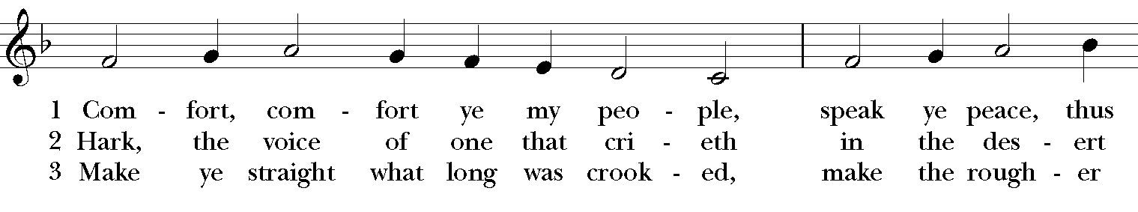
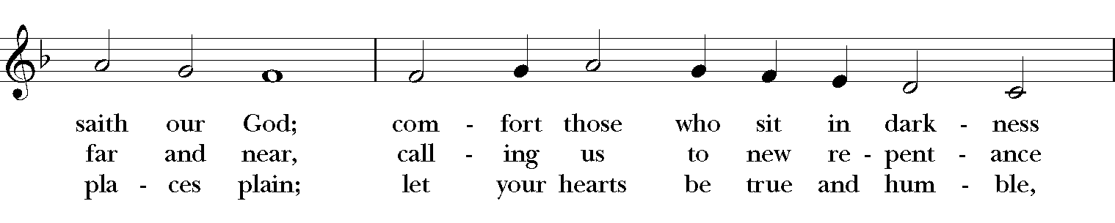
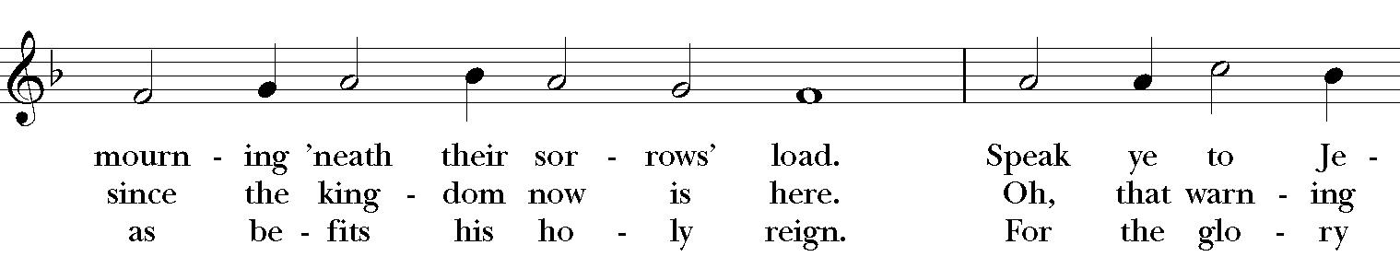
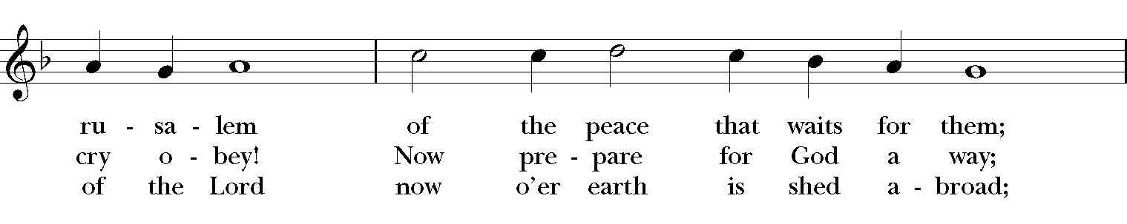
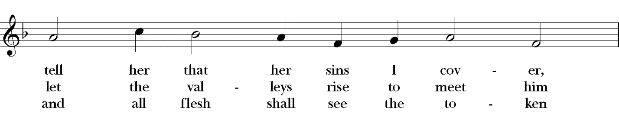
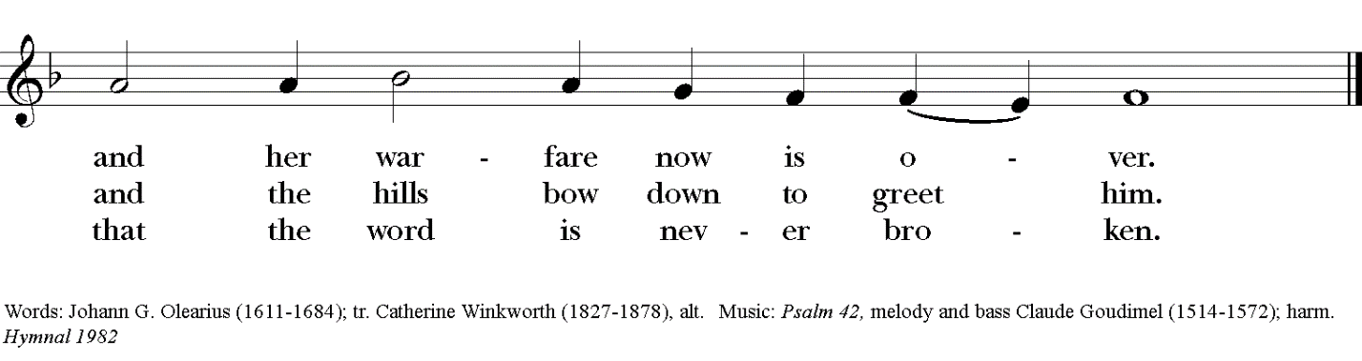

S96 ~ Kyrie eleison (Lord, have mercy)

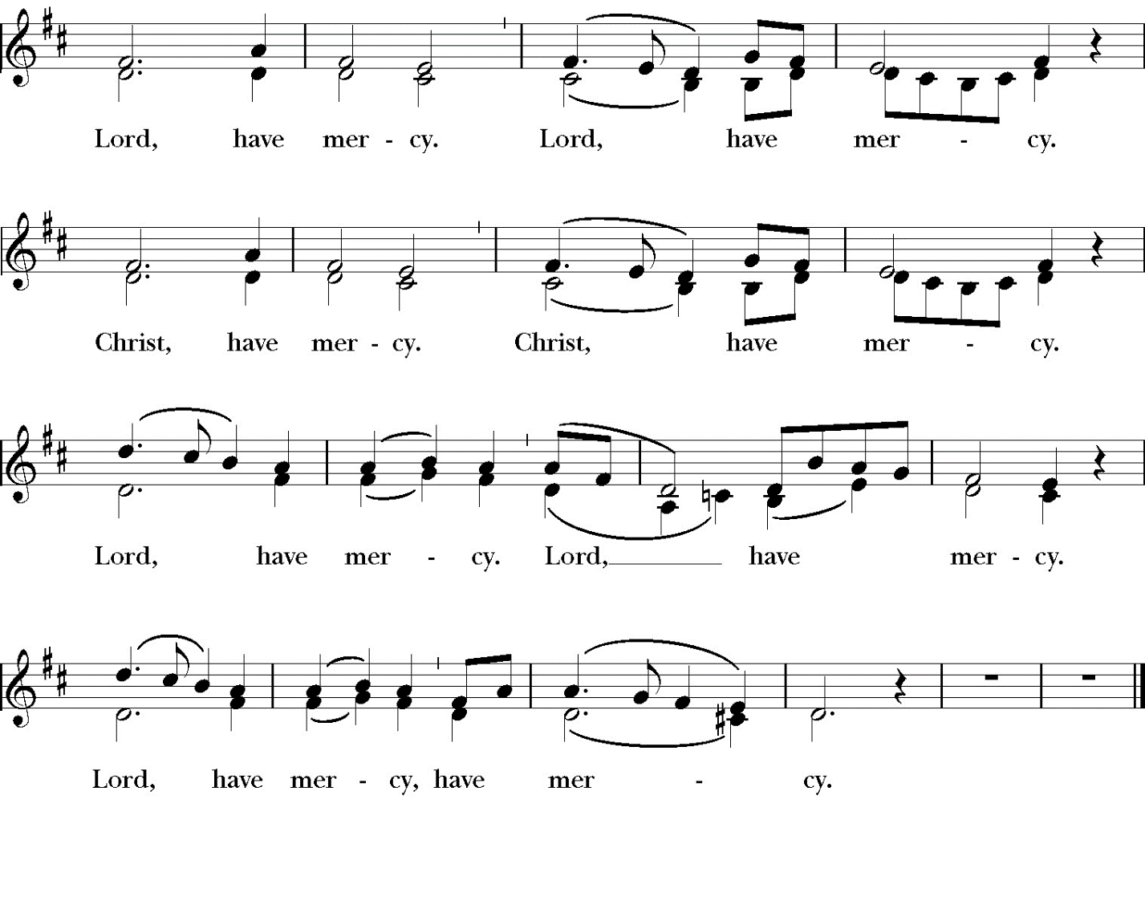

#75

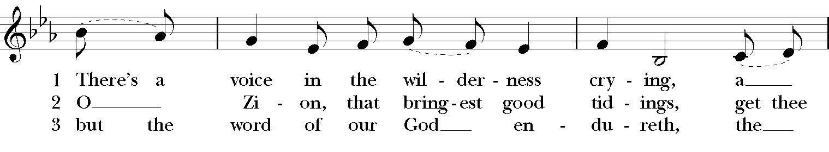
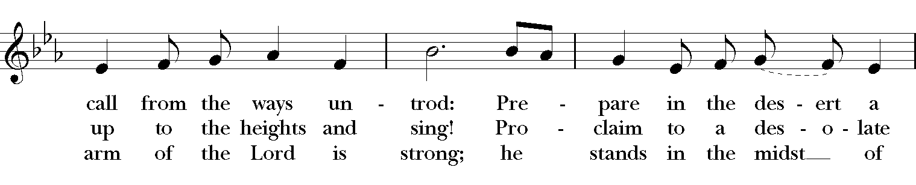
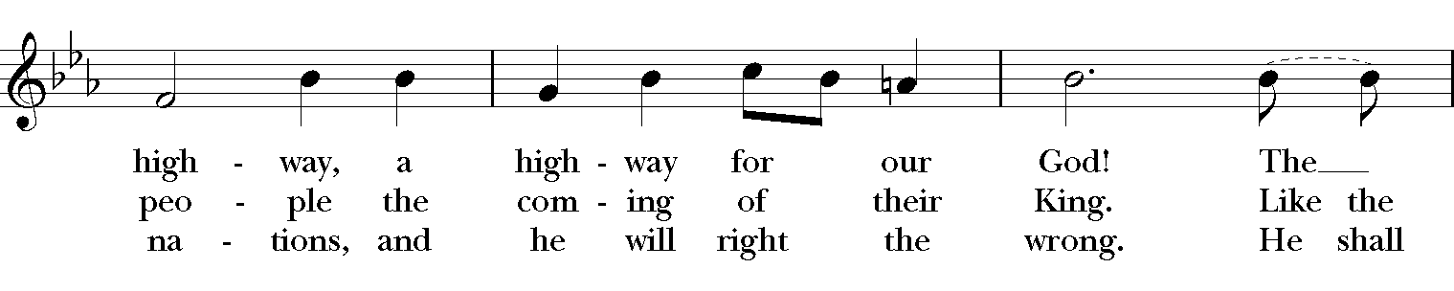
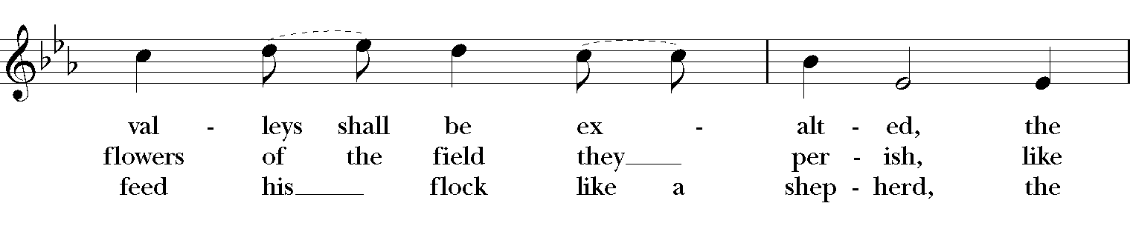
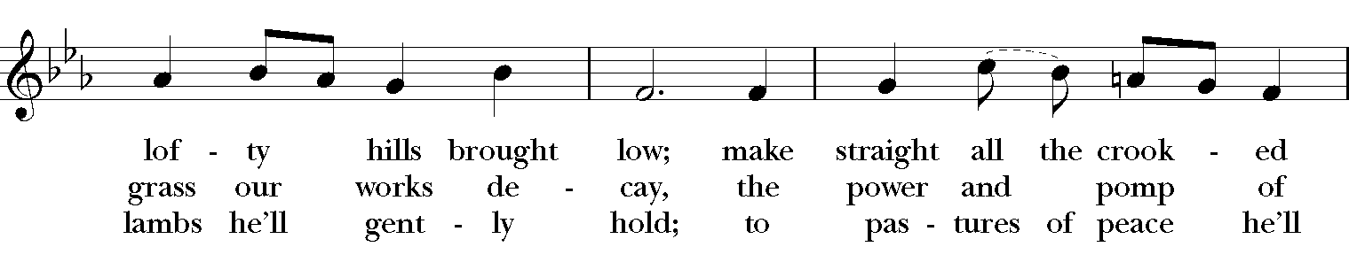
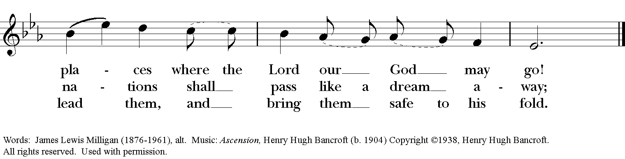

#65

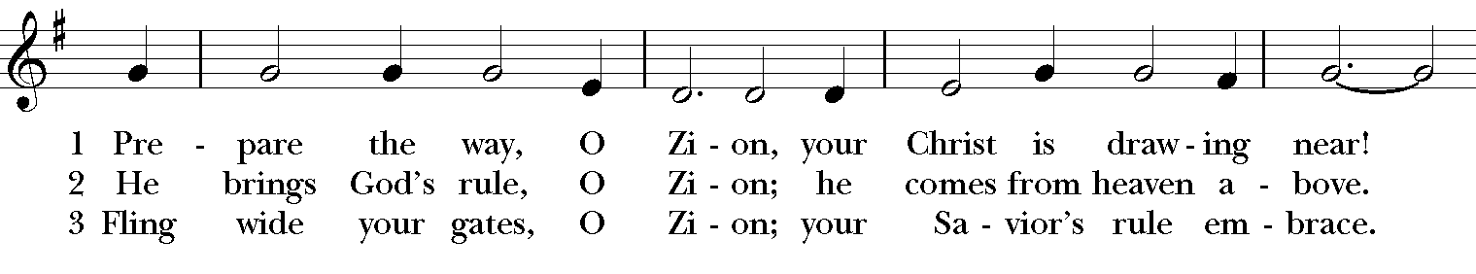
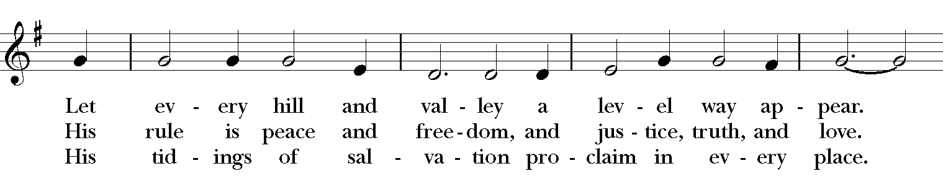
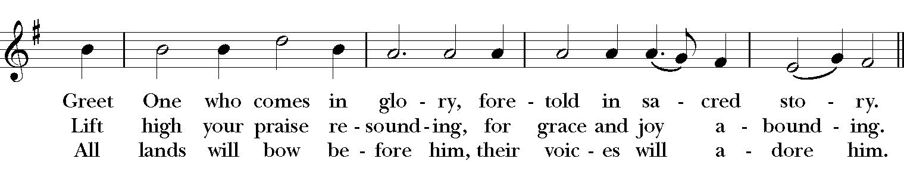
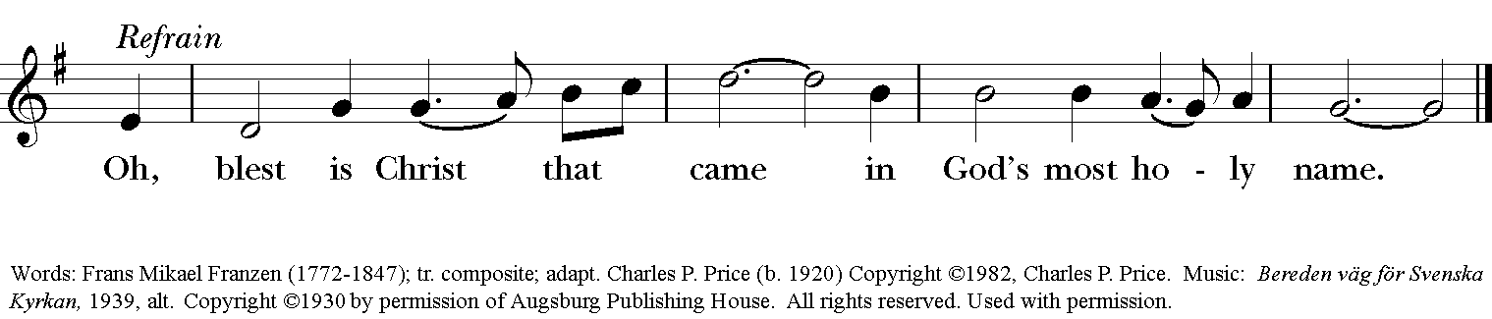

The flowers are given by Teresa Patton
In memory of her husband, Randy Patton

Pianist: Karen Fuss
Lay Reader: Pat Walker
Celebrant: The Rev. Dr. Maurice Geldert
Usher: Cory Butler
Altar Guild: Karen Hendrix
Debbie Smith
Congregation: In-person together with friends viewing through Facebook Livestream

Prayer for a new Rector

Almighty God, giver of every good gift: Look graciously on your Church, and so guide the minds of those who shall choose a rector for this parish, that we may receive a faithful pastor, who will care for your people and equip us for our ministries; through Jesus Christ our Lord. Amen.

Our prayers for our members and their families:
Lynne & Jimmy Hooper, Ward & Taylor Willis, Barbara Whitfield’s mother & father, Jeff Sturm, Janelle McGuire, Andy Morehouse, Pat, Kelli, Jack Giovo, Laura Read, Jerimiah Bryant, Randy, Ronnie Whitaker, Christa Kelley, Stuart Shanor, Carol Anne, Elly Mulkey, Bud Milner & Kimberly Ramsey, Jerry and Marty Childress, Marilyn Manatt, Gary Smith, Michelle, Ann Wonders, Isabel Castillo, Lisa Huff, Molly Pittman, Dwight & Anne Crowder, Julie Deaton, Betty, Victoria S., Aaron & Sarah, Kim C., Richard Morris, Maddy, Abby K & family, Janet M., Martin Kelly, Victoria Cobb, Pat Wiberg, Cory Woodbury, Andrew W., Matthew, Kendall & Pam Kelley, David Smith, Breanna Hickey, Billie Weber, Lynn Waggoner, Rachel, Gabe Martin, Amanda Olivo, Sevie Bates, Florence Carr, Jessica Morris, Alice Smith, Beth Rogers, Jeannine Byron, Melody Green, Marisa, Lew Hightower, Jennie Evans, Clayton Thompson, Bill & Meredith Patton, Annette Mader, John Keeth, Soraya, Manuel, Charmaine & Charles Martin, Julian Linares, Raymond Linares, Jennifer Linares, Jean Hooper, Cheryl Grey, Cassie, Gary & Judy Larson, Sandi Olivo, Nick Brisco

Our prayers for friends of St. Andrew’s:
Gretta Dickman, Susan H., Canon Lee Curtis, Bill Murphy, Jo Pendergrass, Nancy W., Andres Adauto, Coy Dickson, Steve Hazelbaker, Johnny Pena, Rebecca Ellis, Victor & Laquita Pierce, Robert, Mark, Jenice Furguson, Rev. Susanna Metz, Del Journey, Courtney, Heidi Huckabee, Janie Mendoza, Bill Anderson, Elena & family, Elena & Blanca’s mother, Joan Accardi, Robert, Aurora, Patty & George Swenson, Tristen, Belma & Alan Cloud, Josie Powell, Clifford Sipple family, Julie & Donna Franco, Dayna, Karen Anderson, Dee & Eddie, Andrea, Mitchel Rosen, Cox Family, Melissa J. & family, Fr. Hector Trejo, (Juarez), Shawna & family, Stephanie K., Sarah, Veronica, Michelle Siebel, Kalistro Linares, Michele Hillman, Sarah Wooldridge, Jerry & M.J., Rex Kartchner, Alison, Emily, Janet Carter, Meredith Miller, Maryanne D’Arcangelis, Christopher, Josie & Lloyd, Fern Simpson, Lara, Dyan, Nancy Klima, M. Lopez, Ed Tinsley, Wilson, Susan, Keith Maston, Kevin Maston, Carli Salyards, Tammy Reed, Frank Roberts and family, Elizabeth Klijnsmit, Jaime Alvarez, Ron & Twylla M, Rosemary Henry, Mathew & family, Effie Silva, Baldo & Rena, Marty G., Tom & Marilyn

