0
St. Andrew’s Episcopal Church

The Twentieth Sunday after Pentecost
Proper 23
October 10, 2021 9:00 AM
Rite II

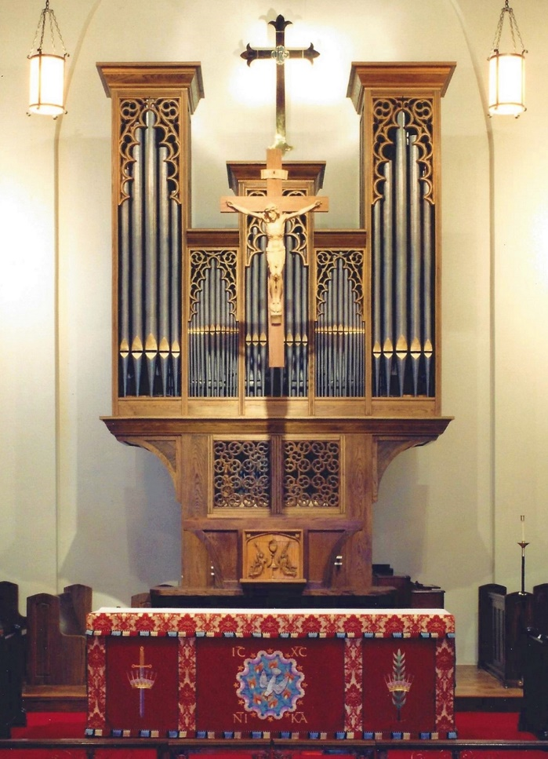

Lord God, you alone are the source of every good gift. Fill our hearts with faithfulness that when we are called to serve, we may answer, “here I am Lord,” with a spirit of discipleship. We pledge ourselves to be good and faithful stewards of the gifts you have entrusted to us, to share our time, talent and our material gifts as an outward sign of the treasure we hold in Jesus. Amen

505 N. Pennsylvania Ave.
Roswell, NM 88201
575-622-1353
standrewschurch@cableone.net
www.standrewsroswell.com

Prelude: O Jesus, I Have Promised – Meiningens, 1693 arr Cindy Berry

Hymns are printed in the back of the bulletin, beginning on page 18.

Processional Hymn #460 stanzas 1,2,4 – Alleluia! sing to Jesus!

The people standing, the Celebrant says

Blessed be God: Father, Son, and Holy Spirit
People And blessed be his kingdom, now and for ever. Amen

The Celebrant may say

Almighty God, to you all hearts are open, all desires known,
and from you no secrets are hid: Cleanse the thoughts of our
hearts by the inspiration of your Holy Spirit, that we may
perfectly love you, and worthily magnify your holy Name;
through Christ our Lord. Amen.

When appointed, the following hymn or some other song of praise is sung
or said, all standing

Gloria in excelsis ~ Hymnal S-280

Glory to God in the highest,
and peace to his people on earth.

Lord God, heavenly King,
almighty God and Father,
we worship you, we give you thanks,
we praise you for your glory.

Lord Jesus Christ, only Son of the Father,
Lord God, Lamb of God,
you take away the sin of the world:
have mercy on us;

you are seated at the right hand of the Father:
receive our prayer.

For you alone are the Holy One,
you alone are the Lord,
you alone are the Most High,
Jesus Christ,
with the Holy Spirit,
in the glory of God the Father. Amen.

The Collect of the Day

The Celebrant says to the people

The Lord be with you.
People And also with you.
Celebrant Let us pray.

The Celebrant says the Collect.
Lord, we pray that your grace may always precede and follow us, that we may continually be given to good works; through Jesus Christ our Lord, who lives and reigns with you and the Holy Spirit, one God, now and for ever. Amen.

The Lessons

The people sit.

Job 23:1-9, 16-17
Job said:
"Today also my complaint is bitter;
his hand is heavy despite my groaning.
Oh, that I knew where I might find him,
that I might come even to his dwelling!
I would lay my case before him,
and fill my mouth with arguments.
I would learn what he would answer me,
and understand what he would say to me.
Would he contend with me in the greatness of his power?
No; but he would give heed to me.
There an upright person could reason with him,
and I should be acquitted forever by my judge.
"If I go forward, he is not there;
or backward, I cannot perceive him;
on the left he hides, and I cannot behold him;
I turn to the right, but I cannot see him.
God has made my heart faint;
the Almighty has terrified me;
If only I could vanish in darkness,
and thick darkness would cover my face!"

The Word of the Lord.
People Thanks be to God.

Silence may follow.

Psalm 22:1-15
Deus, Deus meus
1 My God, my God, why have you forsaken me? *
and are so far from my cry
and from the words of my distress?
2 O my God, I cry in the daytime, but you do not answer; *
by night as well, but I find no rest.
3 Yet you are the Holy One, *
enthroned upon the praises of Israel.
4 Our forefathers put their trust in you; *
they trusted, and you delivered them.
5 They cried out to you and were delivered; *
they trusted in you and were not put to shame.
6 But as for me, I am a worm and no man, *
scorned by all and despised by the people.
7 All who see me laugh me to scorn; *
they curl their lips and wag their heads, saying,
8 "He trusted in the Lord; let him deliver him; *
let him rescue him, if he delights in him."
9 Yet you are he who took me out of the womb, *
and kept me safe upon my mother's breast.
10 I have been entrusted to you ever since I was born; *
you were my God when I was still in my mother's womb.
11 Be not far from me, for trouble is near, *
and there is none to help.
12 Many young bulls encircle me; *
strong bulls of Bashan surround me.
13 They open wide their jaws at me, *
like a ravening and a roaring lion.

14 I am poured out like water;
all my bones are out of joint; *
my heart within my breast is melting wax.
15 My mouth is dried out like a pot-sherd;
my tongue sticks to the roof of my mouth; *
and you have laid me in the dust of the grave.

The Epistle

Hebrews 4:12-16
The word of God is living and active, sharper than any two-edged sword, piercing until it divides soul from spirit, joints from marrow; it is able to judge the thoughts and intentions of the heart. And before him no creature is hidden, but all are naked and laid bare to the eyes of the one to whom we must render an account.
Since, then, we have a great high priest who has passed through the heavens, Jesus, the Son of God, let us hold fast to our confession. For we do not have a high priest who is unable to sympathize with our weaknesses, but we have one who in every respect has been tested as we are, yet without sin. Let us therefore approach the throne of grace with boldness, so that we may receive mercy and find grace to help in time of need.

The Word of the Lord.
People Thanks be to God.

Sequence Hymn #488 – Be thou my vision

Then, all standing, the Deacon or a Priest reads the Gospel, first saying

The Holy Gospel of our Lord Jesus Christ according to Mark
People Glory to you, Lord Christ.

The Gospel

Mark 10:17-31
As Jesus was setting out on a journey, a man ran up and knelt before him, and asked him, “Good Teacher, what must I do to inherit eternal life?” Jesus said to him, “Why do you call me good? No one is good but God alone. You know the commandments: ‘You shall not murder; You shall not commit adultery; You shall not steal; You shall not bear false witness; You shall not defraud; Honor your father and mother.’” He said to him, “Teacher, I have kept all these since my youth.” Jesus, looking at him, loved him and said, “You lack one thing; go, sell what you own, and give the money to the poor, and you will have treasure in heaven; then come, follow me.” When he heard this, he was shocked and went away grieving, for he had many possessions.
Then Jesus looked around and said to his disciples, “How hard it will be for those who have wealth to enter the kingdom of God!” And the disciples were perplexed at these words. But Jesus said to them again, “Children, how hard it is to enter the kingdom of God! It is easier for a camel to go through the eye of a needle than for someone who is rich to enter the kingdom of God.” They were greatly astounded and said to one another, “Then who can be saved?” Jesus looked at them and said, “For mortals it is impossible, but not for God; for God all things are possible.”
Peter began to say to him, “Look, we have left everything and followed you.” Jesus said, “Truly I tell you, there is no one who has left house or brothers or sisters or mother or father or children or fields, for my sake and for the sake of the good news, who will not receive a hundredfold now in this age—houses, brothers and sisters, mothers and children, and fields with persecutions—and in the age to come eternal life. But many who are first will be last, and the last will be first.”

The Gospel of the Lord.
People Praise to you, Lord Christ.

The Sermon

The Nicene Creed

We believe in one God,
the Father, the Almighty,
maker of heaven and earth,
of all that is, seen and unseen.

We believe in one Lord, Jesus Christ,
the only Son of God,
eternally begotten of the Father,
God from God, Light from Light,
true God from true God,
begotten, not made,
of one Being with the Father.
Through him all things were made.
For us and for our salvation
he came down from heaven:
by the power of the Holy Spirit
he became incarnate from the Virgin Mary,
and was made man.
For our sake he was crucified under Pontius Pilate;
he suffered death and was buried.
On the third day he rose again
in accordance with the Scriptures;
he ascended into heaven
and is seated at the right hand of the Father.
He will come again in glory to judge the living and the dead,
and his kingdom will have no end.

We believe in the Holy Spirit, the Lord, the giver of life,
who proceeds from the Father and the Son.
With the Father and the Son he is worshiped and glorified.
He has spoken through the Prophets.
We believe in one holy catholic and apostolic Church.
We acknowledge one baptism for the forgiveness of sins.
We look for the resurrection of the dead,
and the life of the world to come. Amen.

The Prayers of the People

Form III

The Leader and People pray responsively

Father, we pray for your holy Catholic Church;
That we all may be one.

Grant that every member of the Church may truly and
humbly serve you;
That your Name may be glorified by all people.

We pray for all bishops, priests, and deacons;
That they may be faithful ministers of your Word and
Sacraments.

We pray for all who govern and hold authority in the nations
of the world;
That there may be justice and peace on the earth.

Give us grace to do your will in all that we undertake;
That our works may find favor in your sight.

Have compassion on those who suffer from any grief or trouble;
That they may be delivered from their distress.

Give to the departed eternal rest;
Let light perpetual shine upon them.

We praise you for your saints who have entered into joy;
May we also come to share in your heavenly kingdom.

Let us pray for our own needs and those of others.

Silence

The People may add their own petitions.

The Celebrant adds a concluding Collect.

Confession of Sin

A Confession of Sin is said here if it has not been said earlier. On
occasion, the Confession may be omitted.

The Deacon or Celebrant says

Let us confess our sins against God and our neighbor.

Silence may be kept.

Minister and People

Most merciful God,
we confess that we have sinned against you
in thought, word, and deed,
by what we have done,
and by what we have left undone.
We have not loved you with our whole heart;
we have not loved our neighbors as ourselves.
We are truly sorry and we humbly repent.
For the sake of your Son Jesus Christ,
have mercy on us and forgive us;
that we may delight in your will,
and walk in your ways,
to the glory of your Name. Amen.

The Bishop when present, or the Priest, stands and says

Almighty God have mercy on you, forgive you all your sins
through our Lord Jesus Christ, strengthen you in all
goodness, and by the power of the Holy Spirit keep you in
eternal life. Amen.

The Peace

All stand. The Celebrant says to the people

The peace of the Lord be always with you.
People And also with you.

During the Peace, please observe safe practices.

Announcements

The Holy Communion

Offertory Sentence

Walk in love, as Christ loved us and gave himself for us, an
offering and sacrifice to God. Ephesians 5:2

Offertory Music: Awake My Heart – Jane M. Marshall

The Great Thanksgiving

Eucharistic Prayer A

The people remain standing. The Celebrant, whether bishop or priest,
faces them and sings or says

The Lord be with you.
People And also with you.
Celebrant Lift up your hearts.
People We lift them to the Lord.
Celebrant Let us give thanks to the Lord our God.
People It is right to give him thanks and praise.

Then, facing the Holy Table, the Celebrant proceeds

It is right, and a good and joyful thing, always and everywhere to give thanks to you, Father Almighty, Creator of heaven and earth, through Jesus Christ our Lord; who on the first day of the week overcame death and the grave, and by his glorious resurrection opened to us the way of everlasting life.

Here a Proper Preface is sung or said on all Sundays, and on other
occasions as appointed.

Therefore we praise you, joining our voices with Angels and
Archangels and with all the company of heaven, who for ever
sing this hymn to proclaim the glory of your Name:

Celebrant and People

Holy, holy, holy Lord, God of power and might,
heaven and earth are full of your glory.
Hosanna in the highest.
Blessed is he who comes in the name of the Lord.
Hosanna in the highest.

The people stand or kneel.

Then the Celebrant continues

Holy and gracious Father: In your infinite love you made us
for yourself; and, when we had fallen into sin and become
subject to evil and death, you, in your mercy, sent Jesus
Christ, your only and eternal Son, to share our human
nature, to live and die as one of us, to reconcile us to you, the
God and Father of all.

He stretched out his arms upon the cross, and offered himself,
in obedience to your will, a perfect sacrifice for the whole
world.

On the night he was handed over to suffering and death, our
Lord Jesus Christ took bread; and when he had given thanks
to you, he broke it, and gave it to his disciples, and said, “Take,
eat: This is my Body, which is given for you. Do this for the
remembrance of me.”

After supper he took the cup of wine; and when he had given
thanks, he gave it to them, and said, “Drink this, all of you:
This is my Blood of the new Covenant, which is shed for you
and for many for the forgiveness of sins. Whenever you drink
it, do this for the remembrance of me.”

Therefore we proclaim the mystery of faith:

Celebrant and People

Christ has died.
Christ is risen.
Christ will come again.

The Celebrant continues

We celebrate the memorial of our redemption, O Father, in
this sacrifice of praise and thanksgiving. Recalling his death,
resurrection, and ascension, we offer you these gifts.

Sanctify them by your Holy Spirit to be for your people the
Body and Blood of your Son, the holy food and drink of new
and unending life in him. Sanctify us also that we may faithfully
receive this holy Sacrament, and serve you in unity, constancy,
and peace; and at the last day bring us with all your saints
into the joy of your eternal kingdom.

All this we ask through your Son Jesus Christ. By him, and
with him, and in him, in the unity of the Holy Spirit all honor
and glory is yours, Almighty Father, now and for ever. AMEN.

And now, as our Savior
Christ has taught us,
we are bold to say,

People and Celebrant

Our Father, who art in heaven,
hallowed be thy Name,
thy kingdom come,
thy will be done,
on earth as it is in heaven.
Give us this day our daily bread.
And forgive us our trespasses,
as we forgive those
who trespass against us.
And lead us not into temptation,
but deliver us from evil.
For thine is the kingdom,
and the power, and the glory,
for ever and ever. Amen.

The Breaking of the Bread

The Celebrant breaks the consecrated Bread.

A period of silence is kept.

Then may be sung or said

[Alleluia.] Christ our Passover is sacrificed for us;
Therefore let us keep the feast. [Alleluia.]

In Lent, Alleluia is omitted, and may be omitted at other times except
during Easter Season.

Facing the people, the Celebrant says the following Invitation

The Gifts of God for the People of God.

and may add Take them in remembrance that Christ died for
you, and feed on him in your hearts by faith,
with thanksgiving.

The ministers receive the Sacrament in both kinds, and then immediately deliver it to the people.

The Bread and the Cup are given to the communicants with these words

The Body of our Lord Jesus Christ keep you in everlasting life. [Amen.]

or with these words

The Body of Christ, the bread of heaven. [Amen.]

During the ministration of Communion, hymns, psalms, or anthems may be sung.

Prayer for Online Worshipers

The Celebrant may lead online worshipers in the prayer for Spiritual Communion.

Celebrant and People

God of grace, we present to you our souls and bodies with the earnest wish that we may always be united to you and each other. Since we may not always be together to receive you sacramentally, unite us spiritually that our hearts may embrace you with all the affections of our souls. Let nothing ever separate us from you, through the communion of saints, in all times and places. Amen.

After Communion, the Celebrant says

Let us pray.

Celebrant and People

Eternal God, heavenly Father,
you have graciously accepted us as living members
of your Son our Savior Jesus Christ,

and you have fed us with spiritual food
in the Sacrament of his Body and Blood.
Send us now into the world in peace,
and grant us strength and courage
to love and serve you
with gladness and singleness of heart;
through Christ our Lord. Amen.

The Bishop when present, or the Priest, may bless the people.

Blessing

Recessional Hymn #680 stanzas 1,2,3,6 – O God, our help in ages past

Dismissal

The Deacon, or the Celebrant, dismisses them with these words

Let us go forth in the name of Christ.
People Thanks be to God.

Postlude: Guide Me, O Thou Great Jehovah – John Hughes arr Phillip Keveren

The flowers are given by Janet Perri
In memory of Levi Stevens

Pianist: Karen Fuss
Lay Reader: John Fuss
Celebrant: The Rev. Dr. Maurice Geldert
Usher: Rich Altans
Altar Guild: P.J. Greer
Karen Hendrix
Debbie Smith
Congregation: In-person together with friends viewing through Facebook Livestream

#460 – stanzas 1,2,4

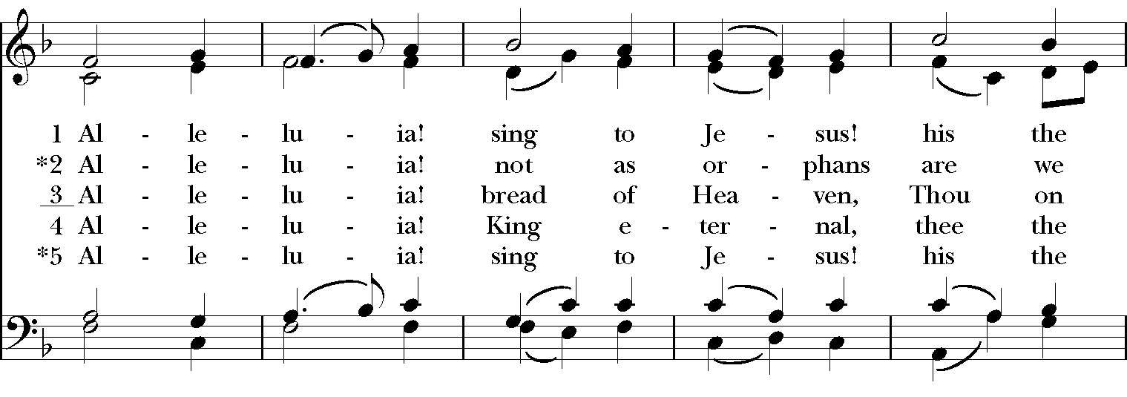
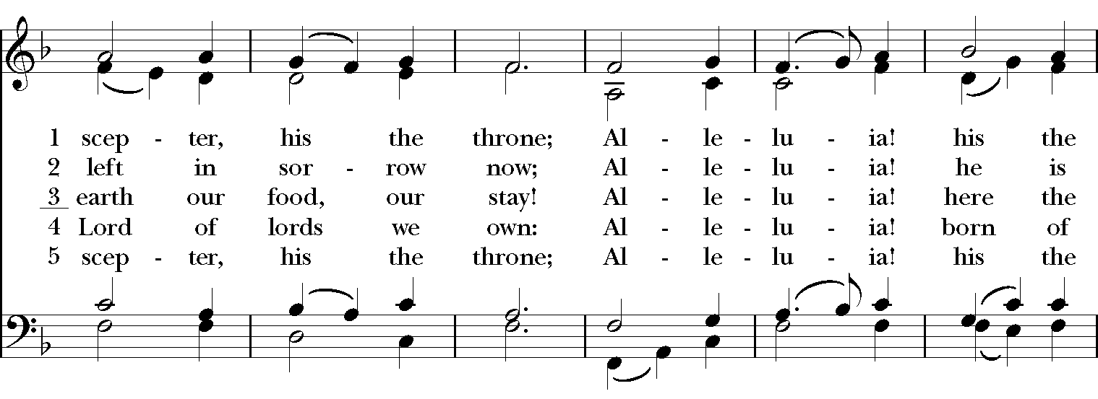
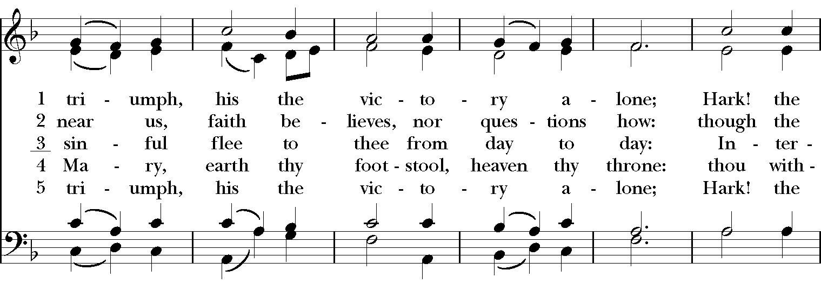

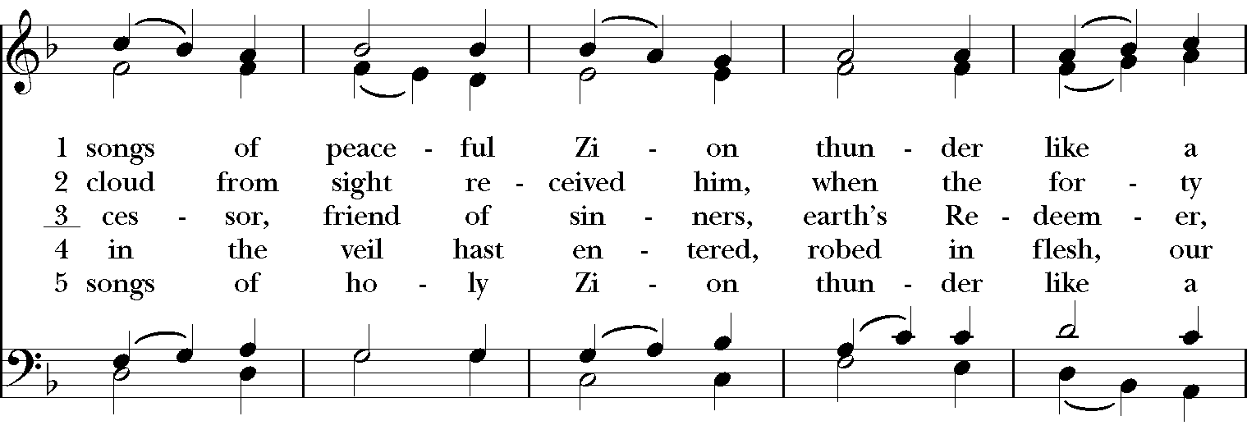
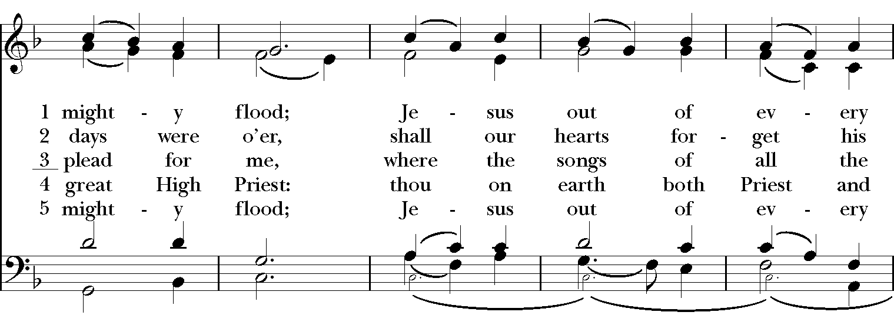
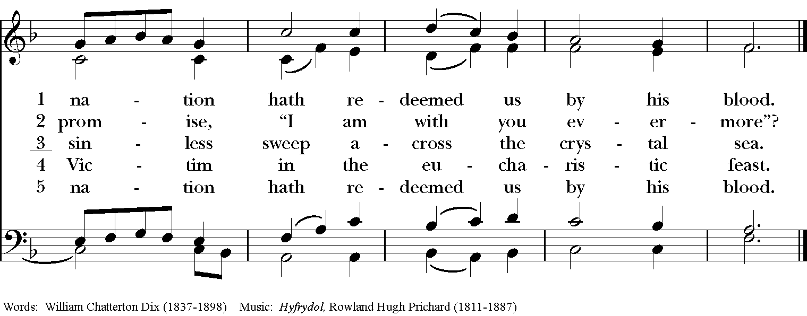

#488

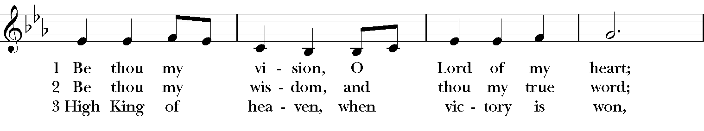
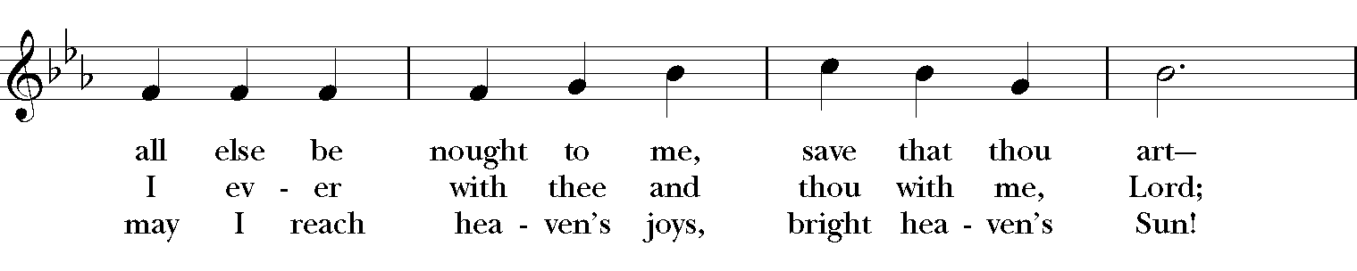
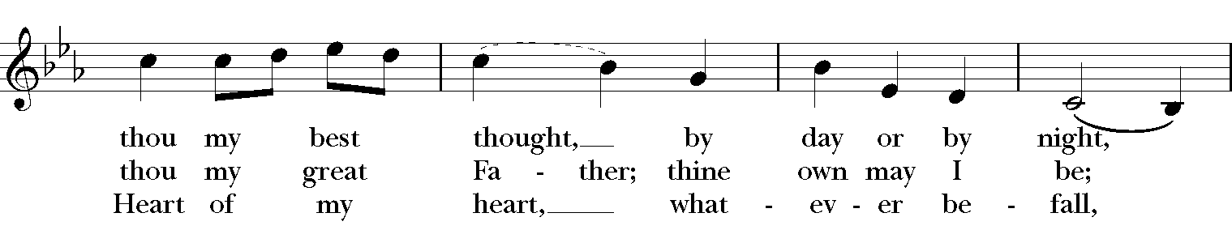
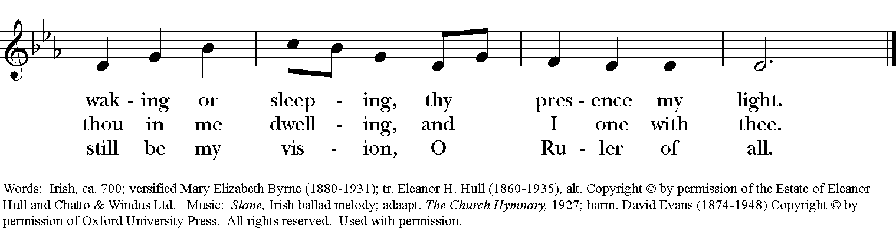

#680 – stanzas 1,2,3,6

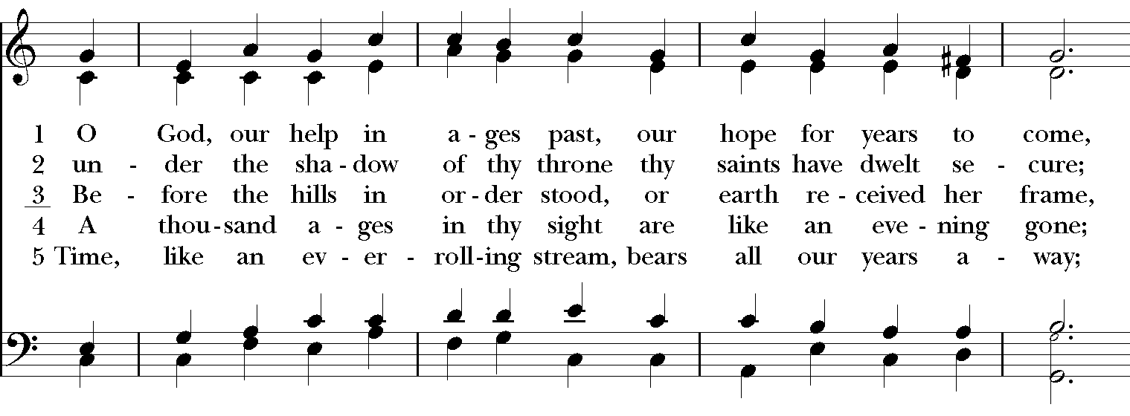
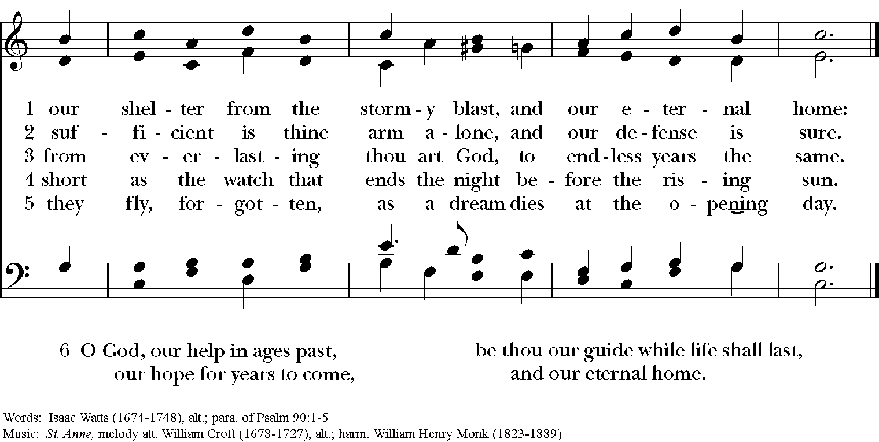

Prayer for a new Rector

Almighty God, giver of every good gift: Look graciously on your Church, and so guide the minds of those who shall choose a rector for this parish, that we may receive a faithful pastor, who will care for your people and equip us for our ministries; through Jesus Christ our Lord. Amen.

Our prayers for our members and their families:

Andy Morehouse, Pat, Kelli, Jack Giovo, Laura Read, Jerimiah Bryant, Randy, Kay Stovell, Brennan, Duane & Sue, Ronnie Whitaker, Christa Kelley, Stuart Shanor, Carol Anne, Elly Mulkey, Bud Milner and Kimberly Ramsey, Jerry and Marty Childress, Marilyn Manatt and Janie Blue, Gary Smith, Michelle, Ann Wonders, Isabel Castillo, Lisa Huff, Molly Pittman, Dwight and Anne Crowder, Julie Deaton, Betty, Victoria S., Andrew P., Aaron & Sarah, Kim C., Lynne and Jimmy Hooper, Richard Morris, Maddy, Abby K & family, Janet M., Martin Kelly, Victoria Cobb, Pat Wiberg, Cory Woodbury, Andrew W., Matthew, Kendall & Pam Kelley, David Smith, Breanna Hickey, Billie Weber, Lynn Waggoner, Rachel, Gabe Martin, Amanda Olivo, Sevie Bates, Florence Carr, Jessica Morris, Alice Smith, Beth Rogers, Jeannine Byron, Melody Green, Marisa, Lew Hightower, Jennie Evans, Clayton Thompson, Bill & Meredith Patton, Annette Mader, John Keeth, Soraya, Manuel, Charmaine and Charles Martin, Julian Linares, Raymond Linares, Jennifer Linares, Jean Hooper, Cheryl Grey, Cassie, Gary and Judy Larson, Sandi Olivo

Our prayers for friends of St. Andrew’s:

Gretta Dickman, Susan H., Canon Lee Curtis, Bill Murphy, Jo Pendergrass, Nancy W., Andres Adauto, Coy Dickson, Steve Hazelbaker, Johnny Pena, Rebecca Ellis, Victor & Laquita Pierce, Robert, Mark, Jenice Furguson, The Rev. Susanna Metz, Del Journey, Courtney, Heidi Huckabee, Janie Mendoza, Bill Anderson, Elena and family, Elena & Blanca’s mother and family, Joan Accardi, Robert, Aurora, Patty & George Swenson, Tristen, Belma & Alan Cloud, Josie Powell, Clifford Sipple Family, Julie and Donna Franco, Dayna, Karen Anderson, Dee & Eddie, Andrea, Mitchel Rosen, the Cox Family, Melissa J. & family, Fr. Hector Trejo, (Vicar of Juarez), Shawna and family, Stephanie K., Sarah, Veronica, Michelle Siebel, Kalistro Linares, Michele Hillman, Sarah Wooldridge, Jerry & M.J., Rex Kartchner, Alison, Emily, Janet Carter, Meredith Miller, Maryanne D’Arcangelis, Christopher, Josie & Lloyd, Fern Simpson, Lara, Dyan, Nancy Klima, M. Lopez, Ed Tinsley, Wilson, Susan, Keith Maston, Kevin Maston, Carli Salyards, Tammy Reed, Frank Roberts and family, Elizabeth Klijnsmit, Jaime Alvarez, Ron & Twylla M, Rosemary Henry, Mathew and family, Effie Silva, Baldo & Rena, Marty G., Tom & Marilyn

UTO
What is UTO?

The United Thank Offering (UTO) is a ministry of The Episcopal Church
for the mission of the whole church. Through UTO, individuals are invited to
embrace and deepen a personal daily spiritual discipline of gratitude. UTO
encourages people to notice the good things that happen each day, give
thanks to God for those blessings and make an offering for each blessing
using a UTO Blue Box. UTO is entrusted to receive the offerings, and to
distribute the 100% of what is collected to support innovative mission and
ministry throughout The Episcopal Church and Provinces of the Anglican
Communion.

By Heather L. Melton, staff officer for the United Thank Offering

We often say in UTO to give thanks for when a good thing happens in your life; notice the presence of the Holy Spirit in the moment and make a thank offering. This advice is asking us to pause and pay attention, because as humans we often get so bogged down in all the negative and painful things we can miss the good things. So, if you’ve mastered this step of noticing the good things, I want to invite you to join me in trying something new: giving thanks for how things happen to get us to the point of the good thing.
Please make your check payable to St. Andrew’s and note
in the memo line for UTO.

These funds will be presented at the 69th Convention –
Episcopal Diocese of the Rio Grande
on October 28^{th -} 30th 2021.

