…………………………………………0

St. Andrew’s Episcopal Church

**2nd Sunday after the Epiphany**

**January 16, 2022 10:00 AM**

**Rite II**



*Lord God, you alone are the source of every good gift. Fill our hearts with faithfulness that when we are called to serve, we may answer, “here I am Lord,” with a spirit of discipleship. We pledge ourselves to be good and faithful stewards of the gifts you have entrusted to us, to share our time, talent and our material gifts as an outward sign of the treasure we hold in Jesus.* Amen

505 N. Pennsylvania Ave.

Roswell, NM 88201

575-622-1353

[church@standrewsroswell.com](mailto:church@standrewsroswell.com)

www.standrewsroswell.com

**Prelude: *Christ, Whose Glory Fills the Skies* – Johann Werner**

**arr Cindy Berry**

*Hymns are printed at the back of the bulletin, beginning on page 14.*

**Processional Hymn #7 – *Christ, whose glory fills the skies***

*The people standing, the Celebrant says*

Blessed be God: Father, Son, and Holy Spirit.

*People* And blessed be his kingdom, now and for ever. Amen.

*The Celebrant may say*

Almighty God, to you all hearts are open, all desires known, and from you no secrets are hid: Cleanse the thoughts of our hearts by the inspiration of your Holy Spirit, that we may perfectly love you, and worthily magnify your holy Name; through Christ our Lord. *Amen.*

**Hymn S280 – *Gloria in excelsis (Glory to God)***

**The Collect of the Day**

*The Celebrant says to the people*

The Lord be with you.

*People* And also with you.

*Celebrant* Let us pray.

*The Celebrant says the Collect.*

Almighty God, whose Son our Savior Jesus Christ is the light of the world: Grant that your people, illumined by your Word and Sacraments, may shine with the radiance of Christ's glory, that he may be known, worshipped, and obeyed to the ends of the earth; through Jesus Christ our Lord, who with you and the Holy Spirit lives and reigns, one God, now and for ever.  *Amen*.

**The Lessons**

*The people sit.*

### Isaiah 62:1-5

For Zion's sake I will not keep silent, and for Jerusalem's sake I will not rest,

until her vindication shines out like the dawn,  
and her salvation like a burning torch.

The nations shall see your vindication, and all the kings your glory;

and you shall be called by a new name that the mouth of the Lord will give.

You shall be a crown of beauty in the hand of the Lord,  
and a royal diadem in the hand of your God.

You shall no more be termed Forsaken,   
and your land shall no more be termed Desolate;

but you shall be called My Delight Is in Her, and your land Married;

for the Lord delights in you, and your land shall be married.

For as a young man marries a young woman,   
so shall your builder marry you,

and as the bridegroom rejoices over the bride,   
so shall your God rejoice over you.

The Word of the Lord.

*People* Thanks be to God.

### Psalm 36:5-10

*Dixit injustus*

5 Your love, O Lord, reaches to the heavens, *  
and your faithfulness to the clouds.

6 Your righteousness is like the strong mountains,  
your justice like the great deep; *  
you save both man and beast, O Lord.

7 How priceless is your love, O God! *  
your people take refuge under the shadow of your wings.

8 They feast upon the abundance of your house; *  
you give them drink from the river of your delights.

9 For with you is the well of life, *  
and in your light we see light.

10 Continue your loving-kindness to those who know you, *  
and your favor to those who are true of heart.

**The Epistle**

### 1 Corinthians 12:1-11

Now concerning spiritual gifts, brothers and sisters, I do not want you to be uninformed. You know that when you were pagans, you were enticed and led astray to idols that could not speak. Therefore I want you to understand that no one speaking by the Spirit of God ever says "Let Jesus be cursed!" and no one can say "Jesus is Lord" except by the Holy Spirit.

Now there are varieties of gifts, but the same Spirit; and there are varieties of services, but the same Lord; and there are varieties of activities, but it is the same God who activates all of them in everyone.

To each is given the manifestation of the Spirit for the common good. To one is given through the Spirit the utterance of wisdom, and to another the utterance of knowledge according to the same Spirit, to another faith by the same Spirit, to another gifts of healing by the one Spirit, to another the working of miracles, to another prophecy, to another the discernment of spirits, to another various kinds of tongues, to another the interpretation of tongues. All these are activated by one and the same Spirit, who allots to

each one individually just as the Spirit chooses.

The Word of the Lord.

*People* Thanks be to God.

**Sequence Hymn #138 – *All praise to you, O Lord***

*Then, all standing, the Deacon or a Priest reads the Gospel, first saying*

The Holy Gospel of our Lord Jesus Christ according to John

*People* Glory to you, Lord Christ.

**The Gospel**

### John 2:1-11

On the third day there was a wedding in Cana of Galilee, and the mother of Jesus was there. Jesus and his disciples had also been invited to the wedding. When the wine gave out, the mother of Jesus said to him, "They have no wine." And Jesus said to her, "Woman, what concern is that to you and to me? My hour has not yet come." His mother said to the servants, "Do whatever he tells you." Now standing there were six stone water jars for the Jewish rites of purification, each holding twenty or thirty gallons. Jesus said to them, "Fill the jars with water." And they filled them up to the brim. He said to them, "Now draw some out, and take it to the chief steward." So they took it. When the steward tasted the water that had become wine, and did not know where it came from (though the servants who had drawn the water knew), the steward called the bridegroom and said to him, "Everyone serves the good wine first, and then the inferior wine after the guests have become drunk. But you have kept the good wine until now." Jesus did this, the first of his signs, in Cana of Galilee, and revealed his glory; and his disciples believed in him.

The Gospel of the Lord.

*People* Praise to you, Lord Christ.

**The Sermon**

**The Nicene Creed**

We believe in one God, the Father, the Almighty,

maker of heaven and earth, of all that is, seen and unseen.

We believe in one Lord, Jesus Christ, the only Son of God,

eternally begotten of the Father,

God from God, Light from Light, true God from true God,

begotten, not made, of one Being with the Father.

Through him all things were made.

For us and for our salvation he came down from heaven:

by the power of the Holy Spirit

he became incarnate from the Virgin Mary, and was made man.

For our sake he was crucified under Pontius Pilate;

he suffered death and was buried.

On the third day he rose again in accordance with the Scriptures;

he ascended into heaven and is seated at the right hand of the Father.

He will come again in glory to judge the living and the dead,

and his kingdom will have no end.

We believe in the Holy Spirit, the Lord, the giver of life,

who proceeds from the Father and the Son.

With the Father and the Son he is worshiped and glorified.

He has spoken through the Prophets.

We believe in one holy catholic and apostolic Church.

We acknowledge one baptism for the forgiveness of sins.

We look for the resurrection of the dead,

and the life of the world to come. Amen.

**The Prayers of the People – Form IV**

*Deacon or other leader*

Let us pray for the Church and for the world.

Grant, Almighty God, that all who confess your Name may be united in your truth, live together in your love, and reveal your glory in the world.

*Silence*

Lord, in your mercy

*Hear our prayer*.

Guide the people of this land, and of all the nations, in the ways of justice and peace; that we may honor one another and serve the common good.

*Silence*

Lord, in your mercy

*Hear our prayer*.

Give us all a reverence for the earth as your own creation, that we may use its resources rightly in the service of others and to your honor and glory.

*Silence*

Lord, in your mercy

*Hear our prayer.*

Bless all whose lives are closely linked with ours, and grant that we may serve Christ in them, and love one another as he loves us.

*Silence*

Lord, in your mercy

*Hear our prayer.*

Comfort and heal all those who suffer in body, mind, or spirit; give them courage and hope in their troubles, and bring them the joy of your salvation.

*Silence*

Lord, in your mercy

*Hear our prayer*.

We commend to your mercy all who have died, that your will for them may be fulfilled; and we pray that we may share with all your saints in your eternal kingdom.

*Silence*

Lord, in your mercy

*Hear our prayer*.

*The Celebrant adds a concluding Collect.*

**Confession of Sin**

*The Deacon or Celebrant says*

Let us confess our sins against God and our neighbor.

*Minister and People*

Most merciful God, we confess that we have sinned against you

in thought, word, and deed, by what we have done,

and by what we have left undone.

We have not loved you with our whole heart;

we have not loved our neighbors as ourselves.

We are truly sorry and we humbly repent.

For the sake of your Son Jesus Christ, have mercy on us and forgive us;

that we may delight in your will, and walk in your ways,

to the glory of your Name. Amen.

*The Bishop when present, or the Priest, stands and says*

Almighty God have mercy on you, forgive you all your sins

through our Lord Jesus Christ, strengthen you in all goodness, and by the power of the Holy Spirit keep you in eternal life. *Amen.*

**The Peace**

*All stand. The Celebrant says to the people*

The peace of the Lord be always with you.

*People* And also with you.

***During the Peace, please observe safe practices.***

**Announcements**

**The Holy Communion**

**Offertory Sentence:** Walk in love, as Christ loved us and gave himself for us, an offering and sacrifice to God. *Ephesians 5:2*

**Offertory Music: *Shine, Jesus, Shine* – Graham Kendrick, arr Wagner**

**The Great Thanksgiving**

***Eucharistic Prayer B***

*The people remain standing. The Celebrant, whether bishop or priest, faces them and sings or says*

The Lord be with you.

*People* And also with you.

*Celebrant* Lift up your hearts.

*People* We lift them to the Lord.

*Celebrant* Let us give thanks to the Lord our God.

*People* It is right to give him thanks and praise.

*Then, facing the Holy Table, the Celebrant proceeds*

It is right, and a good and joyful thing, always and everywhere to give thanks to you, Father Almighty, Creator of heaven and earth.

*Here a Proper Preface is sung or said on all Sundays, and on other occasions as appointed*.

Therefore we praise you, joining our voices with Angels and Archangels and with all the company of heaven, who for ever sing this hymn to proclaim the glory of your Name:

**Hymn S130 – *Sanctus***

*The people stand or kneel*.

*Then the Celebrant continues*

We give thanks to you, O God, for the goodness and love which you have made known to us in creation; in the calling of Israel to be your people; in your Word spoken through the prophets; and above all in the Word made flesh, Jesus, your Son. For in these last days you sent him to be incarnate from the Virgin Mary, to be the Savior and Redeemer of the world. In him, you have delivered us from evil, and made us worthy to stand before you. In him, you have brought us out of error into truth, out of sin into righteousness, out of death into life.

On the night before he died for us, our Lord Jesus Christ took bread;

and when he had given thanks to you, he broke it, and gave it to his disciples, and said, “Take, eat: This is my Body, which is given for you. Do this for the remembrance of me.”

After supper he took the cup of wine; and when he had given thanks,

he gave it to them, and said, “Drink this, all of you: This is my Blood

of the new Covenant, which is shed for you and for many for the forgiveness of sins. Whenever you drink it, do this for the remembrance of me.”

Therefore, according to his command, O Father,

*Celebrant and People*

We remember his death,

We proclaim his resurrection,

We await his coming in glory;

*The Celebrant continues*

And we offer our sacrifice of praise and thanksgiving to you, O Lord of all; presenting to you, from your creation, this bread and this wine.

We pray you, gracious God, to send your Holy Spirit upon these gifts that they may be the Sacrament of the Body of Christ and his Blood of the new Covenant. Unite us to your Son in his sacrifice, that we may be acceptable through him, being sanctified by the Holy Spirit. In the fullness of time, put all things in subjection under your Christ, and bring us to that heavenly country where, with [ _________ and] all your saints, we may enter the everlasting heritage of your sons and daughters; through Jesus Christ our Lord, the firstborn of all creation, the head of the Church, and the author of our salvation.

By him, and with him, and in him, in the unity of the Holy Spirit all honor and glory is yours, Almighty Father, now and for ever. *Amen.*

And now, as our Savior Christ has taught us, we are bold to say,

*People and Celebrant*

Our Father, who art in heaven, hallowed be thy Name,

thy kingdom come, thy will be done, on earth as it is in heaven.

Give us this day our daily bread.

And forgive us our trespasses, as we forgive those who trespass against us.

And lead us not into temptation, but deliver us from evil.

For thine is the kingdom, and the power, and the glory,

for ever and ever. Amen.

**The Breaking of the Bread**

*The Celebrant breaks the consecrated Bread.*

*A period of silence is kept. Then may be sung or said*

[Alleluia.] Christ our Passover is sacrificed for us;

*Therefore let us keep the feast. [Alleluia.]*

*Facing the people, the Celebrant says the following Invitation*

The Gifts of God for the People of God.

*and may add* Take them in remembrance that Christ died for you, and feed on him in your hearts by faith, with thanksgiving.

*The Bread and the Cup are given to the communicants with these words*

The Body of our Lord Jesus Christ keep you in everlasting life. [*Amen.*]

*or with these words* The Body of Christ, the bread of heaven. [*Amen.*]

*During the ministration of Communion, hymns, psalms, or anthems may be sung.*

***Prayer for Online Worshipers***

*The Celebrant may lead online worshipers in the prayer for Spiritual Communion.*

*Celebrant and People*

God of grace, we present to you our souls and bodies with the earnest wish that we may always be united to you and each other. Since we may not always be together to receive you sacramentally, unite us spiritually

that our hearts may embrace you with all the affections of our souls. Let nothing ever separate us from you, through the communion of saints, in all times and places. Amen.

*After Communion, the Celebrant says*

Let us pray.

*Celebrant and People*

Eternal God, heavenly Father, you have graciously accepted us as living members of your Son our Savior Jesus Christ, and you have fed us with spiritual food in the Sacrament of his Body and Blood. Send us now into the world in peace, and grant us strength and courage to love and serve you with gladness and singleness of heart; through Christ our Lord. Amen.

**Blessing**

**Recessional Hymn #542 – *Christ is the world’s true light***

**Dismissal**

**Postlude: *We’ve a Story to Tell to the Nations –* Ernest Nichol arr Lloyd Larson**

**The flowers this morning are offered in thanksgiving for**

**our church family and in memory of those we have lost**

**Pianist:** Karen Fuss

**Lay Reader:** Pat Walker

**Celebrant:** The Rev. Dr. Maurice Geldert

**Usher:** Duane Evans

**Altar Guild:** Sue Evans

Diana Hudson

Anita Smith

**Congregation:** In-person together with friends viewing through Facebook Livestream

**#7**

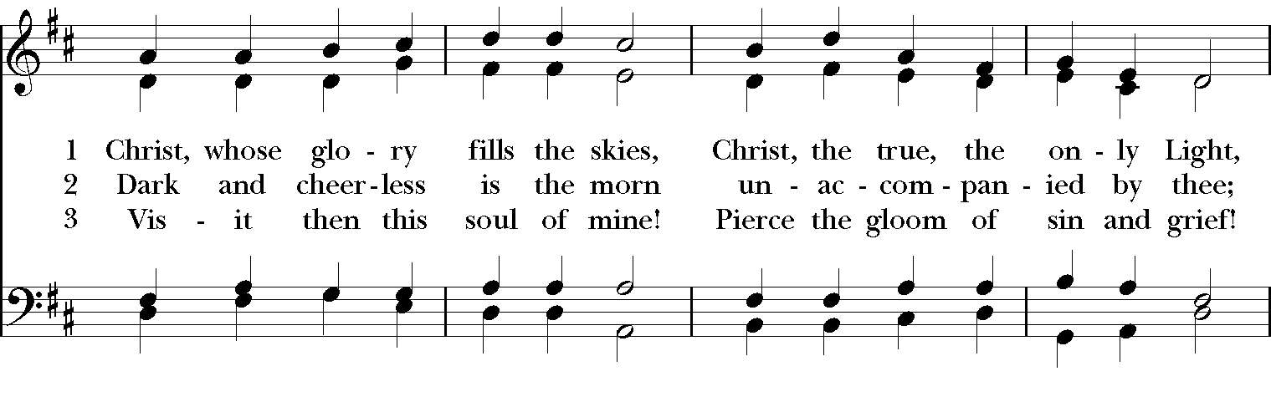

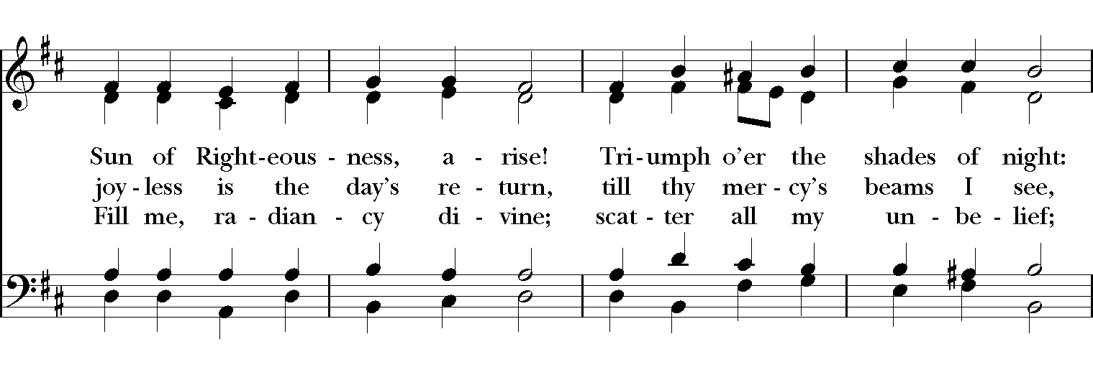

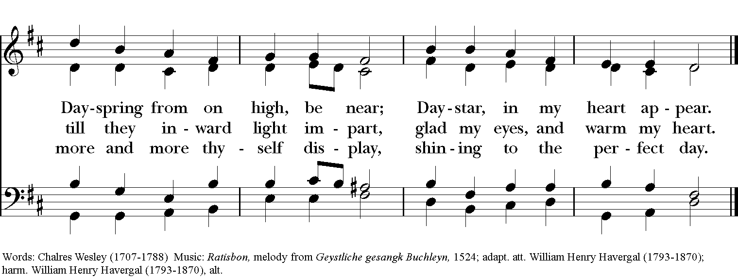

**Hymn S280 – *Gloria in excelsis (Glory to God)***

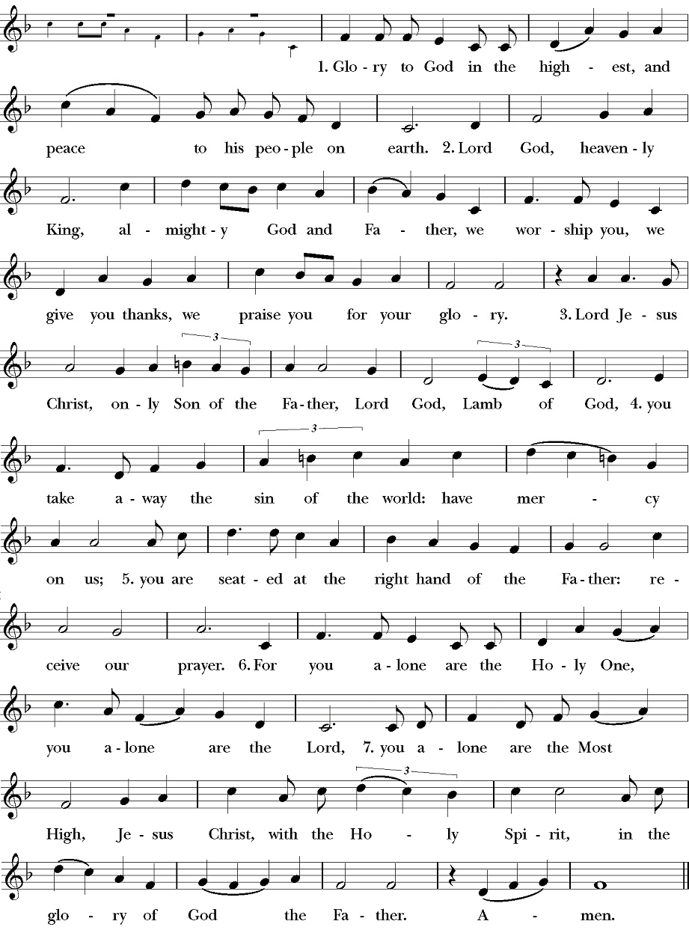

**#138**

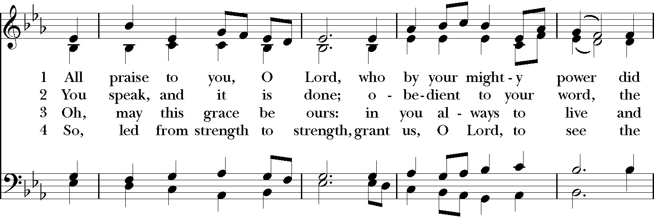

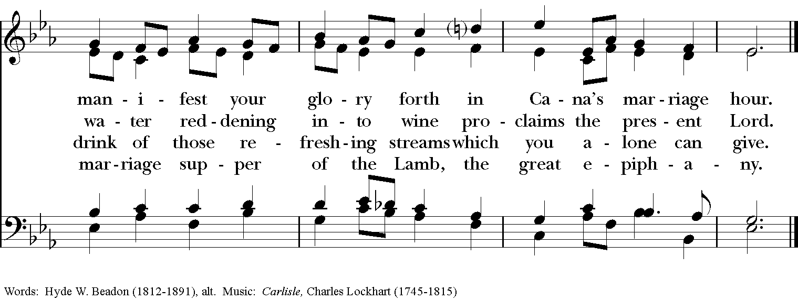

**Hymn S130 – *Sanctus***

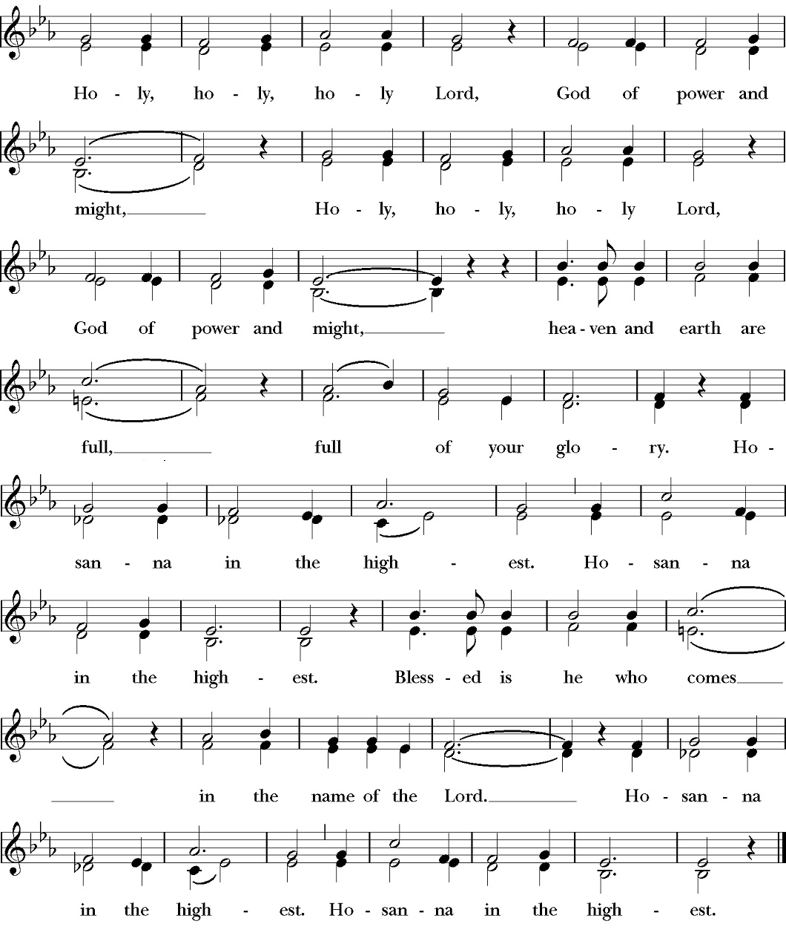

**#542**

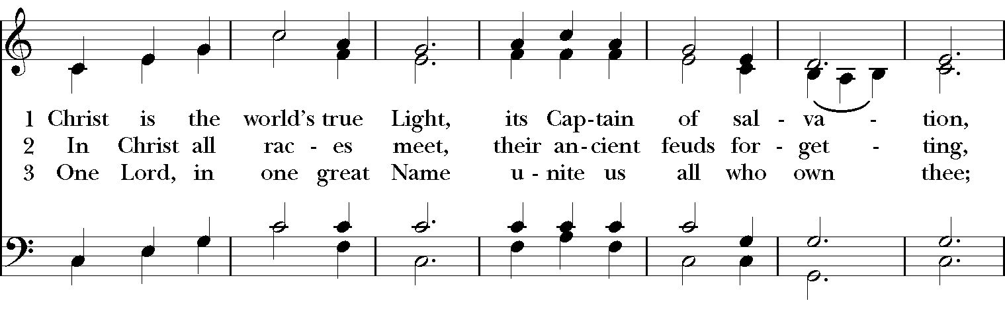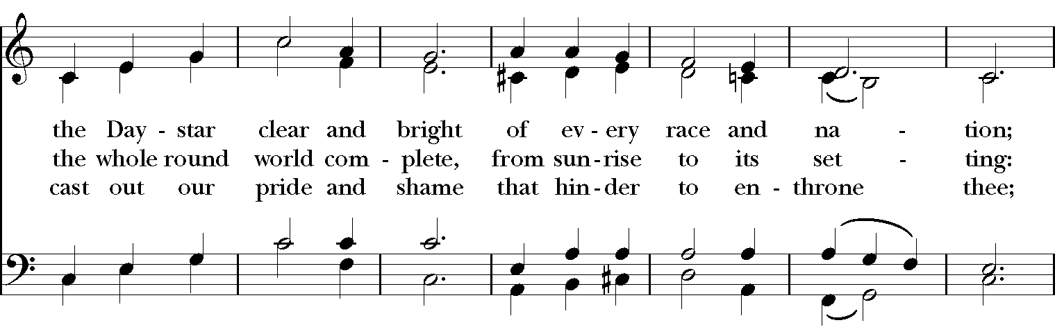

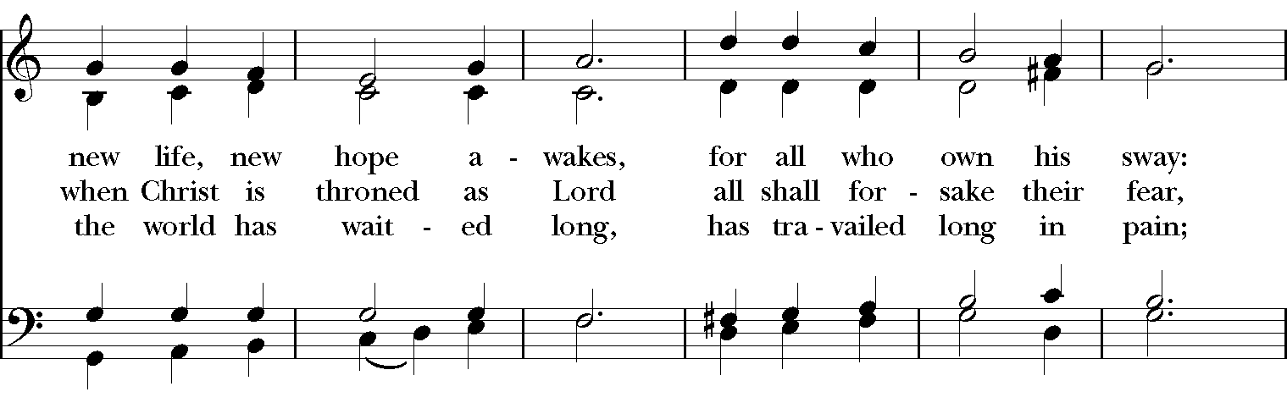

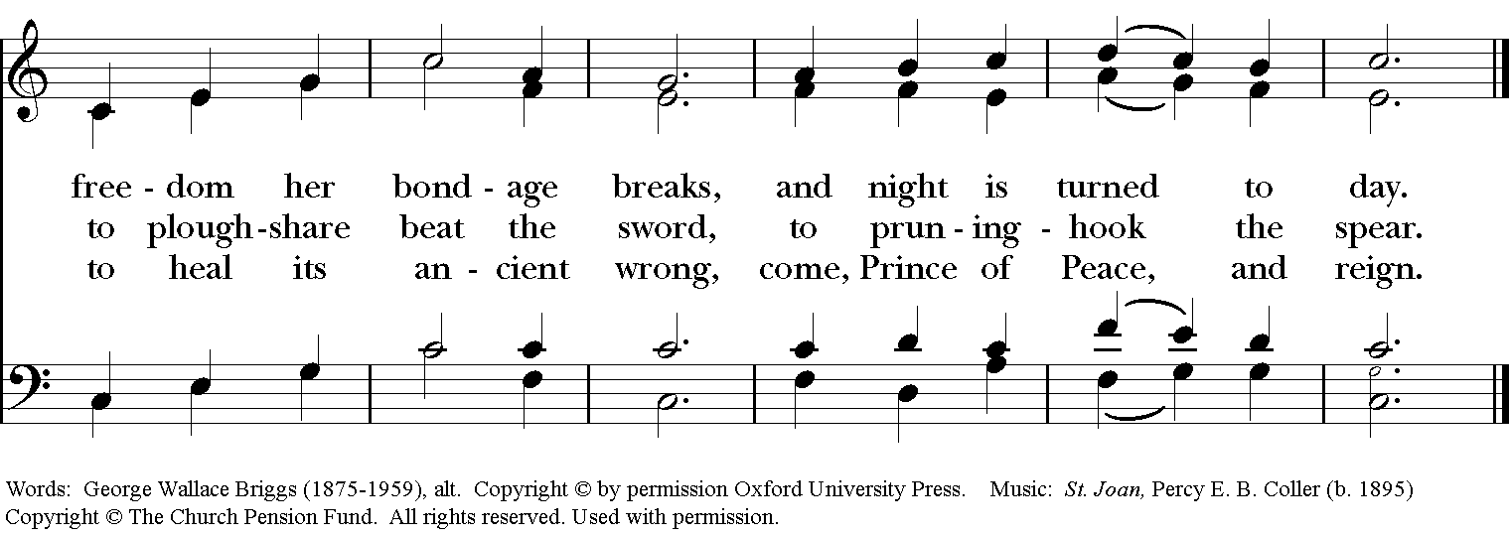

**Our prayers for our members and their families:**

Sara & Bob Armstrong, Cory Woodbury, the Hooper family, Ward & Taylor Willis, Barbara & Dan Whitfield, Janelle McGuire, Andy Morehouse, Pat, Kelli, Jack Giovo, Laura Read, Jerimiah Bryant, Ronnie Whitaker, Christa Kelley, Stuart Shanor, Carol Anne, Elly Mulkey, Bud Milner, Jerry & Marty Childress, Marilyn Manatt, Gary Smith, Michelle, Ann Wonders, Isabel Castillo, Lisa Huff, Molly Pittman, Dwight & Anne Crowder, Julie Deaton, Betty, Victoria S., Aaron & Sarah, Kim C., Richard Morris, Maddy, Abby K & family, Janet M., Martin Kelly, Victoria Cobb, Pat Wiberg, Andrew W., Matthew, Kendall & Pam Kelley, David Smith, Breanna Hickey, Billie Weber, Lynn Waggoner, Rachel, Gabe Martin, Amanda Olivo, Sevie Bates, Florence Carr, Jessica Morris, Alice Smith, Beth Rogers, Jeannine Byron, Melody Green, Marisa, Lew Hightower, Jennie Evans, Clayton Thompson, Bill & Meredith Patton, Annette Mader, John Keeth, Soraya, Manuel, Charmaine & Charles Martin, Julian Linares, Raymond Linares, Jennifer Linares, Jean Hooper, Cheryl Grey, Cassie, Gary Larson, Sandi Olivo, Nick Brisco

**Our prayers for friends of St. Andrew’s**:

Gretta Dickman, Susan H., Canon Lee Curtis, Bill Murphy, Jo Pendergrass, Nancy W., Andres Adauto, Coy Dickson, Steve Hazelbaker, Johnny Pena, Rebecca Ellis, Victor & Laquita Pierce, Robert, Mark, Jenice Furguson, Rev. Susanna Metz, Del Journey, Courtney, Heidi Huckabee, Janie Mendoza, Elena & family, Elena & Blanca’s mother, Joan Accardi, Robert, Aurora, Patty & George Swenson, Tristen, Belma & Alan Cloud, Josie Powell, Clifford Sipple family, Julie & Donna Franco, Dayna, Karen Anderson, Dee & Eddie, Andrea, Mitchel Rosen, Cox Family, Melissa J. & family, Fr. Hector Trejo, Shawna & family, Stephanie K., Sarah, Veronica, Michelle Siebel, Kalistro Linares, Michele Hillman, Sarah Wooldridge, Jerry & M.J., Rex Kartchner, Alison, Emily, Janet Carter, Meredith Miller, Maryanne D’Arcangelis, Christopher, Josie & Lloyd, Fern Simpson, Lara, Dyan, Nancy Klima, M. Lopez, Ed Tinsley, Wilson, Susan, Keith Maston, Kevin Maston, Carli Salyards, Tammy Reed, Frank Roberts and family, Elizabeth Klijnsmit, Jaime Alvarez, Ron & Twylla M, Rosemary Henry, Mathew & family, Effie Silva, Baldo & Rena, Marty G., Tom & Marilyn